20160323
# How to turn on appropriate option with OME template.
# Follow option must be turned on to send snmp trap to OME and then to SupportAssist and then auto open case if it need.
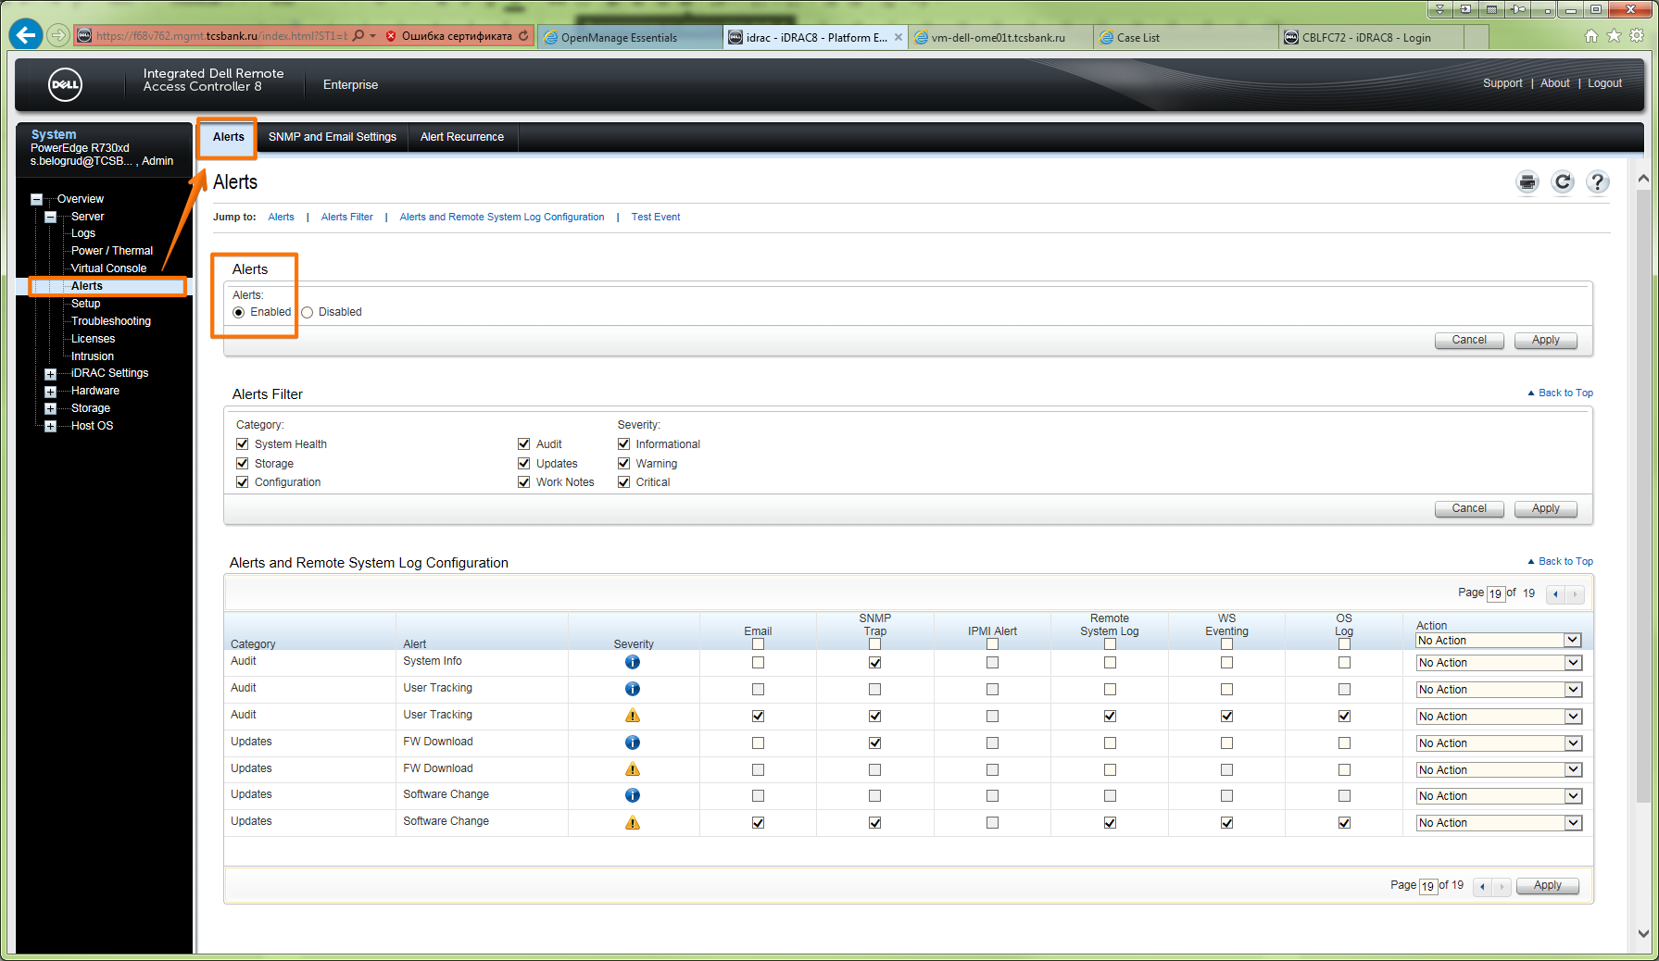

# To find what’s name of appropriate option name in template in OME, I have created two templates of same server.
# One template with turned on target option and one template with turned off target option.
# Then these two templates have been downloaded and copaired with total commander utility.
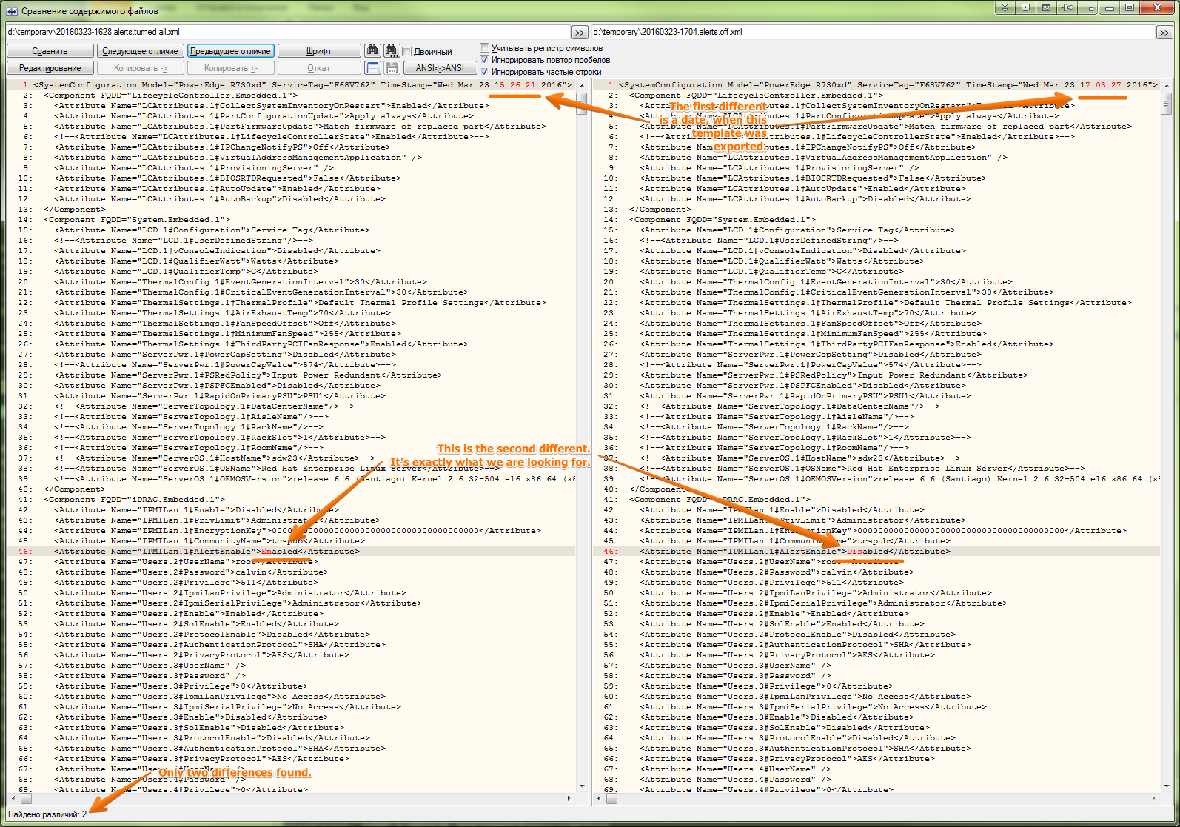

# Then I create filter, that match “IPMILan” and have found option what I should use in my result template.

20160323
# In assume - what new knowledge we have after resolving this issue.

*.
I can get access to this data with this link: https://vm-dell-ome01t.tcsbank.ru:2607/api/OME.svc/Alerts
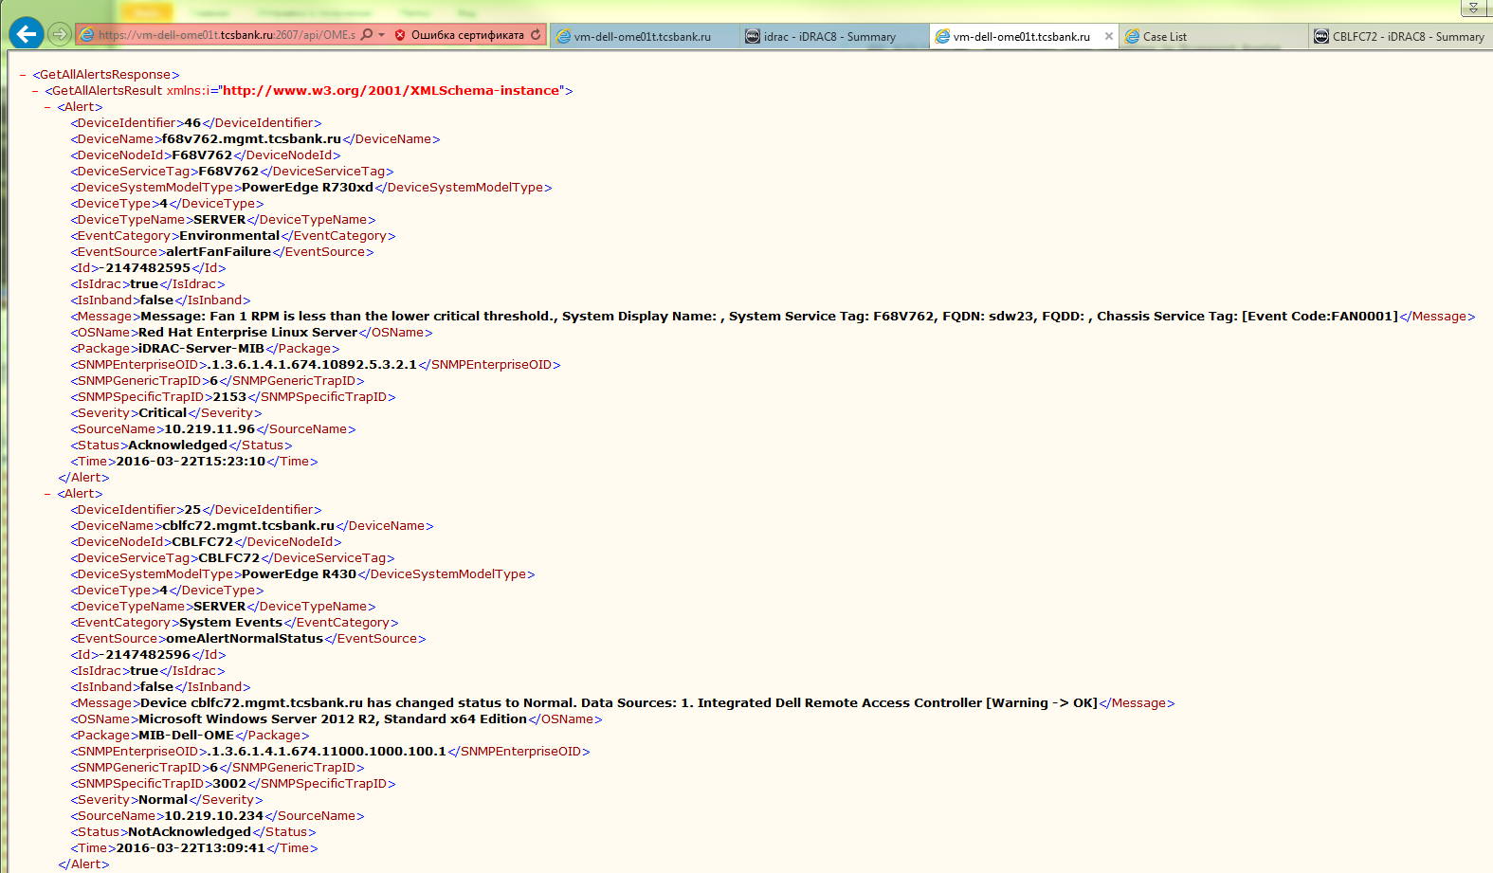

*. I can create test case.

From: Belogrud Sergey Vladimirovich [mailto:s.belogrud@tinkoff.ru]
Sent: Tuesday, March 22, 2016 5:55 AM
To: Bilinski, Joe <Joe_Bilinski@DELL.com>; Frachisse, Laurent <Laurent_Frachisse@Dell.com>
Cc: Kretkiewicz, Piotr <Piotr_Kretkiewicz@Dell.com>; Udovenko, Oleg <Oleg_Udovenko@Dell.com>; Leonov Aleksey Vladimirovich <a.leonov@tinkoff.ru>
Subject: RE: 925239190 - Automatic case creation in Support Assist

Hello Joe, Laurent and other.

I have done test.
But there were no any alerts in OME at all.
Case in SupportAssist, of course, was not created too.

[root@ds-gp-prd-sdw23 ~]# racadm eventfilters test -i FAN0001
RAC1027: Successfully sent the alert for the specified event to the configured
destination.
Verify if the alerts were received by the configured destination. Otherwise,
reconfigure the destination and retry the operation.

[root@ds-gp-prd-sdw23 ~]#

*. I can set debug mode for SupportAssist.

From: Laurent_Frachisse@Dell.com [mailto:Laurent_Frachisse@Dell.com]
Sent: Tuesday, March 08, 2016 11:53 AM
To: Belogrud Sergey Vladimirovich
Cc: Piotr_Kretkiewicz@Dell.com; Oleg_Udovenko@Dell.com; Robert_Quinn@Dell.com; Leonov Aleksey Vladimirovich
Subject: RE: 925239190 - Automatic case creation in Support Assist

Hello Sergey

For the events that occurred in February I can confirm that there was no events received on the Support Assist server database. It is possible that the Software was in maintenance mode following too many alerts within 60 minutes.

For the Support Assist case creation would that be possible to activate the debug mode during racadm test ?

HKEY_LOCAL_MACHINE\SOFTWARE\Wow6432Node\Dell\Dell Integrated Support
Change Value name = LogFileLevel, from INFO to DEBUG and restart the Dell SupportAssist service.
The temp changes should create a case on the 5th try within 5 hours. I didn’t see temp alerts on the image you provided. Was it done on this Device?

To create a case, I would suggest
1. changing the log level to DEBUG
2. Run 4 temp changes, make sure 4 of them are viewing in OME
3. Verify SupportAssist is not in Maintenance Mode, if so take it out of MMode
4. Run the 5th temp test

*. I can use follow command for test purposes.

From: Belogrud Sergey Vladimirovich
Sent: Thursday, March 03, 2016 3:48 PM
To: 'Laurent_Frachisse@Dell.com'
Cc: Piotr_Kretkiewicz@Dell.com; Oleg_Udovenko@Dell.com; Leonov Aleksey Vladimirovich
Subject: RE: 925239190 - Automatic case creation in Support Assist

Hi Laurent.

I have tested changing temperature threshold.
Follow cycle was repeated six time.

[root@ds-gp-prd-sdw23 ~]# racadm sensorsettings set iDRAC.Embedded.1#SystemBoardInletTemp -level max 8
Object value modified successfully

[root@ds-gp-prd-sdw23 ~]# racadm getsensorinfo | grep -A 1 -B 2 SystemBoardInletTemp
Sensor Type : TEMPERATURE
<Sensor Name> <Status> <Reading> <lc> <uc> <lnc>[R/W] <unc>[R/W]
[Key = iDRAC.Embedded.1#SystemBoardInletTemp]
System Board Inlet Temp Warning 29C -7C 47C 3C [Y] 8C [Y]
[root@ds-gp-prd-sdw23 ~]# racadm sensorsettings set iDRAC.Embedded.1#SystemBoardInletTemp -level max 42
Object value modified successfully

[root@ds-gp-prd-sdw23 ~]# racadm getsensorinfo | grep -A 1 -B 2 SystemBoardInletTemp
Sensor Type : TEMPERATURE
<Sensor Name> <Status> <Reading> <lc> <uc> <lnc>[R/W] <unc>[R/W]
[Key = iDRAC.Embedded.1#SystemBoardInletTemp]
System Board Inlet Temp Ok 29C -7C 47C 3C [Y] 42C [Y]
[root@ds-gp-prd-sdw23 ~]#

*. I can manually get dset data.

From: Belogrud Sergey Vladimirovich [mailto:s.belogrud@tinkoff.ru]
Sent: Thursday, February 18, 2016 12:16 PM
To: Frachisse, Laurent
Cc: Kretkiewicz, Piotr; Udovenko, Oleg; Leonov Aleksey Vladimirovich
Subject: [WARNING: MESSAGE ENCRYPTED]RE: 925239190 - Automatic case creation in Support Assist

Hello Laurent.

Point No.1.
I have run utility, what you asked.
Its output file is attached.

PS C:\Program Files (x86)\Dell\AdvDiags\DSET\bin> .\DellSystemInfo.exe -s 10.219.11.96 -u root -r c:\dset.zip
Dell System E-Support Tool, Version 3.7.0
@2004-2014 Dell Inc. All Rights Reserved.

Please enter "root" password: ****
* Gathering Chassis information...
* Gathering Storage information...
* Gathering System Summary information...
* Preparing and Compressing Report...
* Saving DSET CIM report to path: c:\ with report file name: dset.zip
PS C:\Program Files (x86)\Dell\AdvDiags\DSET\bin> dir C:\dset.zip

Directory: C:\

Mode LastWriteTime Length Name
---- ------------- ------ ----
-a--- 18.02.2016 14:56 2148610 dset.zip

PS C:\Program Files (x86)\Dell\AdvDiags\DSET\bin>
...

*. I can unzip dset.zip file with password “dell”.
There is one file (hta file). It could be opened with web-browser.
This file contains any errors of motherboard if it exist.

*. Now I know how maintenance mode looks.
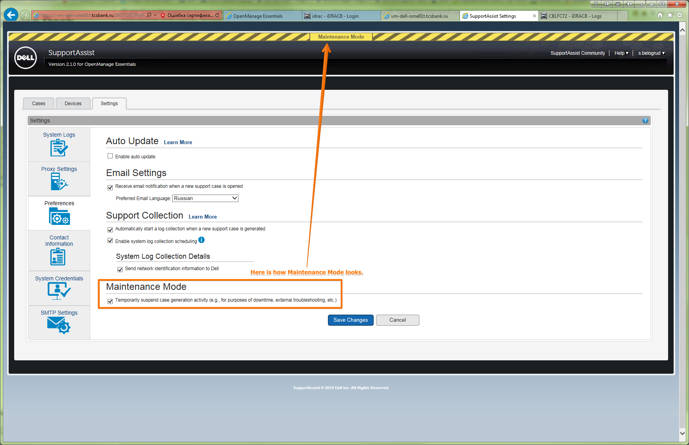

From: Belogrud Sergey Vladimirovich
Sent: Wednesday, February 17, 2016 1:05 PM
To: 'Oleg_Udovenko@Dell.com'
Cc: Leonov Aleksey Vladimirovich; Piotr_Kretkiewicz@Dell.com
Subject: RE: Dell Support Case: 925239190 [R730xd]

Что ж многообещающе и амбициозно. Рад, что всё именно так. J
Это предвещает позитив в нашем взаимодействии.

Ждём отклика Ваших коллег.

From: Oleg_Udovenko@Dell.com [mailto:Oleg_Udovenko@Dell.com]
Sent: Wednesday, February 17, 2016 12:56 PM
To: Belogrud Sergey Vladimirovich
Cc: Leonov Aleksey Vladimirovich; Piotr_Kretkiewicz@Dell.com
Subject: RE: Dell Support Case: 925239190 [R730xd]

Dell Customer Communication
> Важно, что бы у Ваших клиентов не появлялось чувства, что техподдержкой Dell применяется схема «косить» и «забивать».
Еще ни разу мне не приходило таких отзывов от клиентов. Иногда бывают задержки в ответах от техподдержки, но только из-за занятости инженеров.

> Слегка удивляет, что на эти вопросы нет готовых ответов… Через них должен проходить каждый первый Ваш customer, кто установил Dell OpenManage Essentials.
OpenManage Essential не сильно распространен в россии. И должен сказать, что каждый раз проблемы разные. Поэтому и привлекаются коллеги из софтовой команды, которые сталкиваются с этим гораздо чаще. К сожалению у них также довольно большая нагрузка, поэатому они не всегда могут ответить сразу.

> Удалённое подключение теоретически возможно, но мало-вероятно – я бы на него не расчитывал.
Быстрее и проще решить Ваши вопросы во время удаленной сессии. Наша софтовая команда работает именно так.

Best Regards / С уважением
Oleg Udovenko
Enterprise Resolution Manager

Dell | Global Support & Deployment
Ext: +49 345 782 25317|| Int: 31 25317
Oleg_Udovenko@dell.com

How am I doing? E-mail my manager Tino Buttenberg for any feedback.

Dell Halle GmbH in Vertretung der Dell GmbH. Raffineriestraße 28, 06112 Halle (Saale), Germany
Geschäftsführer: Doris Albiez, Sanjay Tyagi
Vorsitzender des Aufsichtsrates: Jürgen Renz
Eingetragen beim Amtsgericht Stendal unter HRB 215298, USt.-ID: DE242553389
WEEE-Reg.Nr. der Dell GmbH: DE 49515708

From: Belogrud Sergey Vladimirovich [mailto:s.belogrud@tinkoff.ru]
Sent: Wednesday, 17 February, 2016 10:39
To: Udovenko, Oleg <Oleg_Udovenko@Dell.com>
Cc: Leonov Aleksey Vladimirovich <a.leonov@tinkoff.ru>; Kretkiewicz, Piotr <Piotr_Kretkiewicz@Dell.com>
Subject: RE: Dell Support Case: 925239190 [R730xd]

> Если бы у меня были ответы, я бы их Вам уже дал.
Это хорошо.
> Проблемами ПО у нас занимается софтовая команда, которая разбросана по всей Европе, поэтому не всегда есть возможность спросить у них сразу напрямую.
Если нужно – подождём.
Важно, что бы у Ваших клиентов не появлялось чувства, что техподдержкой Dell применяется схема «косить» и «забивать».

> Отсюда вопрос: говорите ли Вы по-английски? А также будет ли у него возможность удаленно подключиться к системе с установленным Open Manage Essential и Support Assist?
В принципе да – говорю. Однако, возможно, в письменной форме диалог будет конструктивнее и предметнее (по крайней мене на начальном этапе). Слегка удивляет, что на эти вопросы нет готовых ответов… Через них должен проходить каждый первый Ваш customer, кто установил Dell OpenManage Essentials.
Удалённое подключение теоретически возможно, но мало-вероятно – я бы на него не расчитывал. Во первых вопросы довольно общие (пока во всяком случае). Во вторых наша организация – это банк. И элемент безопасности здесь более, чем организациях попроще.

From: Oleg_Udovenko@Dell.com [mailto:Oleg_Udovenko@Dell.com]
Sent: Wednesday, February 17, 2016 12:27 PM
To: Belogrud Sergey Vladimirovich
Cc: Leonov Aleksey Vladimirovich; Piotr_Kretkiewicz@Dell.com
Subject: RE: Dell Support Case: 925239190 [R730xd]

Dell Customer Communication
Добрый день, Сергей!

Если бы у меня были ответы, я бы их Вам уже дал.
Проблемами ПО у нас занимается софтовая команда, которая разбросана по всей Европе, поэтому не всегда есть возможность спросить у них сразу напрямую.
Данным вопросом скорее всего будет заниматься коллега из Франции. Отсюда вопрос: говорите ли Вы по-английски? А также будет ли у него возможность удаленно подключиться к системе с установленным Open Manage Essential и Support Assist?

Best Regards / С уважением
Oleg Udovenko
Enterprise Resolution Manager

Dell | Global Support & Deployment
Ext: +49 345 782 25317|| Int: 31 25317
Oleg_Udovenko@dell.com

How am I doing? E-mail my manager Tino Buttenberg for any feedback.

Dell Halle GmbH in Vertretung der Dell GmbH. Raffineriestraße 28, 06112 Halle (Saale), Germany
Geschäftsführer: Doris Albiez, Sanjay Tyagi
Vorsitzender des Aufsichtsrates: Jürgen Renz
Eingetragen beim Amtsgericht Stendal unter HRB 215298, USt.-ID: DE242553389
WEEE-Reg.Nr. der Dell GmbH: DE 49515708

From: Belogrud Sergey Vladimirovich [mailto:s.belogrud@tinkoff.ru]
Sent: Wednesday, 17 February, 2016 10:08
To: Udovenko, Oleg <Oleg_Udovenko@Dell.com>
Cc: Leonov Aleksey Vladimirovich <a.leonov@tinkoff.ru>; Kretkiewicz, Piotr <Piotr_Kretkiewicz@Dell.com>
Subject: RE: Dell Support Case: 925239190 [R730xd]

Отлично, что Вы на связи, Олег.

>> Я не заметил, что кейс был открыт через Techdirekt, а не через SupportAssist.
Именно так – кейс был открыт Леоновым Алексеем с помощью сайта Dell TechDirect.

>> Тогда явно видится, что проблема в настройках SupportAssist. Подскажите, пожалуйста, проверили ли Вы настройки по всем рекомендациям, предоставленным Петром?
Именно так – я проверил настройки ПО Dell SupportAssist, установленного на одном из наших серверов (на том же где, установлен Dell OpenManage Essentials).
Могу выслать скриншоты, если это нужно.
Под всеми рекомендациями, кстати, предоставленными Петром Вы подразумеваете вот лишь это бессловесное короткое видео: https://www.youtube.com/watch?v=clMwAT2Wbkk

1.1.
Ранее я уже писал об этом:
> Я перепроверил настройки Dell SupportAssist и все настройки выглядят корректными.
> Можно-ли как-то протестировать работу этого ПО?
> Протестировать, что оно обнаруживает неисправности, уведомляет о них, может создавать кейсы?
В том числе я спрашивал о возможностях проверки. Вы не ответили.

1.2.
Я так же спрашивал об этом:
> Наличие этого контракта можно увидеть в Dell License Manager?
Вы не ответили.

1.3.
Я спрашивал и об этом:
> При попытке что-то поднастроить в опции Support Assist на сайте Dell TechDirect, элементы настройки не удаётся изменить.
> Настройки на странице ниже не изменяются – их изменение заблокировано.
> Как их настраивать?
Вы не ответили.

Приходится Выжимать из Вас ответы, Олег, что не особо приятно.

From: Oleg_Udovenko@Dell.com [mailto:Oleg_Udovenko@Dell.com]
Sent: Wednesday, February 17, 2016 11:52 AM
To: Belogrud Sergey Vladimirovich
Cc: Leonov Aleksey Vladimirovich; Piotr_Kretkiewicz@Dell.com
Subject: RE: Dell Support Case: 925239190 [R730xd]

Dell Customer Communication
Добрый день, Сергей!

Пока Петр ждет ответа от нашей софтовой команды. Если в этом будет необходимость, они свяжутся с Вами для решения дальнейших проблем.
Я не заметил, что кейс был открыт через Techdirekt, а не через SupportAssist. Тогда явно видится, что проблема в настройках SupportAssist. Подскажите, пожалуйста, проверили ли Вы настройки по всем рекомендациям, предоставленным Петром?

Как только мы получим ответ от нашей софтовой команды, мы сразу свяжемся с Вами.
Best Regards / С уважением
Oleg Udovenko
Enterprise Resolution Manager

Dell | Global Support & Deployment
Ext: +49 345 782 25317|| Int: 31 25317
Oleg_Udovenko@dell.com

How am I doing? E-mail my manager Tino Buttenberg for any feedback.

Dell Halle GmbH in Vertretung der Dell GmbH. Raffineriestraße 28, 06112 Halle (Saale), Germany
Geschäftsführer: Doris Albiez, Sanjay Tyagi
Vorsitzender des Aufsichtsrates: Jürgen Renz
Eingetragen beim Amtsgericht Stendal unter HRB 215298, USt.-ID: DE242553389
WEEE-Reg.Nr. der Dell GmbH: DE 49515708

From: Belogrud Sergey Vladimirovich [mailto:s.belogrud@tinkoff.ru]
Sent: Wednesday, 17 February, 2016 09:39
To: Udovenko, Oleg <Oleg_Udovenko@Dell.com>
Cc: Leonov Aleksey Vladimirovich <a.leonov@tinkoff.ru>; Kretkiewicz, Piotr <Piotr_Kretkiewicz@Dell.com>
Subject: RE: Dell Support Case: 925239190 [R730xd]

Добрый день Олег.

Вы уже в работе?
С нетерпением жду от Вас ответа.
Есть-ли причины затягивать с ответами по достаточно общей тематике - создание кейсов, настройки опций на сайте Dell TechDirect, работа/не работа утилиты Dell SupportAssist на сервере с установленным Dell OpenManageEssentials, лицензии?
Может быть Вы адресуете меня сразу к Вашим специалистам, кто плотно разбирается в этих вопросах использования Dell OpenManage Essentials?

From: Belogrud Sergey Vladimirovich
Sent: Tuesday, February 16, 2016 6:41 PM
To: 'Oleg_Udovenko@Dell.com'
Cc: Leonov Aleksey Vladimirovich; Piotr_Kretkiewicz@Dell.com
Subject: RE: Dell Support Case: 925239190 [R730xd]

Добрый день Олег.

Спасибо за Ваши пояснения.
Надеюсь с Вашей помощью решение вопросов пойдёт проворнее.

Ещё раз уточнюсь. Ибо путаница может возникнуть из-за специфический названий сервисов под которыми Вы понимаете одно а я другое.

> 1. Открытие заявки: мы узнали о неисправном диске из заявки, открытой Support Assist.
Правильно-ли я понимаю, что кейс был открыт автоматически с помощью ПО Dell SupportAssist установленном на одном из наших серверов?
Потому, что у меня информация другая. Я понял так, что заявка была открыта вручную нашим сотрудником на Вашем сайте Dell TechDirect.
Собственно вот этот кейс, как он выглядит на сайте Dell TechDirect.

> 2. Информирование Вас об открытой заявке: это действительно вопрос настройки ПО, проверьте, пожалуйста, разрешено ли у Вас информирование по email, а также правильно ли настроено ПО.
Вы пишите про Support Assist и его настройки.
Вы имеете в виду ПО Dell SupportAssist установленном на одном из наших серверов?
Или Вы имеете в виду вот эту опцию на сайте Dell TechDirect?

При попытке что-то поднастроить в опции Support Assist на сайте Dell TechDirect, элементы настройки не удаётся изменить.
Настройки на странице ниже не изменяются – их изменение заблокировано.
Как их настраивать?

> 3. По вашему второму вопросу: Петр уточнит у насшей софтовой команды, могут ли они помочь в данном случае и дать какие-либо рекомендации. На получение ответа от софтовой команды требуется время.
Надеюсь, что в этот раз ответ будет.

From: Oleg_Udovenko@Dell.com [mailto:Oleg_Udovenko@Dell.com]
Sent: Tuesday, February 16, 2016 6:03 PM
To: Belogrud Sergey Vladimirovich; Piotr_Kretkiewicz@Dell.com
Cc: Leonov Aleksey Vladimirovich
Subject: RE: Dell Support Case: 925239190 [R730xd]

Dell Customer Communication
Добрый день, Сергей!

Меня зовут Олег Удовенко, я являюсь Resolution Manager‘ом в компании Dell. Давайте я внесу немного ясности:

1. Открытие заявки: мы узнали о неисправном диске из заявки, открытой Support Assist.
2. Информирование Вас об открытой заявке: это действительно вопрос настройки ПО, проверьте, пожалуйста, разрешено ли у Вас информирование по email, а также правильно ли настроено ПО.
3. По вашему второму вопросу: Петр уточнит у насшей софтовой команды, могут ли они помочь в данном случае и дать какие-либо рекомендации. На получение ответа от софтовой команды требуется время.

Пожaлуйста, оставляйте меня в копии переписки, чтобы я мог следить за прогрессом в данном инциденте.

Best Regards / С уважением
Oleg Udovenko
Enterprise Resolution Manager

Dell | Global Support & Deployment
Ext: +49 345 782 25317|| Int: 31 25317
Oleg_Udovenko@dell.com

How am I doing? E-mail my manager Tino Buttenberg for any feedback.

Dell Halle GmbH in Vertretung der Dell GmbH. Raffineriestraße 28, 06112 Halle (Saale), Germany
Geschäftsführer: Doris Albiez, Sanjay Tyagi
Vorsitzender des Aufsichtsrates: Jürgen Renz
Eingetragen beim Amtsgericht Stendal unter HRB 215298, USt.-ID: DE242553389
WEEE-Reg.Nr. der Dell GmbH: DE 49515708

From: Belogrud Sergey Vladimirovich [mailto:s.belogrud@tinkoff.ru]
Sent: Tuesday, 16 February, 2016 15:31
To: Kretkiewicz, Piotr <Piotr_Kretkiewicz@Dell.com>
Cc: Udovenko, Oleg <Oleg_Udovenko@Dell.com>; Leonov Aleksey Vladimirovich <a.leonov@tinkoff.ru>
Subject: RE: Dell Support Case: 925239190 [R730xd]

Спасибо за попытку ответить на заданные вопросы.
Однако вопросы всё ещё остаются.
И, кстати, на второй вопрос вообще не прозвуючало какого-либо ответа.

Информация, которая доступна по Вашим ссылкам, к сожалению не прояснила ситуацию.

Вопрос 1.

Правильно-ли я понял, что кейс по неисправности жеского диска на сервере c сервис-тегом F68V762 не был автоматически открыт ПО Dell SupportAssist потому, что для этого сервера нет активного Dell ProSupport contract?
«SupportAssist FAQs OME 1.3» (http://i.dell.com/sites/doccontent/shared-content/solutions/en/Documents/supportassist-faq.pdf ).

Наличие этого контракта можно увидеть в Dell License Manager?
Вот, например, что отображается по данному серверу у нас.

Я перепроверил настройки Dell SupportAssist и все настройки выглядят корректными.
Можно-ли как-то протестировать работу этого ПО?
Протестировать, что оно обнаруживает неисправности, уведомляет о них, может создавать кейсы?

Как это описано в документе по предоставленной Вами ссылке: «SupportAssist FAQs OME 1.3» (http://i.dell.com/sites/doccontent/shared-content/solutions/en/Documents/supportassist-faq.pdf ).

Вопрос 2.
И собственно проигнорированный вопрос.
Вы или другие специалисты Dell могут что-то конкретное разъяснить по заданному вопросу?
Сообщите пожалуйста условия, которые нужно выполнить, чтобы специалисты Dell, которые в этом разбираются, сомогли заняться вопросом.

From: Piotr_Kretkiewicz@Dell.com [mailto:Piotr_Kretkiewicz@Dell.com]
Sent: Tuesday, February 16, 2016 3:56 PM
To: Belogrud Sergey Vladimirovich
Cc: Leonov Aleksey Vladimirovich
Subject: RE: Dell Support Case: 925239190 [R730xd]

Добрый день еще раз,

Я получил информацию, что, скорее всего, тут возникли проблемы с неправильным настроеннем утилиты.

Высылаю Вам ссылку, как настраивать:
https://www.youtube.com/watch?v=clMwAT2Wbkk

При возникновении неисправности в сервере, с активной гарантией ProSupport, Dell SupportAssist открывает новый кейс. Тогда Вы получаете уведомление по электронной почте с номером заявки, а затем сотрудник службы технической поддержки свяжаеться с Вами и решает проблему. И так мы получили от Вас информацию по поводу сбойного диска в том сервере.

Больше информации найдете тут:
http://i.dell.com/sites/doccontent/shared-content/solutions/en/Documents/supportassist-faq.pdf

Можете тоже купить дополнительную опцию (настройку) для гарантии Делл или спросить у продавцов о такой возможности:

Удаленное консультирование по вопросам конфигурирования систем и приложений (Remote Consulting Services) может быть использовано в случае возникновения необходимости переконфигурирования систем хранения данных, серверов, коммутаторов, операционных систем, получения консультаций по дизайну на предмет соответствия требованиям Заказчика. Существует возможность приобрести почасовые консультации (оплата за 1 час работы инженера) или консультацию по проблеме (фиксированная стоимость за решение проблемы). Консультации проводятся удаленно экспертами Dell, обладающими необходимыми знаниями (сертификатами). Подробнее о данном виде услуг и продуктов / технологий, по отношению к которым они оказываются можно узнать по ссылке.

С уважением,

Пётр Креткевич
Enterprise Technical Support Analyst
Dell | Global Support Services
piotr_kretkiewicz@dell.com

Dell Halle GmbH in Vertretung der Dell GmbH, Raffineriestraße 28, 06112 Halle (Saale), Germany
Geschäftsführer: Doris Albiez, Sanjay Tyagi
Vorsitzender des Aufsichtsrates: Jürgen Renz
Eingetragen beim Amtsgericht Stendal unter HRB 215298, USt.-ID: DE242553389
WEEE-Reg.Nr. der Dell GmbH: DE 49515708

Если у вас возникли положительные или отрицательные впечатления от работы по этому кейсу (заявке), напишите небольшое письмо моему менеджеру, который отвечает за качество работы поддержки по серверам:

Олег Удовенко Oleg_Udovenko@dell.com на русском языке
Sven Jung Sven_Jung@dell.com на английском языке

Номера горячей линии поддержки:
ProSupport
Россия: +7 499 500 8393 / 8 10 800 209 71044
Украина: 0800 502 0340 / 0800 502 034
Эстония: 0800-2226
Латвия: 800 028 87
Литва: 880 030 097
Казахстан: +7 800 333 4225 / +7 800 333 4218
Азербайджан: 0887773355

Поддержка на русском языке работает с понедельника по пятницу с 9 до 19 по московскому времени и c 8 до 18 по киевскому времени. В остальное время звонки автоматически переводятся на английскую линию поддержки.

From: Belogrud Sergey Vladimirovich [mailto:s.belogrud@tinkoff.ru]
Sent: Tuesday, February 16, 2016 12:34 PM
To: Kretkiewicz, Piotr
Cc: Leonov Aleksey Vladimirovich
Subject: RE: Dell Support Case: 925239190 [R730xd]

Хорошо, что процесс идёт и находится под Вашим контролем.
Надеюсь результат не заставит себя ждать.

Кстати, я могу напрямую повзаимодействовать с Вашими коллегами из другой команды (которые более сведущи по тематике OpenManage Essentials).
Конечно если так будет эффективнее для нас обоих и для всех в целом.

From: Piotr_Kretkiewicz@Dell.com [mailto:Piotr_Kretkiewicz@Dell.com]
Sent: Tuesday, February 16, 2016 1:58 PM
To: Belogrud Sergey Vladimirovich
Subject: RE: Dell Support Case: 925239190 [R730xd]

Добрый день Сергей,

Извините за задержку.
Я занимаюсь техническими проблемами, но я попросил помощи коллег с другой команды с решением Вашего вопроса и сейчас жду ответа

С уважением,

Пётр Креткевич
Enterprise Technical Support Analyst
Dell | Global Support Services
piotr_kretkiewicz@dell.com

Dell Halle GmbH in Vertretung der Dell GmbH, Raffineriestraße 28, 06112 Halle (Saale), Germany
Geschäftsführer: Doris Albiez, Sanjay Tyagi
Vorsitzender des Aufsichtsrates: Jürgen Renz
Eingetragen beim Amtsgericht Stendal unter HRB 215298, USt.-ID: DE242553389
WEEE-Reg.Nr. der Dell GmbH: DE 49515708

Если у вас возникли положительные или отрицательные впечатления от работы по этому кейсу (заявке), напишите небольшое письмо моему менеджеру, который отвечает за качество работы поддержки по серверам:

Олег Удовенко Oleg_Udovenko@dell.com на русском языке
Sven Jung Sven_Jung@dell.com на английском языке

Номера горячей линии поддержки:
ProSupport
Россия: +7 499 500 8393 / 8 10 800 209 71044
Украина: 0800 502 0340 / 0800 502 034
Эстония: 0800-2226
Латвия: 800 028 87
Литва: 880 030 097
Казахстан: +7 800 333 4225 / +7 800 333 4218
Азербайджан: 0887773355

Поддержка на русском языке работает с понедельника по пятницу с 9 до 19 по московскому времени и c 8 до 18 по киевскому времени. В остальное время звонки автоматически переводятся на английскую линию поддержки.

From: Belogrud Sergey Vladimirovich [mailto:s.belogrud@tinkoff.ru]
Sent: Monday, February 15, 2016 2:56 PM
To: Kretkiewicz, Piotr
Subject: RE: Dell Support Case: 925239190 [R730xd]

Здравствуйте Пётр.

Есть пара вопросов, связанных с этим кейсом.
Если эти вопросы не к Вам, то пожалуйста сориентируйте к кому можно с ним обратиться.

Вопрос следующий.

1.
У нас установлено с недавних пор ПО Dell OpenManage Essentials.
И установлен один их его компонентов Dell SupportAssist.
Так вот в Dell SupportAssist ни как не заметно, что на сервере возникла неисправность и список Case List пуст.
Мне казалось, что это как раз то ПО, которое должно как-то замечать неполадки на серверах и может быть даже самостоятельно создавать кейсы по неисправностям (или хотя-бы показывать уже открытые кейсы).
Помогите пожалуйста разобраться для чего нужно ПО Dell SupportAssist применительно к данному случаю.

Здесь видно, что в списке проинтвентаризированных серверов присутствует сервер на котором возникла неисправность.

Замечу, что регулярный сбор “System Logs” в этом ПО отключен.
Отключен по причине описанной ниже – во втором вопросе.

Это замеченная неисправность на сервере на страничке ПО Dell OpenManage Essentials.

2.
И есть ещё один важный вопрос.
Он тоже связан с использованием Dell SupportAssist.
При использовании Dell SupportAssist была замечена следующая пренеприятная его особенность.
Когда для нескольких серверов была выбрана опция “Send System Logs” (в столбце «Status» у них через некоторое время сменилось значение на «Collection Uploaded»).
Через не продолжительное время на этих серверах было зафиксировано наличие загруженных модулей iptables (nf_conntrack в частности), которые приводят в неработоспособность прикладное ПО, установленное на этих серверах ( прикладно ПО это GreenPlum).

Выяснение причин загрузки в RAM модулей iptables привело к записям в файле журнала событий /var/log/messages в котором были записи выполнения процедуры сбора неких данных с помощью iDRAC.
То есть получилось так, что вызов опции “Send System Logs” сломал прикладное ПО GreenPlum, из-за загрузки модулей iptables. Предположительно, что причина тому некие манипуляции с сетевыми интерфейсами сервера в конце сбора данных.

На серверах используется Red Hat Enterprise Linux Server release 6.6 (Santiago).
Вот так это было:

[root@ds-gp-prd-sdw10 ~]# less /var/log/messages
...
Jan 14 12:56:52 sdw10 kernel: usb 1-1.6.2: new high speed USB device number 7 using ehci_hcd
Jan 14 12:56:52 sdw10 kernel: usb 1-1.6.2: New USB device found, idVendor=0624, idProduct=0250
Jan 14 12:56:52 sdw10 kernel: usb 1-1.6.2: New USB device strings: Mfr=4, Product=5, SerialNumber=6
Jan 14 12:56:52 sdw10 kernel: usb 1-1.6.2: Product: Mass Storage Function
Jan 14 12:56:52 sdw10 kernel: usb 1-1.6.2: Manufacturer: Avocent
Jan 14 12:56:52 sdw10 kernel: usb 1-1.6.2: SerialNumber: 20120731
Jan 14 12:56:52 sdw10 kernel: usb 1-1.6.2: configuration #1 chosen from 1 choice
Jan 14 12:56:52 sdw10 kernel: scsi4 : SCSI emulation for USB Mass Storage devices
Jan 14 12:56:53 sdw10 kernel: scsi 4:0:0:0: Direct-Access iDRAC SECUPD 0329 PQ: 0 ANSI: 0 CCS
Jan 14 12:56:53 sdw10 kernel: sd 4:0:0:0: Attached scsi generic sg3 type 0
Jan 14 12:56:53 sdw10 kernel: sd 4:0:0:0: [sdd] 2112 512-byte logical blocks: (1.08 MB/1.03 MiB)
Jan 14 12:56:53 sdw10 kernel: sd 4:0:0:0: [sdd] Write Protect is off
Jan 14 12:56:53 sdw10 kernel: sd 4:0:0:0: [sdd] Assuming drive cache: write through
Jan 14 12:56:53 sdw10 kernel: sd 4:0:0:0: [sdd] Assuming drive cache: write through
Jan 14 12:56:53 sdw10 kernel: sdd:
Jan 14 12:56:53 sdw10 kernel: sd 4:0:0:0: [sdd] Assuming drive cache: write through
Jan 14 12:56:53 sdw10 kernel: sd 4:0:0:0: [sdd] Attached SCSI removable disk
Jan 14 12:57:11 sdw10 kernel: usb 1-1.6.2: USB disconnect, device number 7
Jan 14 12:57:16 sdw10 kernel: usb 1-1.6.2: new high speed USB device number 8 using ehci_hcd
Jan 14 12:57:16 sdw10 kernel: usb 1-1.6.2: New USB device found, idVendor=0624, idProduct=0250
Jan 14 12:57:16 sdw10 kernel: usb 1-1.6.2: New USB device strings: Mfr=4, Product=5, SerialNumber=6
Jan 14 12:57:16 sdw10 kernel: usb 1-1.6.2: Product: Mass Storage Function
Jan 14 12:57:16 sdw10 kernel: usb 1-1.6.2: Manufacturer: Avocent
Jan 14 12:57:16 sdw10 kernel: usb 1-1.6.2: SerialNumber: 20120731
Jan 14 12:57:16 sdw10 kernel: usb 1-1.6.2: configuration #1 chosen from 1 choice
Jan 14 12:57:16 sdw10 kernel: scsi5 : SCSI emulation for USB Mass Storage devices
Jan 14 12:57:17 sdw10 kernel: scsi 5:0:0:0: Direct-Access iDRAC SECUPD 0329 PQ: 0 ANSI: 0 CCS
Jan 14 12:57:17 sdw10 kernel: sd 5:0:0:0: Attached scsi generic sg3 type 0
Jan 14 12:57:17 sdw10 kernel: sd 5:0:0:0: [sdd] 2112 512-byte logical blocks: (1.08 MB/1.03 MiB)
Jan 14 12:57:18 sdw10 kernel: sd 5:0:0:0: [sdd] Write Protect is off
Jan 14 12:57:18 sdw10 kernel: sd 5:0:0:0: [sdd] Assuming drive cache: write through
Jan 14 12:57:18 sdw10 kernel: sd 5:0:0:0: [sdd] Assuming drive cache: write through
Jan 14 12:57:18 sdw10 kernel: sdd:
Jan 14 12:57:18 sdw10 kernel: sd 5:0:0:0: [sdd] Assuming drive cache: write through
Jan 14 12:57:18 sdw10 kernel: sd 5:0:0:0: [sdd] Attached SCSI removable disk
Jan 14 12:57:34 sdw10 kernel: usb 1-1.6.2: USB disconnect, device number 8
Jan 14 12:57:56 sdw10 kernel: bnx2x 0000:01:00.2: em3: using MSI-X IRQs: sp 189 fp[0] 191 ... fp[7] 198
Jan 14 12:57:57 sdw10 kernel: ADDRCONF(NETDEV_UP): em3: link is not ready
Jan 14 12:57:57 sdw10 kernel: bnx2x 0000:01:00.3: em4: using MSI-X IRQs: sp 199 fp[0] 201 ... fp[7] 208
Jan 14 12:57:57 sdw10 kernel: ADDRCONF(NETDEV_UP): em4: link is not ready
Jan 14 12:58:08 sdw10 snmpd[118113]: Got trap from peer on fd 11
Jan 14 12:58:13 sdw10 snmpd[118113]: Got trap from peer on fd 11
Jan 14 12:58:18 sdw10 kernel: process `cp' is using deprecated sysctl (syscall) net.ipv6.neigh.default.retrans_time; Use net.ipv6.neigh.default.retrans_time_ms instead.
Jan 14 12:58:19 sdw10 kernel: ip_tables: (C) 2000-2006 Netfilter Core Team
Jan 14 12:58:19 sdw10 kernel: nf_conntrack version 0.5.0 (16384 buckets, 65536 max)
Jan 14 12:58:21 sdw10 kernel: ACPI: No handler for Region [POWR] (ffff88305beb81e0) [IPMI]
Jan 14 12:58:30 sdw10 kernel: nf_conntrack: table full, dropping packet.
Jan 14 12:58:30 sdw10 kernel: nf_conntrack: table full, dropping packet.
Jan 14 12:58:45 sdw10 kernel: nf_conntrack: table full, dropping packet.
Jan 14 12:58:46 sdw10 kernel: nf_conntrack: table full, dropping packet.
...
Jan 14 14:21:35 sdw10 kernel: nf_conntrack: table full, dropping packet.
…

В то же время сегодня ночью зафиксированы аналогичные сообщения в /var/log/messages и загруженных модулей iptables не обнаружено. Ничего не сломалось.
Что за ПО подключалось и собирало данные – не известно.

…
Feb 15 00:11:14 sdw23 snmpd[132486]: Got trap from peer on fd 11
Feb 15 00:11:56 sdw23 kernel: usb 1-1.6.2: new high speed USB device number 9 using ehci_hcd
Feb 15 00:11:56 sdw23 kernel: usb 1-1.6.2: New USB device found, idVendor=0624, idProduct=0250
Feb 15 00:11:56 sdw23 kernel: usb 1-1.6.2: New USB device strings: Mfr=4, Product=5, SerialNumber=6
Feb 15 00:11:56 sdw23 kernel: usb 1-1.6.2: Product: Mass Storage Function
Feb 15 00:11:56 sdw23 kernel: usb 1-1.6.2: Manufacturer: Avocent
Feb 15 00:11:56 sdw23 kernel: usb 1-1.6.2: SerialNumber: 20120731
Feb 15 00:11:56 sdw23 kernel: usb 1-1.6.2: configuration #1 chosen from 1 choice
Feb 15 00:11:56 sdw23 kernel: scsi6 : SCSI emulation for USB Mass Storage devices
Feb 15 00:11:57 sdw23 kernel: scsi 6:0:0:0: Direct-Access iDRAC SECUPD 0329 PQ: 0 ANSI: 0 CCS
Feb 15 00:11:57 sdw23 kernel: sd 6:0:0:0: Attached scsi generic sg3 type 0
Feb 15 00:11:57 sdw23 kernel: sd 6:0:0:0: [sdd] 2112 512-byte logical blocks: (1.08 MB/1.03 MiB)
Feb 15 00:11:57 sdw23 kernel: sd 6:0:0:0: [sdd] Write Protect is off
Feb 15 00:11:57 sdw23 kernel: sd 6:0:0:0: [sdd] Assuming drive cache: write through
Feb 15 00:11:57 sdw23 kernel: sd 6:0:0:0: [sdd] Assuming drive cache: write through
Feb 15 00:11:57 sdw23 kernel: sdd:
Feb 15 00:11:57 sdw23 kernel: sd 6:0:0:0: [sdd] Assuming drive cache: write through
Feb 15 00:11:57 sdw23 kernel: sd 6:0:0:0: [sdd] Attached SCSI removable disk
Feb 15 00:12:14 sdw23 kernel: usb 1-1.6.2: USB disconnect, device number 9
Feb 15 00:12:20 sdw23 kernel: usb 1-1.6.2: new high speed USB device number 10 using ehci_hcd
Feb 15 00:12:20 sdw23 kernel: usb 1-1.6.2: New USB device found, idVendor=0624, idProduct=0250
Feb 15 00:12:20 sdw23 kernel: usb 1-1.6.2: New USB device strings: Mfr=4, Product=5, SerialNumber=6
Feb 15 00:12:20 sdw23 kernel: usb 1-1.6.2: Product: Mass Storage Function
Feb 15 00:12:20 sdw23 kernel: usb 1-1.6.2: Manufacturer: Avocent
Feb 15 00:12:20 sdw23 kernel: usb 1-1.6.2: SerialNumber: 20120731
Feb 15 00:12:20 sdw23 kernel: usb 1-1.6.2: configuration #1 chosen from 1 choice
Feb 15 00:12:20 sdw23 kernel: scsi7 : SCSI emulation for USB Mass Storage devices
Feb 15 00:12:21 sdw23 kernel: scsi 7:0:0:0: Direct-Access iDRAC SECUPD 0329 PQ: 0 ANSI: 0 CCS
Feb 15 00:12:21 sdw23 kernel: sd 7:0:0:0: Attached scsi generic sg3 type 0
Feb 15 00:12:21 sdw23 kernel: sd 7:0:0:0: [sdd] 2112 512-byte logical blocks: (1.08 MB/1.03 MiB)
Feb 15 00:12:21 sdw23 kernel: sd 7:0:0:0: [sdd] Write Protect is off
Feb 15 00:12:21 sdw23 kernel: sd 7:0:0:0: [sdd] Assuming drive cache: write through
Feb 15 00:12:21 sdw23 kernel: sd 7:0:0:0: [sdd] Assuming drive cache: write through
Feb 15 00:12:21 sdw23 kernel: sdd:
Feb 15 00:12:21 sdw23 kernel: sd 7:0:0:0: [sdd] Assuming drive cache: write through
Feb 15 00:12:21 sdw23 kernel: sd 7:0:0:0: [sdd] Attached SCSI removable disk
Feb 15 00:12:26 sdw23 puppet-agent[34383]: Finished catalog run in 1.34 seconds
Feb 15 00:12:38 sdw23 kernel: usb 1-1.6.2: USB disconnect, device number 10
Feb 15 00:12:41 sdw23 udevd[1249]: can not read '/etc/udev/rules.d/00-secupd-dell.rules'
Feb 15 00:13:03 sdw23 kernel: bnx2x 0000:01:00.2: em3: using MSI-X IRQs: sp 189 fp[0] 191 ... fp[7] 198
Feb 15 00:13:03 sdw23 kernel: ADDRCONF(NETDEV_UP): em3: link is not ready
Feb 15 00:13:03 sdw23 kernel: bnx2x 0000:01:00.3: em4: using MSI-X IRQs: sp 199 fp[0] 201 ... fp[7] 208
Feb 15 00:13:03 sdw23 kernel: ADDRCONF(NETDEV_UP): em4: link is not ready
Feb 15 00:16:03 sdw23 snmpd[132486]: truncating integer value > 32 bits
…

С уважением,

Сергей Белогруд
Старший системный администратор

1-й Волоколамский проезд, дом 10, стр. 1
Москва, 123060, Россия
Тел.: +7 (495) 648 1000 (вн. 2173)
Моб.: +7 (915) 046 4278
Факс: +7 (495) 645 5909
E-mail: s.belogrud@tinkoff.ru
www.tinkoff.ru

From: Piotr_Kretkiewicz@Dell.com [mailto:Piotr_Kretkiewicz@Dell.com]
Sent: Monday, February 15, 2016 3:15 PM
To: Leonov Aleksey Vladimirovich
Cc: Belogrud Sergey Vladimirovich
Subject: RE: Dell Support Case: 925239190 [R730xd]

Спасибо за все информации.

Запчасть находиться на складе и завтра должен приехать курьер с жестким диском.
Курьер делает до 3-ёх попыток чтобы забрать деталь. Сразу отдавать неисправную нет необходимости

С уважением,

Пётр Креткевич
Enterprise Technical Support Analyst
Dell | Global Support Services
piotr_kretkiewicz@dell.com

Dell Halle GmbH in Vertretung der Dell GmbH, Raffineriestraße 28, 06112 Halle (Saale), Germany
Geschäftsführer: Doris Albiez, Sanjay Tyagi
Vorsitzender des Aufsichtsrates: Jürgen Renz
Eingetragen beim Amtsgericht Stendal unter HRB 215298, USt.-ID: DE242553389
WEEE-Reg.Nr. der Dell GmbH: DE 49515708

Если у вас возникли положительные или отрицательные впечатления от работы по этому кейсу (заявке), напишите небольшое письмо моему менеджеру, который отвечает за качество работы поддержки по серверам:

Олег Удовенко Oleg_Udovenko@dell.com на русском языке
Sven Jung Sven_Jung@dell.com на английском языке

Номера горячей линии поддержки:
ProSupport
Россия: +7 499 500 8393 / 8 10 800 209 71044
Украина: 0800 502 0340 / 0800 502 034
Эстония: 0800-2226
Латвия: 800 028 87
Литва: 880 030 097
Казахстан: +7 800 333 4225 / +7 800 333 4218
Азербайджан: 0887773355

Поддержка на русском языке работает с понедельника по пятницу с 9 до 19 по московскому времени и c 8 до 18 по киевскому времени. В остальное время звонки автоматически переводятся на английскую линию поддержки.

From: Leonov Aleksey Vladimirovich [mailto:a.leonov@tinkoff.ru]
Sent: Monday, February 15, 2016 1:01 PM
To: Kretkiewicz, Piotr
Cc: Belogrud Sergey Vladimirovich
Subject: RE: Dell Support Case: 925239190 [R730xd]

- 1-й Волоколамский проезд 10к1
- 125424
- Тинькофф Банк
- Леонов Алексей (909) 631 96 17, Белогруд Сергей (915) 046 42 78
- с 11 до 18 часов, будни
- доставить курьером, поменяем самостоятельно.

From: Piotr_Kretkiewicz@Dell.com [mailto:Piotr_Kretkiewicz@Dell.com]
Sent: Monday, February 15, 2016 2:55 PM
To: Leonov Aleksey Vladimirovich
Subject: RE: Dell Support Case: 925239190 [R730xd]

Спасибо

Неисправен только один жесткий диск, так что будем менять его.

Для того чтобы выписать заказ нужна след. информация:
-Адрес
-Почтовый Индекс
-Название компании
-Имя и телефон первого и второго контактного лица
-В какое время Вы работаете
-Уточните как желаете получить запчасть есть два варианта
1. Приедет инженер и заменит
2. Доставка будет осуществлена курьером

С уважением,

Пётр Креткевич
Enterprise Technical Support Analyst
Dell | Global Support Services
piotr_kretkiewicz@dell.com

Dell Halle GmbH in Vertretung der Dell GmbH, Raffineriestraße 28, 06112 Halle (Saale), Germany
Geschäftsführer: Doris Albiez, Sanjay Tyagi
Vorsitzender des Aufsichtsrates: Jürgen Renz
Eingetragen beim Amtsgericht Stendal unter HRB 215298, USt.-ID: DE242553389
WEEE-Reg.Nr. der Dell GmbH: DE 49515708

Если у вас возникли положительные или отрицательные впечатления от работы по этому кейсу (заявке), напишите небольшое письмо моему менеджеру, который отвечает за качество работы поддержки по серверам:

Олег Удовенко Oleg_Udovenko@dell.com на русском языке
Sven Jung Sven_Jung@dell.com на английском языке

Номера горячей линии поддержки:
ProSupport
Россия: +7 499 500 8393 / 8 10 800 209 71044
Украина: 0800 502 0340 / 0800 502 034
Эстония: 0800-2226
Латвия: 800 028 87
Литва: 880 030 097
Казахстан: +7 800 333 4225 / +7 800 333 4218
Азербайджан: 0887773355

Поддержка на русском языке работает с понедельника по пятницу с 9 до 19 по московскому времени и c 8 до 18 по киевскому времени. В остальное время звонки автоматически переводятся на английскую линию поддержки.

From: Leonov Aleksey Vladimirovich [mailto:a.leonov@tinkoff.ru]
Sent: Monday, February 15, 2016 9:41 AM
To: Kretkiewicz, Piotr
Subject: RE: Dell Support Case: 925239190 [R730xd]

Добрый день, Пётр.

лог в аттаче.

From: Piotr_Kretkiewicz@Dell.com [mailto:Piotr_Kretkiewicz@Dell.com]
Sent: Monday, February 15, 2016 11:30 AM
To: Leonov Aleksey Vladimirovich
Subject: Dell Support Case: 925239190 [R730xd]

Добрый день,

Спасибо за контакт с технической поддержкой Dell.
Ваш нр. кейса: 925239190

Cоберите, пожалуйста, логи через IDRAC и получивший файл перешлите мне по электронной почте, удалив перед этим расширение .zip.

С уважением,

Пётр Креткевич
Enterprise Technical Support Analyst
Dell | Global Support Services
piotr_kretkiewicz@dell.com

Dell Halle GmbH in Vertretung der Dell GmbH, Raffineriestraße 28, 06112 Halle (Saale), Germany
Geschäftsführer: Doris Albiez, Sanjay Tyagi
Vorsitzender des Aufsichtsrates: Jürgen Renz
Eingetragen beim Amtsgericht Stendal unter HRB 215298, USt.-ID: DE242553389
WEEE-Reg.Nr. der Dell GmbH: DE 49515708

Если у вас возникли положительные или отрицательные впечатления от работы по этому кейсу (заявке), напишите небольшое письмо моему менеджеру, который отвечает за качество работы поддержки по серверам:

Олег Удовенко Oleg_Udovenko@dell.com на русском языке
Sven Jung Sven_Jung@dell.com на английском языке

Номера горячей линии поддержки:
ProSupport
Россия: +7 499 500 8393 / 8 10 800 209 71044
Украина: 0800 502 0340 / 0800 502 034
Эстония: 0800-2226
Латвия: 800 028 87
Литва: 880 030 097
Казахстан: +7 800 333 4225 / +7 800 333 4218
Азербайджан: 0887773355

Поддержка на русском языке работает с понедельника по пятницу с 9 до 19 по московскому времени и c 8 до 18 по киевскому времени. В остальное время звонки автоматически переводятся на английскую линию поддержки.

17 Февраль 2016 г. 17:41:38 from Laurent Frachisse to All Participants: Hello
17 Февраль 2016 г. 17:42:18 from Sergey Belogrud to All Participants: Hi Laurent.
17 Февраль 2016 г. 17:42:33 from Laurent Frachisse to All Participants: let me try to contact you by phone
17 Февраль 2016 г. 17:43:04 from Sergey Belogrud to All Participants: I'd prefer chat, Laurent.
17 Февраль 2016 г. 17:43:07 from Sergey Belogrud to All Participants: Really.
17 Февраль 2016 г. 17:43:18 from Laurent Frachisse to All Participants: ok
17 Февраль 2016 г. 17:43:25 from Laurent Frachisse to All Participants: that's fine for me
17 Февраль 2016 г. 17:43:41 from Laurent Frachisse to All Participants: so let's open support assist
17 Февраль 2016 г. 17:43:41 from Sergey Belogrud to All Participants: Excellent.
17 Февраль 2016 г. 17:44:08 from Sergey Belogrud to All Participants: Do you see something useful?
17 Февраль 2016 г. 17:44:12 from Laurent Frachisse to All Participants: at the right corner, let's run the connectivity test
17 Февраль 2016 г. 17:44:17 from Sergey Belogrud to All Participants: Do you see my desktop?
17 Февраль 2016 г. 17:44:24 from Laurent Frachisse to All Participants: it is under s.belogrud
17 Февраль 2016 г. 17:44:31 from Laurent Frachisse to All Participants: yes I see the desktop
17 Февраль 2016 г. 17:45:27 from Sergey Belogrud to All Participants: Khmm. I have no see "s.belogrud" at the rigth conner.
17 Февраль 2016 г. 17:45:51 from Laurent Frachisse to All Participants: it is on support assist
17 Февраль 2016 г. 17:45:56 from Laurent Frachisse to All Participants: at the very top
17 Февраль 2016 г. 17:46:16 from Sergey Belogrud to All Participants: I'v found it.
17 Февраль 2016 г. 17:46:26 from Sergey Belogrud to All Participants: And execute.
17 Февраль 2016 г. 17:46:40 from Laurent Frachisse to All Participants: it looks fine, could you run all tests again just to make sure ?
17 Февраль 2016 г. 17:47:02 from Sergey Belogrud to All Participants: Yes, sure.
17 Февраль 2016 г. 17:47:21 from Laurent Frachisse to All Participants: ok so we are fine with connectivity
17 Февраль 2016 г. 17:47:42 from Sergey Belogrud to All Participants: I have received test email from Dell SupportAssist.
17 Февраль 2016 г. 17:47:48 from Laurent Frachisse to All Participants: perfect
17 Февраль 2016 г. 17:47:57 from Laurent Frachisse to All Participants: so let me check something
17 Февраль 2016 г. 17:48:10 from Sergey Belogrud to All Participants: Ok.
17 Февраль 2016 г. 17:48:45 from Laurent Frachisse to All Participants: so let's go to the direcory C:\Program Files (x86)\Dell\Dell Integrated Support\reports\Dset
17 Февраль 2016 г. 17:49:30 from Laurent Frachisse to All Participants: ok
17 Февраль 2016 г. 17:50:03 from Laurent Frachisse to All Participants: on support assist could you select the device tab ?
17 Февраль 2016 г. 17:51:20 from Sergey Belogrud to All Participants: Have done.
17 Февраль 2016 г. 17:51:49 from Sergey Belogrud to All Participants: What next.
17 Февраль 2016 г. 17:52:01 from Laurent Frachisse to All Participants: could you try to select the server and run the send system log ?
17 Февраль 2016 г. 17:52:55 from Sergey Belogrud to All Participants: Take me five second.
17 Февраль 2016 г. 17:53:19 from Laurent Frachisse to All Participants: we need to check if the dset is correctly added to the folder
17 Февраль 2016 г. 17:53:26 from Laurent Frachisse to All Participants: for this service tag
17 Февраль 2016 г. 17:53:54 from Sergey Belogrud to All Participants: I've logged in on this server and run tail /var/log/messages.
17 Февраль 2016 г. 17:54:01 from Sergey Belogrud to All Participants: It's for me.
17 Февраль 2016 г. 17:54:34 from Sergey Belogrud to All Participants: I run "Send System logs".
17 Февраль 2016 г. 17:54:40 from Laurent Frachisse to All Participants: yes please
17 Февраль 2016 г. 17:55:12 from Laurent Frachisse to All Participants: I just want to make sure it works
17 Февраль 2016 г. 17:55:57 from Sergey Belogrud to All Participants: Ok, ok.
17 Февраль 2016 г. 17:56:55 from Sergey Belogrud to All Participants: As I remember, I's not so fast procedure.
17 Февраль 2016 г. 17:57:16 from Sergey Belogrud to All Participants: It took about several minutes last time.
17 Февраль 2016 г. 17:57:26 from Laurent Frachisse to All Participants: yes you are right
17 Февраль 2016 г. 17:57:35 from Laurent Frachisse to All Participants: could you send me the file :
17 Февраль 2016 г. 17:57:46 from Sergey Belogrud to All Participants: What file?
17 Февраль 2016 г. 17:57:46 from Laurent Frachisse to All Participants: C:\Program Files (x86)\Dell\Dell Integrated Support\bin\conf\policy.xml
17 Февраль 2016 г. 17:59:12 from Sergey Belogrud to All Participants: Collection is in progress. You can see it in logs.
17 Февраль 2016 г. 18:00:34 from Sergey Belogrud to All Participants: You can see nf_conntrack module started!
17 Февраль 2016 г. 18:00:43 from Laurent Frachisse to All Participants: yes I see
17 Февраль 2016 г. 18:01:46 from Sergey Belogrud to All Participants: I must fast remove it. Instead it will broke our application.
17 Февраль 2016 г. 18:02:27 from Laurent Frachisse to All Participants: you mean nf_conntrack ?
17 Февраль 2016 г. 18:02:50 from Sergey Belogrud to All Participants: Yes.
17 Февраль 2016 г. 18:03:07 from Laurent Frachisse to All Participants: ok
17 Февраль 2016 г. 18:03:28 from Laurent Frachisse to All Participants: could we make sure that the dset is in the folder for this service tag ?
17 Февраль 2016 г. 18:03:55 from Sergey Belogrud to All Participants: We use application software - that name is GreenPlum.
17 Февраль 2016 г. 18:04:09 from Sergey Belogrud to All Participants: This software is a part of Big Data software.
17 Февраль 2016 г. 18:04:33 from Laurent Frachisse to All Participants: and nf_conntrack could interfere with it ?
17 Февраль 2016 г. 18:04:57 from Sergey Belogrud to All Participants: And it's huge feature is - it's brokes if iptables module (like nf_conntrack) is running.
17 Февраль 2016 г. 18:05:09 from Laurent Frachisse to All Participants: ok I understand
17 Февраль 2016 г. 18:06:00 from Sergey Belogrud to All Participants: Seems, I have removed iptables modules successfully.
17 Февраль 2016 г. 18:06:30 from Laurent Frachisse to All Participants: can we check if we have a dest for this server in the folder ?
17 Февраль 2016 г. 18:07:20 from Sergey Belogrud to All Participants: Ok. Just a cuple things.
17 Февраль 2016 г. 18:07:39 from Sergey Belogrud to All Participants: I will send you file Policy.xml. And we continue.
17 Февраль 2016 г. 18:07:45 from Laurent Frachisse to All Participants: ok
17 Февраль 2016 г. 18:10:55 from Sergey Belogrud to All Participants: I've send email to you with attached file.
17 Февраль 2016 г. 18:11:14 from Laurent Frachisse to All Participants: perfect I will have a look
17 Февраль 2016 г. 18:11:28 from Laurent Frachisse to All Participants: let's see if the dset is in the folder
17 Февраль 2016 г. 18:11:40 from Sergey Belogrud to All Participants: Of course.
17 Февраль 2016 г. 18:12:27 from Sergey Belogrud to All Participants: Let me remind - where can I find it?
17 Февраль 2016 г. 18:12:42 from Laurent Frachisse to All Participants: yes
17 Февраль 2016 г. 18:12:51 from Sergey Belogrud to All Participants: Here? Right?
17 Февраль 2016 г. 18:13:02 from Laurent Frachisse to All Participants: yes
17 Февраль 2016 г. 18:13:52 from Sergey Belogrud to All Participants: Little remark.
17 Февраль 2016 г. 18:14:22 from Sergey Belogrud to All Participants: I have opened a window where you can see, that Frequency is None.
17 Февраль 2016 г. 18:14:55 from Sergey Belogrud to All Participants: I have turned off periodic "System Log Collection Schedule".
17 Февраль 2016 г. 18:15:03 from Laurent Frachisse to All Participants: yes i see
17 Февраль 2016 г. 18:16:13 from Sergey Belogrud to All Participants: It because it start collection on our server, that have GreenPlum installed, and it runs iptables modules and our software crush after it.
17 Февраль 2016 г. 18:16:26 from Laurent Frachisse to All Participants: yes I understand
17 Февраль 2016 г. 18:16:37 from Laurent Frachisse to All Participants: for that specific problem
17 Февраль 2016 г. 18:16:54 from Sergey Belogrud to All Participants: If this is usless for our research - that's only just I want you know.
17 Февраль 2016 г. 18:17:01 from Laurent Frachisse to All Participants: have you thought about using iDRAC instaed of having openmange installed on your OS ?
17 Февраль 2016 г. 18:18:07 from Sergey Belogrud to All Participants: I think - that's no problem. Even it's more easy for us.
17 Февраль 2016 г. 18:18:22 from Sergey Belogrud to All Participants: But where I can configure it?
17 Февраль 2016 г. 18:18:38 from Laurent Frachisse to All Participants: that might be an option for you
17 Февраль 2016 г. 18:19:20 from Laurent Frachisse to All Participants: but you would need to configure openmanage essential to discover your servers through iDRAC
17 Февраль 2016 г. 18:19:31 from Sergey Belogrud to All Participants: I see - I have configured it both. Do you see it?
17 Февраль 2016 г. 18:20:07 from Laurent Frachisse to All Participants: in openmanage essential ?
17 Февраль 2016 г. 18:20:13 from Sergey Belogrud to All Participants: How to understand - what method is using if both are configured?
17 Февраль 2016 г. 18:20:47 from Sergey Belogrud to All Participants: I have configured it in OME and in SupportAssist too.
17 Февраль 2016 г. 18:20:56 from Laurent Frachisse to All Participants: yes I see
17 Февраль 2016 г. 18:21:31 from Sergey Belogrud to All Participants: But my question was about SupportAssist.
17 Февраль 2016 г. 18:21:45 from Laurent Frachisse to All Participants: I think that if you select the credentials type in support Assist iDRAC
17 Февраль 2016 г. 18:22:03 from Laurent Frachisse to All Participants: it shoudl use iDRAC to collect the dset instaed of openmanage
17 Февраль 2016 г. 18:22:35 from Sergey Belogrud to All Participants: I mean - I have configured "Credential Type" -> Linux. And "Credential Type" -> iDRAC.
17 Февраль 2016 г. 18:24:02 from Laurent Frachisse to All Participants: that is the global default settings
17 Февраль 2016 г. 18:24:28 from Laurent Frachisse to All Participants: the one used if no specific credentials are defined on the device
17 Февраль 2016 г. 18:25:06 from Laurent Frachisse to All Participants: you can define specific credentials for each device indiviualy from the devices tab
17 Февраль 2016 г. 18:25:23 from Laurent Frachisse to All Participants: you can also group devices
17 Февраль 2016 г. 18:25:45 from Laurent Frachisse to All Participants: and define specific credentials for the group
17 Февраль 2016 г. 18:25:47 from Sergey Belogrud to All Participants: Well. Anyway - you know, that we have troubles with iptables modules on our server. I suppose that no matter what type of credential we use (idrac or linux) we will get troubles with iptables.
17 Февраль 2016 г. 18:26:05 from Sergey Belogrud to All Participants: It takes time to finish my thought. :-)
17 Февраль 2016 г. 18:26:19 from Sergey Belogrud to All Participants: Where can I found default settings?
17 Февраль 2016 г. 18:27:20 from Laurent Frachisse to All Participants: if you use the iDRAC credentials then nothing should run directly on your OS
17 Февраль 2016 г. 18:27:30 from Laurent Frachisse to All Participants: if you ahve a test server we can try
17 Февраль 2016 г. 18:28:32 from Sergey Belogrud to All Participants: Well - I have no test server. But if I will enough fast I can remove iptables modules and nothing bad will happens.
17 Февраль 2016 г. 18:29:16 from Sergey Belogrud to All Participants: Tell me where I can find the "Defaul global settings" - you have written about it.
17 Февраль 2016 г. 18:29:24 from Laurent Frachisse to All Participants: this is it :)
17 Февраль 2016 г. 18:29:38 from Sergey Belogrud to All Participants: Well. ok. :-)
17 Февраль 2016 г. 18:29:38 from Laurent Frachisse to All Participants: edit Device type credentials
17 Февраль 2016 г. 18:30:15 from Laurent Frachisse to All Participants: then you may define device-specific credentials that will overwrite this default policy
17 Февраль 2016 г. 18:30:54 from Sergey Belogrud to All Participants: Yes, but as I remember I didn't define it for servers.
17 Февраль 2016 г. 18:31:23 from Sergey Belogrud to All Participants: So, I remove the "Credential Type" Linux.
17 Февраль 2016 г. 18:31:36 from Sergey Belogrud to All Participants: And only iRAC credentials will stay.
17 Февраль 2016 г. 18:31:40 from Laurent Frachisse to All Participants: yes let's try iDRAC
17 Февраль 2016 г. 18:32:38 from Laurent Frachisse to All Participants: save changes
17 Февраль 2016 г. 18:33:04 from Sergey Belogrud to All Participants: I cannot, if I remove username and password.
17 Февраль 2016 г. 18:33:51 from Sergey Belogrud to All Participants: You see it.
17 Февраль 2016 г. 18:34:00 from Sergey Belogrud to All Participants: Khmm. So how can I remove it.
17 Февраль 2016 г. 18:34:28 from Laurent Frachisse to All Participants: can't you just select idRAC, usenername password then save changed ?
17 Февраль 2016 г. 18:34:49 from Laurent Frachisse to All Participants: yes
17 Февраль 2016 г. 18:34:57 from Laurent Frachisse to All Participants: now the default policy is iDRAC
17 Февраль 2016 г. 18:35:05 from Sergey Belogrud to All Participants: Mmmm.
17 Февраль 2016 г. 18:35:06 from Laurent Frachisse to All Participants: let's try again
17 Февраль 2016 г. 18:35:12 from Laurent Frachisse to All Participants: on the server
17 Февраль 2016 г. 18:35:36 from Sergey Belogrud to All Participants: Ok. But just let's check, that this server have no defined individual settings.
17 Февраль 2016 г. 18:35:53 from Laurent Frachisse to All Participants: that's what I thought yes
17 Февраль 2016 г. 18:36:05 from Sergey Belogrud to All Participants: Looks good.
17 Февраль 2016 г. 18:36:09 from Laurent Frachisse to All Participants: good
17 Февраль 2016 г. 18:36:24 from Sergey Belogrud to All Participants: Let's start "Send System Logs" again.
17 Февраль 2016 г. 18:36:26 from Laurent Frachisse to All Participants: make sure you have your console open
17 Февраль 2016 г. 18:36:45 from Laurent Frachisse to All Participants: so that we can check that nothing is loaded on your system
17 Февраль 2016 г. 18:37:06 from Sergey Belogrud to All Participants: Yes.
17 Февраль 2016 г. 18:37:40 from Sergey Belogrud to All Participants: I would like to know - is this method no load iptables modules.
17 Февраль 2016 г. 18:37:51 from Sergey Belogrud to All Participants: Or we are wrong.
17 Февраль 2016 г. 18:38:30 from Laurent Frachisse to All Participants: from my understanding it should not load the module in your OS
17 Февраль 2016 г. 18:38:34 from Sergey Belogrud to All Participants: And we have main question. Is SupportAssist be able to open cases or no.
17 Февраль 2016 г. 18:38:39 from Laurent Frachisse to All Participants: if the iDRAC is used to collect the logs
17 Февраль 2016 г. 18:38:47 from Sergey Belogrud to All Participants: We will see it soon.
17 Февраль 2016 г. 18:38:53 from Laurent Frachisse to All Participants: that's an other question
17 Февраль 2016 г. 18:39:04 from Laurent Frachisse to All Participants: we will investigae it as well
17 Февраль 2016 г. 18:40:12 from Sergey Belogrud to All Participants: Other question is follow. We have failed HDD on this server. But SupportAssist had not created support case about it.
17 Февраль 2016 г. 18:40:23 from Laurent Frachisse to All Participants: yes I know
17 Февраль 2016 г. 18:40:33 from Laurent Frachisse to All Participants: it should have I think
17 Февраль 2016 г. 18:40:52 from Laurent Frachisse to All Participants: i will ask you to send me the support assist logs for that day
17 Февраль 2016 г. 18:41:01 from Laurent Frachisse to All Participants: and I will investigate it
17 Февраль 2016 г. 18:41:22 from Laurent Frachisse to All Participants: yes I see
17 Февраль 2016 г. 18:41:51 from Sergey Belogrud to All Participants: I want to know - why so. In addition I see only blank "Case List" table.
17 Февраль 2016 г. 18:42:57 from Sergey Belogrud to All Participants: You see - again iptables modules loaded!
17 Февраль 2016 г. 18:43:01 from Laurent Frachisse to All Participants: yes
17 Февраль 2016 г. 18:43:06 from Laurent Frachisse to All Participants: I don't see why
17 Февраль 2016 г. 18:44:48 from Laurent Frachisse to All Participants: can you send me that ?
17 Февраль 2016 г. 18:44:56 from Laurent Frachisse to All Participants: this log entries ?
17 Февраль 2016 г. 18:45:05 from Sergey Belogrud to All Participants: Yes of course. And I don't know why too.
17 Февраль 2016 г. 18:45:17 from Sergey Belogrud to All Participants: Ok. I will send it.
17 Февраль 2016 г. 18:45:23 from Laurent Frachisse to All Participants: thanks
17 Февраль 2016 г. 18:45:54 from Laurent Frachisse to All Participants: also can you send me the logs
17 Февраль 2016 г. 18:45:56 from Laurent Frachisse to All Participants: C:\Program Files (x86)\Dell\Dell Integrated Support\logs
17 Февраль 2016 г. 18:46:30 from Laurent Frachisse to All Participants: the log files for the day 15 / 02
17 Февраль 2016 г. 18:46:36 from Sergey Belogrud to All Participants: I can imagine, that load iptables module relates with working with network interfaces. And possible with
17 Февраль 2016 г. 18:46:42 from Sergey Belogrud to All Participants: this: Feb 17 18:41:53 sdw23 udevd[1249]: can not read '/etc/udev/rules.d/00-secupd-dell.rules'
17 Февраль 2016 г. 18:47:14 from Laurent Frachisse to All Participants: with iDRAC, the dset is taken buy connecting the iDRAc
17 Февраль 2016 г. 18:47:31 from Laurent Frachisse to All Participants: it is supposed to work even when openmanage is not ont the OS
17 Февраль 2016 г. 18:47:37 from Sergey Belogrud to All Participants: I will send /var/log/messages from this server, but later - after we finish our session. Ok?
17 Февраль 2016 г. 18:47:45 from Laurent Frachisse to All Participants: yes please
17 Февраль 2016 г. 18:48:34 from Sergey Belogrud to All Participants: You want all logs in log's directory?
17 Февраль 2016 г. 18:48:53 from Sergey Belogrud to All Participants: Oh. I see - logs for 15/02.
17 Февраль 2016 г. 18:48:56 from Laurent Frachisse to All Participants: yes that will be better
17 Февраль 2016 г. 18:49:12 from Laurent Frachisse to All Participants: that's when the problem occured
17 Февраль 2016 г. 18:50:11 from Sergey Belogrud to All Participants: So, what you say about blank "Case List" window in SupportAssist?
17 Февраль 2016 г. 18:50:52 from Sergey Belogrud to All Participants: Why there are "No support cases currently open"?
17 Февраль 2016 г. 18:51:43 from Laurent Frachisse to All Participants: the system should automatically open a case
17 Февраль 2016 г. 18:51:52 from Sergey Belogrud to All Participants: As you know, the case about failed HDD was open manualy (and this HDD was already replaced to new one).
17 Февраль 2016 г. 18:51:56 from Laurent Frachisse to All Participants: wehn specifics alerts are detected
17 Февраль 2016 г. 18:53:22 from Sergey Belogrud to All Participants: How we can understand - why this software didn't receive signals about hardware failures?
17 Февраль 2016 г. 18:53:43 from Laurent Frachisse to All Participants: that's whay I need to check the logs
17 Февраль 2016 г. 18:53:53 from Sergey Belogrud to All Participants: Oh, Ok.
17 Февраль 2016 г. 18:54:24 from Laurent Frachisse to All Participants: you are right you should have had a case opened
17 Февраль 2016 г. 18:54:34 from Laurent Frachisse to All Participants: when the drive failed
17 Февраль 2016 г. 18:54:48 from Laurent Frachisse to All Participants: I need to investigate the logs
17 Февраль 2016 г. 18:55:03 from Laurent Frachisse to All Participants: for that day
17 Февраль 2016 г. 18:55:05 from Sergey Belogrud to All Participants: So, everything we can do now is - to send you logs. And you will analyze it and after that we will continue?
17 Февраль 2016 г. 18:55:53 from Laurent Frachisse to All Participants: yes I need to investigate this logs
17 Февраль 2016 г. 18:56:33 from Sergey Belogrud to All Participants: I mean what better - to stay logged in to the Webex. Or we finish now. And I will send you all logs.
17 Февраль 2016 г. 18:57:10 from Laurent Frachisse to All Participants: Sergey I need a bit of time. I may have to work with the developpers too
17 Февраль 2016 г. 18:57:40 from Sergey Belogrud to All Participants: No problem. I will wait.
17 Февраль 2016 г. 18:57:59 from Laurent Frachisse to All Participants: I also need to understand why nf_conntrack gets loaded
17 Февраль 2016 г. 18:58:17 from Sergey Belogrud to All Participants: Now we finish our session? Right? Ok, ok.
17 Февраль 2016 г. 18:58:22 from Laurent Frachisse to All Participants: it could make sense if we use openmanage to collect the dset
17 Февраль 2016 г. 18:58:40 from Laurent Frachisse to All Participants: but it does not make sense with iDRAC
17 Февраль 2016 г. 18:58:50 from Laurent Frachisse to All Participants: it is aproblem in your environement
17 Февраль 2016 г. 18:58:58 from Laurent Frachisse to All Participants: and we need to undersdtand
17 Февраль 2016 г. 18:59:01 from Sergey Belogrud to All Participants: If you want to check something else - just say it to me. We check it now.
17 Февраль 2016 г. 18:59:23 from Laurent Frachisse to All Participants: i may have to set up my own environment
17 Февраль 2016 г. 18:59:26 from Laurent Frachisse to All Participants: with a linux
17 Февраль 2016 г. 18:59:57 from Sergey Belogrud to All Participants: Yes, of course.
17 Февраль 2016 г. 19:00:07 from Laurent Frachisse to All Participants: thank you
17 Февраль 2016 г. 19:00:28 from Sergey Belogrud to All Participants: Big thanks to you Laurent.
17 Февраль 2016 г. 19:00:31 from Laurent Frachisse to All Participants: i will send you an email with what we have done and waht the next steps are
17 Февраль 2016 г. 19:00:42 from Laurent Frachisse to All Participants: no problem
17 Февраль 2016 г. 19:01:12 from Sergey Belogrud to All Participants: It's good idea. I will be waiting for your email.
17 Февраль 2016 г. 19:01:18 from Laurent Frachisse to All Participants: have you sent me the logs ?
17 Февраль 2016 г. 19:01:33 from Sergey Belogrud to All Participants: Yes sure.
17 Февраль 2016 г. 19:01:35 from Sergey Belogrud to All Participants: Of course.
17 Февраль 2016 г. 19:01:43 from Laurent Frachisse to All Participants: i will wait for them
17 Февраль 2016 г. 19:03:53 from Sergey Belogrud to All Participants: I have sent you logs from our OME server.
17 Февраль 2016 г. 19:04:22 from Sergey Belogrud to All Participants: After a while, I will send you our linux's log-file.
17 Февраль 2016 г. 19:04:31 from Laurent Frachisse to All Participants: yes please
17 Февраль 2016 г. 19:04:50 from Laurent Frachisse to All Participants: thanks i will close the session and send an email

From: Belogrud Sergey Vladimirovich
Sent: Wednesday, February 17, 2016 8:33 PM
To: 'Laurent_Frachisse@Dell.com'
Cc: Piotr_Kretkiewicz@Dell.com; Oleg_Udovenko@Dell.com; Leonov Aleksey Vladimirovich
Subject: RE: 925239190 - Automatic case creation in Support Assist

That’s right Laurent.

I’d like to add some details to «problem 1».

Here is part of /var/log/messages file, that was taken some time ago. At that time we didn't know about tragic feature of SupportAssist software, that conclude in loading iptables modules and exactly nf_conntract module, after option «Send System Logs» was executed in it.
Here you can see, that after short time, since dset was taken, appears lot of rows with information about dropped packets:
Jan 14 12:58:30 sdw10 kernel: nf_conntrack: table full, dropping packet.
Exactly this behavior is the reason of crushing of our application software GreenPlum.
And by the way, this part of log was taken from other server, not from this server, what we have used in our Webex session. In our Webex session we have used server from the last case, that was created about out of order HDD on it.

[root@ds-gp-prd-sdw10 ~]# less /var/log/messages
...
Jan 14 12:56:52 sdw10 kernel: usb 1-1.6.2: new high speed USB device number 7 using ehci_hcd
Jan 14 12:56:52 sdw10 kernel: usb 1-1.6.2: New USB device found, idVendor=0624, idProduct=0250
Jan 14 12:56:52 sdw10 kernel: usb 1-1.6.2: New USB device strings: Mfr=4, Product=5, SerialNumber=6
Jan 14 12:56:52 sdw10 kernel: usb 1-1.6.2: Product: Mass Storage Function
Jan 14 12:56:52 sdw10 kernel: usb 1-1.6.2: Manufacturer: Avocent
Jan 14 12:56:52 sdw10 kernel: usb 1-1.6.2: SerialNumber: 20120731
Jan 14 12:56:52 sdw10 kernel: usb 1-1.6.2: configuration #1 chosen from 1 choice
Jan 14 12:56:52 sdw10 kernel: scsi4 : SCSI emulation for USB Mass Storage devices
Jan 14 12:56:53 sdw10 kernel: scsi 4:0:0:0: Direct-Access iDRAC SECUPD 0329 PQ: 0 ANSI: 0 CCS
Jan 14 12:56:53 sdw10 kernel: sd 4:0:0:0: Attached scsi generic sg3 type 0
Jan 14 12:56:53 sdw10 kernel: sd 4:0:0:0: [sdd] 2112 512-byte logical blocks: (1.08 MB/1.03 MiB)
Jan 14 12:56:53 sdw10 kernel: sd 4:0:0:0: [sdd] Write Protect is off
Jan 14 12:56:53 sdw10 kernel: sd 4:0:0:0: [sdd] Assuming drive cache: write through
Jan 14 12:56:53 sdw10 kernel: sd 4:0:0:0: [sdd] Assuming drive cache: write through
Jan 14 12:56:53 sdw10 kernel: sdd:
Jan 14 12:56:53 sdw10 kernel: sd 4:0:0:0: [sdd] Assuming drive cache: write through
Jan 14 12:56:53 sdw10 kernel: sd 4:0:0:0: [sdd] Attached SCSI removable disk
Jan 14 12:57:11 sdw10 kernel: usb 1-1.6.2: USB disconnect, device number 7
Jan 14 12:57:16 sdw10 kernel: usb 1-1.6.2: new high speed USB device number 8 using ehci_hcd
Jan 14 12:57:16 sdw10 kernel: usb 1-1.6.2: New USB device found, idVendor=0624, idProduct=0250
Jan 14 12:57:16 sdw10 kernel: usb 1-1.6.2: New USB device strings: Mfr=4, Product=5, SerialNumber=6
Jan 14 12:57:16 sdw10 kernel: usb 1-1.6.2: Product: Mass Storage Function
Jan 14 12:57:16 sdw10 kernel: usb 1-1.6.2: Manufacturer: Avocent
Jan 14 12:57:16 sdw10 kernel: usb 1-1.6.2: SerialNumber: 20120731
Jan 14 12:57:16 sdw10 kernel: usb 1-1.6.2: configuration #1 chosen from 1 choice
Jan 14 12:57:16 sdw10 kernel: scsi5 : SCSI emulation for USB Mass Storage devices
Jan 14 12:57:17 sdw10 kernel: scsi 5:0:0:0: Direct-Access iDRAC SECUPD 0329 PQ: 0 ANSI: 0 CCS
Jan 14 12:57:17 sdw10 kernel: sd 5:0:0:0: Attached scsi generic sg3 type 0
Jan 14 12:57:17 sdw10 kernel: sd 5:0:0:0: [sdd] 2112 512-byte logical blocks: (1.08 MB/1.03 MiB)
Jan 14 12:57:18 sdw10 kernel: sd 5:0:0:0: [sdd] Write Protect is off
Jan 14 12:57:18 sdw10 kernel: sd 5:0:0:0: [sdd] Assuming drive cache: write through
Jan 14 12:57:18 sdw10 kernel: sd 5:0:0:0: [sdd] Assuming drive cache: write through
Jan 14 12:57:18 sdw10 kernel: sdd:
Jan 14 12:57:18 sdw10 kernel: sd 5:0:0:0: [sdd] Assuming drive cache: write through
Jan 14 12:57:18 sdw10 kernel: sd 5:0:0:0: [sdd] Attached SCSI removable disk
Jan 14 12:57:34 sdw10 kernel: usb 1-1.6.2: USB disconnect, device number 8
Jan 14 12:57:56 sdw10 kernel: bnx2x 0000:01:00.2: em3: using MSI-X IRQs: sp 189 fp[0] 191 ... fp[7] 198
Jan 14 12:57:57 sdw10 kernel: ADDRCONF(NETDEV_UP): em3: link is not ready
Jan 14 12:57:57 sdw10 kernel: bnx2x 0000:01:00.3: em4: using MSI-X IRQs: sp 199 fp[0] 201 ... fp[7] 208
Jan 14 12:57:57 sdw10 kernel: ADDRCONF(NETDEV_UP): em4: link is not ready
Jan 14 12:58:08 sdw10 snmpd[118113]: Got trap from peer on fd 11
Jan 14 12:58:13 sdw10 snmpd[118113]: Got trap from peer on fd 11
Jan 14 12:58:18 sdw10 kernel: process `cp' is using deprecated sysctl (syscall) net.ipv6.neigh.default.retrans_time; Use net.ipv6.neigh.default.retrans_time_ms instead.
Jan 14 12:58:19 sdw10 kernel: ip_tables: (C) 2000-2006 Netfilter Core Team
Jan 14 12:58:19 sdw10 kernel: nf_conntrack version 0.5.0 (16384 buckets, 65536 max)
Jan 14 12:58:21 sdw10 kernel: ACPI: No handler for Region [POWR] (ffff88305beb81e0) [IPMI]
Jan 14 12:58:30 sdw10 kernel: nf_conntrack: table full, dropping packet.
Jan 14 12:58:30 sdw10 kernel: nf_conntrack: table full, dropping packet.
Jan 14 12:58:45 sdw10 kernel: nf_conntrack: table full, dropping packet.
Jan 14 12:58:46 sdw10 kernel: nf_conntrack: table full, dropping packet.
...
Jan 14 14:21:35 sdw10 kernel: nf_conntrack: table full, dropping packet.
…

Another one part of log was taken not so long after HDD was failed on server, what we are talking about.
Here we can see, that something have gotten «dset» and there were no iptables modules loaded.
Why so – I don’t know. And what software have gotten «dset» data.

…
Feb 15 00:11:14 sdw23 snmpd[132486]: Got trap from peer on fd 11
Feb 15 00:11:56 sdw23 kernel: usb 1-1.6.2: new high speed USB device number 9 using ehci_hcd
Feb 15 00:11:56 sdw23 kernel: usb 1-1.6.2: New USB device found, idVendor=0624, idProduct=0250
Feb 15 00:11:56 sdw23 kernel: usb 1-1.6.2: New USB device strings: Mfr=4, Product=5, SerialNumber=6
Feb 15 00:11:56 sdw23 kernel: usb 1-1.6.2: Product: Mass Storage Function
Feb 15 00:11:56 sdw23 kernel: usb 1-1.6.2: Manufacturer: Avocent
Feb 15 00:11:56 sdw23 kernel: usb 1-1.6.2: SerialNumber: 20120731
Feb 15 00:11:56 sdw23 kernel: usb 1-1.6.2: configuration #1 chosen from 1 choice
Feb 15 00:11:56 sdw23 kernel: scsi6 : SCSI emulation for USB Mass Storage devices
Feb 15 00:11:57 sdw23 kernel: scsi 6:0:0:0: Direct-Access iDRAC SECUPD 0329 PQ: 0 ANSI: 0 CCS
Feb 15 00:11:57 sdw23 kernel: sd 6:0:0:0: Attached scsi generic sg3 type 0
Feb 15 00:11:57 sdw23 kernel: sd 6:0:0:0: [sdd] 2112 512-byte logical blocks: (1.08 MB/1.03 MiB)
Feb 15 00:11:57 sdw23 kernel: sd 6:0:0:0: [sdd] Write Protect is off
Feb 15 00:11:57 sdw23 kernel: sd 6:0:0:0: [sdd] Assuming drive cache: write through
Feb 15 00:11:57 sdw23 kernel: sd 6:0:0:0: [sdd] Assuming drive cache: write through
Feb 15 00:11:57 sdw23 kernel: sdd:
Feb 15 00:11:57 sdw23 kernel: sd 6:0:0:0: [sdd] Assuming drive cache: write through
Feb 15 00:11:57 sdw23 kernel: sd 6:0:0:0: [sdd] Attached SCSI removable disk
Feb 15 00:12:14 sdw23 kernel: usb 1-1.6.2: USB disconnect, device number 9
Feb 15 00:12:20 sdw23 kernel: usb 1-1.6.2: new high speed USB device number 10 using ehci_hcd
Feb 15 00:12:20 sdw23 kernel: usb 1-1.6.2: New USB device found, idVendor=0624, idProduct=0250
Feb 15 00:12:20 sdw23 kernel: usb 1-1.6.2: New USB device strings: Mfr=4, Product=5, SerialNumber=6
Feb 15 00:12:20 sdw23 kernel: usb 1-1.6.2: Product: Mass Storage Function
Feb 15 00:12:20 sdw23 kernel: usb 1-1.6.2: Manufacturer: Avocent
Feb 15 00:12:20 sdw23 kernel: usb 1-1.6.2: SerialNumber: 20120731
Feb 15 00:12:20 sdw23 kernel: usb 1-1.6.2: configuration #1 chosen from 1 choice
Feb 15 00:12:20 sdw23 kernel: scsi7 : SCSI emulation for USB Mass Storage devices
Feb 15 00:12:21 sdw23 kernel: scsi 7:0:0:0: Direct-Access iDRAC SECUPD 0329 PQ: 0 ANSI: 0 CCS
Feb 15 00:12:21 sdw23 kernel: sd 7:0:0:0: Attached scsi generic sg3 type 0
Feb 15 00:12:21 sdw23 kernel: sd 7:0:0:0: [sdd] 2112 512-byte logical blocks: (1.08 MB/1.03 MiB)
Feb 15 00:12:21 sdw23 kernel: sd 7:0:0:0: [sdd] Write Protect is off
Feb 15 00:12:21 sdw23 kernel: sd 7:0:0:0: [sdd] Assuming drive cache: write through
Feb 15 00:12:21 sdw23 kernel: sd 7:0:0:0: [sdd] Assuming drive cache: write through
Feb 15 00:12:21 sdw23 kernel: sdd:
Feb 15 00:12:21 sdw23 kernel: sd 7:0:0:0: [sdd] Assuming drive cache: write through
Feb 15 00:12:21 sdw23 kernel: sd 7:0:0:0: [sdd] Attached SCSI removable disk
Feb 15 00:12:26 sdw23 puppet-agent[34383]: Finished catalog run in 1.34 seconds
Feb 15 00:12:38 sdw23 kernel: usb 1-1.6.2: USB disconnect, device number 10
Feb 15 00:12:41 sdw23 udevd[1249]: can not read '/etc/udev/rules.d/00-secupd-dell.rules'
Feb 15 00:13:03 sdw23 kernel: bnx2x 0000:01:00.2: em3: using MSI-X IRQs: sp 189 fp[0] 191 ... fp[7] 198
Feb 15 00:13:03 sdw23 kernel: ADDRCONF(NETDEV_UP): em3: link is not ready
Feb 15 00:13:03 sdw23 kernel: bnx2x 0000:01:00.3: em4: using MSI-X IRQs: sp 199 fp[0] 201 ... fp[7] 208
Feb 15 00:13:03 sdw23 kernel: ADDRCONF(NETDEV_UP): em4: link is not ready
Feb 15 00:16:03 sdw23 snmpd[132486]: truncating integer value > 32 bits
…

From: Laurent_Frachisse@Dell.com [mailto:Laurent_Frachisse@Dell.com]
Sent: Wednesday, February 17, 2016 7:15 PM
To: Belogrud Sergey Vladimirovich
Cc: Piotr_Kretkiewicz@Dell.com; Oleg_Udovenko@Dell.com; Leonov Aleksey Vladimirovich
Subject: RE: 925239190 - Automatic case creation in Support Assist

Hello Sergey,

To summarize the Webex session. We come across two problems :

· Module nf_conntrack loaded when the dset is taken.
I am going to test this in my lab. It is not clear why this module is loaded when the dset is taken from the iDRAC.
· The case creation after the disk failure.
I will investigate the logs collected today and check what has happened in support assist at the time the disk failure occurred.

Best regards
Laurent Frachisse

From: Belogrud Sergey Vladimirovich [mailto:s.belogrud@tinkoff.ru]
Sent: Wednesday, February 17, 2016 2:14 PM
To: Frachisse, Laurent
Cc: Kretkiewicz, Piotr; Udovenko, Oleg; Leonov Aleksey Vladimirovich
Subject: RE: 925239190 - Automatic case creation in Support Assist

Hello Laurent.

First of all, please, send me the Webex details. I'll try it to connect, using it. But you should know, that our security service restricts connection to and from Internet, so it’s possible the Webex will be unavailable for us.
Next point - I can send you some screenshots, that you will say me to do. And I can execute some commands, that you tell me to do.
As I have seen, there are not so many points of configuration, so it wouldn't take much time, I think.

Sergey.

From: Leonov Aleksey Vladimirovich
Sent: Wednesday, February 17, 2016 4:56 PM
To: 'Laurent_Frachisse@Dell.com'
Cc: Piotr_Kretkiewicz@Dell.com; Oleg_Udovenko@Dell.com; Belogrud Sergey Vladimirovich
Subject: RE: 925239190 - Automatic case creation in Support Assist

Hello.

add my colleague, Sergey Belogrud. he investigates this problem =).

From: Laurent_Frachisse@Dell.com [mailto:Laurent_Frachisse@Dell.com]
Sent: Wednesday, February 17, 2016 4:30 PM
To: Leonov Aleksey Vladimirovich
Cc: Piotr_Kretkiewicz@Dell.com; Oleg_Udovenko@Dell.com
Subject: 925239190 - Automatic case creation in Support Assist

Hello Mr Leonov

We would like to investigate this problem with a Webex session.

I am available this afternoon until 6pm Russian time or tomorrow morning from 11 am Russian time.

Best regards

Laurent Frachisse
Enterprise Technical Support, Solution Support Team (SST)
Dell | EMEA Expert Center
' + 353 1 279 2763
' + 353 8 60 26 79 06

# Here is what I have seen during the first connect to Webex, when I have used URL from Laurent.

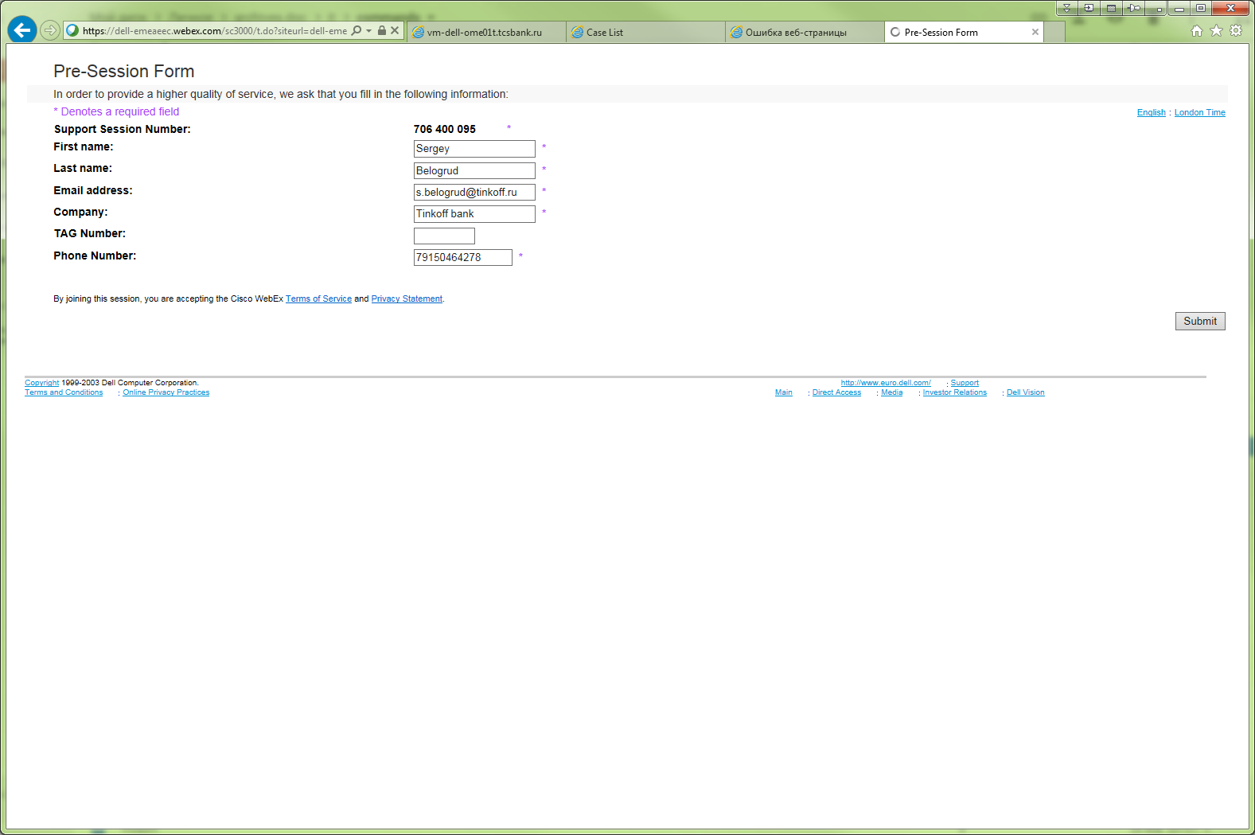

From: Belogrud Sergey Vladimirovich
Sent: Thursday, February 18, 2016 3:16 PM
To: 'Laurent_Frachisse@Dell.com'
Cc: Piotr_Kretkiewicz@Dell.com; Oleg_Udovenko@Dell.com; Leonov Aleksey Vladimirovich
Subject: RE: 925239190 - Automatic case creation in Support Assist

Hello Laurent.

Point No.1.
I have run utility, what you asked.
Its output file is attached.

PS C:\Program Files (x86)\Dell\AdvDiags\DSET\bin> .\DellSystemInfo.exe -s 10.219.11.96 -u root -r c:\dset.zip
Dell System E-Support Tool, Version 3.7.0
@2004-2014 Dell Inc. All Rights Reserved.

Please enter "root" password:
* Gathering Chassis information...
* Gathering Storage information...
* Gathering System Summary information...
* Preparing and Compressing Report...
* Saving DSET CIM report to path: c:\ with report file name: dset.zip
PS C:\Program Files (x86)\Dell\AdvDiags\DSET\bin> dir C:\dset.zip

Directory: C:\

Mode LastWriteTime Length Name
---- ------------- ------ ----
-a--- 18.02.2016 14:56 2148610 dset.zip

PS C:\Program Files (x86)\Dell\AdvDiags\DSET\bin>

I watched /var/log/messages on the server and nothing was happened at all.
No one record, related with executed process.
Nothing iptables modules were loaded.
Everything looks like Ok.

Point No.2.
I have collected today another one archive file with logs.
You can find it attached to this email.

With best wishes,
Sergey

From: Laurent_Frachisse@Dell.com [mailto:Laurent_Frachisse@Dell.com]
Sent: Thursday, February 18, 2016 12:59 PM
To: Belogrud Sergey Vladimirovich
Cc: Piotr_Kretkiewicz@Dell.com; Oleg_Udovenko@Dell.com; Leonov Aleksey Vladimirovich
Subject: RE: 925239190 - Automatic case creation in Support Assist

Hi Sergey

Thanks for this update the problem you described is clear.

Would you mind running the following command:
DellSystemInfo.exe –s IP_iDRAC –u root –r c:\dset.zip
With the IP_iDRAC the IP address of the iDRAC server and where root is the name of the account you use for iDRAC.
You will find this command in the directory C:\Programme (X86)\Dell\AdvDiags\DSET\bin.
Please check the /var/log/message of your server. I want to bypass support assist and be 100% sure that we use iDRAC to get the dset and nothing else.

For the problem 2:
The logs are quite scarce but I suspect Support Assist to be in maintenance mode at the time the problem occurred.

2016-02-15 00:14:30,671: T0xPHOMEScheduler_Worker-20 OMEQueryJob ERROR Message=[Now entering Maintenance Mode due to receiving at least 10 events within 60 minutes!]

Maintenance mode is some sort of security. When Open Manage Essential receives too many alerts, the maintenance mode is enabled and no case will be created. This is to prevent Support Assist to create too many cases if there is for example a problem that would affect all the network. That would also prevent many cases for the same problem.

Could you please send me the last logs in the folder C:\Program Files (x86)\Dell\Dell Integrated Support\logs. Yesterday Support Assist was not in maintenance mode I would like to have a look at the logs when we did the tests.

Best regards
Laurent Frachisse

25 Февраль 2016 г. 17:43:26 from Sergey Belogrud to All Participants: Hi Laurent.
25 Февраль 2016 г. 17:43:33 from Laurent Frachisse to All Participants: Hello
25 Февраль 2016 г. 17:43:51 from Sergey Belogrud to All Participants: Can you see some?
25 Февраль 2016 г. 17:43:56 from Laurent Frachisse to All Participants: yes I see
25 Февраль 2016 г. 17:44:04 from Sergey Belogrud to All Participants: That's perfect.
25 Февраль 2016 г. 17:44:35 from Sergey Belogrud to All Participants: So, what should we do?
25 Февраль 2016 г. 17:44:42 from Sergey Belogrud to All Participants: Repeat my test?
25 Февраль 2016 г. 17:45:05 from Laurent Frachisse to All Participants: when you have changed the discovery range, have you run the discovery ?
25 Февраль 2016 г. 17:45:35 from Sergey Belogrud to All Participants: No. I have no run discovery.
25 Февраль 2016 г. 17:46:32 from Laurent Frachisse to All Participants: If I understand that range is now configured only for iDRAC right ?
25 Февраль 2016 г. 17:46:49 from Sergey Belogrud to All Participants: Exactly!
25 Февраль 2016 г. 17:46:52 from Laurent Frachisse to All Participants: ok
25 Февраль 2016 г. 17:47:10 from Laurent Frachisse to All Participants: so let's run the discovery
25 Февраль 2016 г. 17:47:18 from Sergey Belogrud to All Participants: Ok.
25 Февраль 2016 г. 17:48:10 from Sergey Belogrud to All Participants: Am I doing right?
25 Февраль 2016 г. 17:48:17 from Laurent Frachisse to All Participants: yes that's it
25 Февраль 2016 г. 17:48:49 from Sergey Belogrud to All Participants: Good.
25 Февраль 2016 г. 17:50:59 from Laurent Frachisse to All Participants: pk so now let's have a look at the devices tab
25 Февраль 2016 г. 17:51:24 from Laurent Frachisse to All Participants: let's have a look at the iDRAC
25 Февраль 2016 г. 17:51:29 from Laurent Frachisse to All Participants: the RAC group
25 Февраль 2016 г. 17:52:00 from Laurent Frachisse to All Participants: yes
25 Февраль 2016 г. 17:52:47 from Laurent Frachisse to All Participants: there are still seen as Server type
25 Февраль 2016 г. 17:53:02 from Laurent Frachisse to All Participants: could we just take one server and delete the account
25 Февраль 2016 г. 17:53:22 from Laurent Frachisse to All Participants: then run the discovery again
25 Февраль 2016 г. 17:54:51 from Sergey Belogrud to All Participants: Khmm. Do you want that I'm create special discovery item for one server?
25 Февраль 2016 г. 17:55:07 from Laurent Frachisse to All Participants: if you want you can of course
25 Февраль 2016 г. 17:55:24 from Laurent Frachisse to All Participants: we just have to make sure that the server has no previous entry
25 Февраль 2016 г. 17:55:34 from Laurent Frachisse to All Participants: so we just have to first remove the server
25 Февраль 2016 г. 17:55:40 from Laurent Frachisse to All Participants: then dscover it again
25 Февраль 2016 г. 17:56:11 from Sergey Belogrud to All Participants: Well. As you can see I have ip-range where this server is.
25 Февраль 2016 г. 17:56:20 from Laurent Frachisse to All Participants: ok
25 Февраль 2016 г. 17:56:38 from Sergey Belogrud to All Participants: So I have to make dedicated item of discovery for only one defined server.
25 Февраль 2016 г. 17:56:41 from Laurent Frachisse to All Participants: just make sure the server does not have any previous entry
25 Февраль 2016 г. 17:57:22 from Laurent Frachisse to All Participants: yes if it can help
25 Февраль 2016 г. 17:57:27 from Sergey Belogrud to All Participants: You correct me if I forget something.
25 Февраль 2016 г. 17:57:37 from Laurent Frachisse to All Participants: no just delete the account first
25 Февраль 2016 г. 17:58:07 from Sergey Belogrud to All Participants: Selected account? Right here?
25 Февраль 2016 г. 17:58:21 from Laurent Frachisse to All Participants: yes for the server you want to text on
25 Февраль 2016 г. 17:58:37 from Laurent Frachisse to All Participants: ok
25 Февраль 2016 г. 17:58:59 from Laurent Frachisse to All Participants: so now lets rediscover this server with WS-man
25 Февраль 2016 г. 17:59:08 from Laurent Frachisse to All Participants: so enter the iDRAC ip address
25 Февраль 2016 г. 18:00:25 from Sergey Belogrud to All Participants: Right?
25 Февраль 2016 г. 18:00:33 from Laurent Frachisse to All Participants: yes ok
25 Февраль 2016 г. 18:02:04 from Sergey Belogrud to All Participants: Completed.
25 Февраль 2016 г. 18:02:07 from Laurent Frachisse to All Participants: ok
25 Февраль 2016 г. 18:03:54 from Laurent Frachisse to All Participants: try to serach the IP address
25 Февраль 2016 г. 18:04:02 from Laurent Frachisse to All Participants: Device search tab
25 Февраль 2016 г. 18:04:12 from Laurent Frachisse to All Participants: and the ip address of the iDRAC
25 Февраль 2016 г. 18:05:21 from Laurent Frachisse to All Participants: ok
25 Февраль 2016 г. 18:05:28 from Laurent Frachisse to All Participants: well
25 Февраль 2016 г. 18:05:37 from Sergey Belogrud to All Participants: What's next.
25 Февраль 2016 г. 18:05:43 from Laurent Frachisse to All Participants: it seems that only iDRAC is there
25 Февраль 2016 г. 18:05:50 from Laurent Frachisse to All Participants: no more openmange
25 Февраль 2016 г. 18:06:07 from Laurent Frachisse to All Participants: if you want we can check that server in support assist
25 Февраль 2016 г. 18:06:38 from Sergey Belogrud to All Participants: Can you explain - where is written that only iDRAC now is used?
25 Февраль 2016 г. 18:06:58 from Laurent Frachisse to All Participants: look at the details
25 Февраль 2016 г. 18:07:04 from Laurent Frachisse to All Participants: datasource
25 Февраль 2016 г. 18:07:14 from Laurent Frachisse to All Participants: i don't see openmange any more
25 Февраль 2016 г. 18:07:32 from Laurent Frachisse to All Participants: maybe to be sure can you delete again this account and run again the discovery ?
25 Февраль 2016 г. 18:07:50 from Laurent Frachisse to All Participants: I just want to be sure
25 Февраль 2016 г. 18:09:11 from Sergey Belogrud to All Participants: Now I open details one of other server.
25 Февраль 2016 г. 18:10:14 from Sergey Belogrud to All Participants: So, if I understand right - if we see only two rows - it does mean that we have only iDRAC method.
25 Февраль 2016 г. 18:10:36 from Sergey Belogrud to All Participants: And if we have several of rows - it means that we have other methods?
25 Февраль 2016 г. 18:10:42 from Sergey Belogrud to All Participants: right?
25 Февраль 2016 г. 18:10:49 from Laurent Frachisse to All Participants: yes that's what i see
25 Февраль 2016 г. 18:10:55 from Sergey Belogrud to All Participants: Ok.
25 Февраль 2016 г. 18:11:07 from Laurent Frachisse to All Participants: can you just delete again this server and discover it again please
25 Февраль 2016 г. 18:11:12 from Laurent Frachisse to All Participants: i want to be sure
25 Февраль 2016 г. 18:11:16 from Sergey Belogrud to All Participants: Ok.
25 Февраль 2016 г. 18:12:20 from Sergey Belogrud to All Participants: But, how can I find it. Only via the Search Device?
25 Февраль 2016 г. 18:13:48 from Laurent Frachisse to All Participants: in the server group or the RAC group maybe
25 Февраль 2016 г. 18:14:34 from Sergey Belogrud to All Participants: Yeah, I have found it.
25 Февраль 2016 г. 18:14:40 from Laurent Frachisse to All Participants: sorry which group was that ?
25 Февраль 2016 г. 18:14:59 from Laurent Frachisse to All Participants: the RAC ok
25 Февраль 2016 г. 18:16:28 from Laurent Frachisse to All Participants: great
25 Февраль 2016 г. 18:17:20 from Sergey Belogrud to All Participants: After that I'd like to continue our test with SupportAssist.
25 Февраль 2016 г. 18:17:37 from Laurent Frachisse to All Participants: Yes I want to see it as well
25 Февраль 2016 г. 18:17:38 from Sergey Belogrud to All Participants: If you have no other plan.
25 Февраль 2016 г. 18:17:48 from Laurent Frachisse to All Participants: no we have to clarify this
25 Февраль 2016 г. 18:18:06 from Sergey Belogrud to All Participants: That's good.
25 Февраль 2016 г. 18:19:41 from Laurent Frachisse to All Participants: here we must be carefull
25 Февраль 2016 г. 18:20:05 from Sergey Belogrud to All Participants: Let's run "Send System Logs" now?
25 Февраль 2016 г. 18:20:08 from Laurent Frachisse to All Participants: I am not sure if the database of support assist is cached or not
25 Февраль 2016 г. 18:20:34 from Laurent Frachisse to All Participants: can you check the credentials
25 Февраль 2016 г. 18:20:46 from Sergey Belogrud to All Participants: I see, that name of this server is changed.
25 Февраль 2016 г. 18:21:04 from Sergey Belogrud to All Participants: Before our tricks it was: ds-gp-prd-sdw23.
25 Февраль 2016 г. 18:21:14 from Laurent Frachisse to All Participants: ok
25 Февраль 2016 г. 18:21:22 from Sergey Belogrud to All Participants: Now it is: f68v762.mgmt.tsbank.ru
25 Февраль 2016 г. 18:21:50 from Laurent Frachisse to All Participants: so it seems someting as changed
25 Февраль 2016 г. 18:21:58 from Sergey Belogrud to All Participants: That's right.
25 Февраль 2016 г. 18:22:15 from Sergey Belogrud to All Participants: So... what we will do?
25 Февраль 2016 г. 18:22:18 from Laurent Frachisse to All Participants: so let's start
25 Февраль 2016 г. 18:22:21 from Sergey Belogrud to All Participants: Ok.
25 Февраль 2016 г. 18:22:24 from Laurent Frachisse to All Participants: we have no choice :)
25 Февраль 2016 г. 18:22:42 from Sergey Belogrud to All Participants: We have hope! :-)
25 Февраль 2016 г. 18:22:51 from Laurent Frachisse to All Participants: I know that support assist has its own database
25 Февраль 2016 г. 18:23:06 from Laurent Frachisse to All Participants: it is a sqlite3
25 Февраль 2016 г. 18:23:25 from Laurent Frachisse to All Participants: very good stuff this sqlite3
25 Февраль 2016 г. 18:23:39 from Sergey Belogrud to All Participants: Mmm, ok. Let it be.
25 Февраль 2016 г. 18:24:13 from Sergey Belogrud to All Participants: Let's wait.
25 Февраль 2016 г. 18:24:50 from Sergey Belogrud to All Participants: If everything will be ok - I should delete all servers and rediscover it again?
25 Февраль 2016 г. 18:25:11 from Laurent Frachisse to All Participants: the Linux server yes
25 Февраль 2016 г. 18:25:24 from Laurent Frachisse to All Participants: and rediscover them
25 Февраль 2016 г. 18:26:08 from Sergey Belogrud to All Participants: Ok. We are have troubles only on Linux servers. Only on that servers, that have installed GreenPlum software.
25 Февраль 2016 г. 18:26:57 from Sergey Belogrud to All Participants: There are about 24 servers at all (in our discover sheet).
25 Февраль 2016 г. 18:27:47 from Laurent Frachisse to All Participants: it seems ok right
25 Февраль 2016 г. 18:27:48 from Sergey Belogrud to All Participants: It looks like everything is OK.
25 Февраль 2016 г. 18:27:53 from Laurent Frachisse to All Participants: perfect
25 Февраль 2016 г. 18:28:08 from Laurent Frachisse to All Participants: let's check the dset uploaded
25 Февраль 2016 г. 18:29:22 from Laurent Frachisse to All Participants: before logs
25 Февраль 2016 г. 18:29:23 from Sergey Belogrud to All Participants: Can you remind me - where is it
25 Февраль 2016 г. 18:29:27 from Laurent Frachisse to All Participants: reports i think
25 Февраль 2016 г. 18:29:33 from Laurent Frachisse to All Participants: Dset
25 Февраль 2016 г. 18:29:37 from Sergey Belogrud to All Participants: Here?
25 Февраль 2016 г. 18:29:46 from Laurent Frachisse to All Participants: Dset is the tool that triggers the logs
25 Февраль 2016 г. 18:29:56 from Laurent Frachisse to All Participants: sorry for the dell jargon
25 Февраль 2016 г. 18:29:58 from Laurent Frachisse to All Participants: :)
25 Февраль 2016 г. 18:30:03 from Laurent Frachisse to All Participants: ok
25 Февраль 2016 г. 18:30:09 from Sergey Belogrud to All Participants: No problem.
25 Февраль 2016 г. 18:30:17 from Sergey Belogrud to All Participants: Is it Ok?
25 Февраль 2016 г. 18:30:23 from Laurent Frachisse to All Participants: so let's see if this dset actually has something in it
25 Февраль 2016 г. 18:30:37 from Laurent Frachisse to All Participants: could you extrct it
25 Февраль 2016 г. 18:30:49 from Laurent Frachisse to All Participants: click on hta
25 Февраль 2016 г. 18:30:57 from Laurent Frachisse to All Participants: it should open
25 Февраль 2016 г. 18:31:01 from Laurent Frachisse to All Participants: dell
25 Февраль 2016 г. 18:31:16 from Laurent Frachisse to All Participants: it is a secret :)
25 Февраль 2016 г. 18:31:31 from Laurent Frachisse to All Participants: internet exploerr
25 Февраль 2016 г. 18:31:34 from Sergey Belogrud to All Participants: Ok.
25 Февраль 2016 г. 18:32:12 from Laurent Frachisse to All Participants: well try to copy the file on your desktop
25 Февраль 2016 г. 18:32:20 from Sergey Belogrud to All Participants: Ok.
25 Февраль 2016 г. 18:33:46 from Sergey Belogrud to All Participants: Where to look?
25 Февраль 2016 г. 18:33:56 from Laurent Frachisse to All Participants: can you select storage
25 Февраль 2016 г. 18:34:05 from Laurent Frachisse to All Participants: and hardware logs
25 Февраль 2016 г. 18:34:42 from Laurent Frachisse to All Participants: ok
25 Февраль 2016 г. 18:34:47 from Laurent Frachisse to All Participants: it seems to work
25 Февраль 2016 г. 18:35:03 from Sergey Belogrud to All Participants: Well... It's good.
25 Февраль 2016 г. 18:35:19 from Laurent Frachisse to All Participants: no what would you like to check ?
25 Февраль 2016 г. 18:35:34 from Laurent Frachisse to All Participants: or other questions
25 Февраль 2016 г. 18:35:47 from Sergey Belogrud to All Participants: If in "hardware" we find something - it does mean that there not everything ok?
25 Февраль 2016 г. 18:36:12 from Laurent Frachisse to All Participants: it is a log
25 Февраль 2016 г. 18:36:20 from Laurent Frachisse to All Participants: like the syslog in windows or linux
25 Февраль 2016 г. 18:36:25 from Sergey Belogrud to All Participants: Ok.
25 Февраль 2016 г. 18:36:27 from Laurent Frachisse to All Participants: some events are just info
25 Февраль 2016 г. 18:36:40 from Laurent Frachisse to All Participants: others are warning or critical
25 Февраль 2016 г. 18:36:56 from Laurent Frachisse to All Participants: but this is logs embedded on the motherboard
25 Февраль 2016 г. 18:37:00 from Sergey Belogrud to All Participants: Well. You know - I asked serveral question in my email?
25 Февраль 2016 г. 18:37:10 from Laurent Frachisse to All Participants: yes :)
25 Февраль 2016 г. 18:37:25 from Laurent Frachisse to All Participants: let's take your mail
25 Февраль 2016 г. 18:37:40 from Sergey Belogrud to All Participants: One of them is - how to use deployment to set Temperature Threshhold?
25 Февраль 2016 г. 18:37:48 from Laurent Frachisse to All Participants: yes
25 Февраль 2016 г. 18:38:19 from Laurent Frachisse to All Participants: that's can be made only on openmange
25 Февраль 2016 г. 18:38:26 from Laurent Frachisse to All Participants: do you have openmange on a windows ?
25 Февраль 2016 г. 18:38:44 from Sergey Belogrud to All Participants: Can yoy show me - where I can find appropriate parameter?
25 Февраль 2016 г. 18:39:00 from Laurent Frachisse to All Participants: yes let's open openmange on a windows
25 Февраль 2016 г. 18:39:24 from Sergey Belogrud to All Participants: You mean where is installed OpenManage Essentials?
25 Февраль 2016 г. 18:39:47 from Laurent Frachisse to All Participants: no
25 Февраль 2016 г. 18:40:06 from Laurent Frachisse to All Participants: I mean a tool called openmange or system administrator
25 Февраль 2016 г. 18:40:16 from Laurent Frachisse to All Participants: that is installed on the operating system
25 Февраль 2016 г. 18:40:30 from Laurent Frachisse to All Participants: we need one on a windows to acccess the one on linux
25 Февраль 2016 г. 18:40:57 from Sergey Belogrud to All Participants: Khmm... It looks - like I have no it.
25 Февраль 2016 г. 18:41:05 from Laurent Frachisse to All Participants: :) no problem
25 Февраль 2016 г. 18:41:21 from Sergey Belogrud to All Participants: Can it be installed on server, that have installed OpenManage Essentials?
25 Февраль 2016 г. 18:41:33 from Sergey Belogrud to All Participants: But this server is a vmware server.
25 Февраль 2016 г. 18:41:39 from Laurent Frachisse to All Participants: I think it has to be installed on a physical server
25 Февраль 2016 г. 18:42:01 from Laurent Frachisse to All Participants: there is also a command line tool
25 Февраль 2016 г. 18:42:04 from Laurent Frachisse to All Participants: that we can use
25 Февраль 2016 г. 18:42:11 from Laurent Frachisse to All Participants: but i have never done that
25 Февраль 2016 г. 18:42:23 from Laurent Frachisse to All Participants: I need to do some research
25 Февраль 2016 г. 18:43:02 from Sergey Belogrud to All Participants: Is it really unavailable to get configuration from server and change one of lots parameter in it.
25 Февраль 2016 г. 18:43:15 from Sergey Belogrud to All Participants: There are so many parameters...
25 Февраль 2016 г. 18:43:50 from Laurent Frachisse to All Participants: sorry Sergey I am not sure I see what you mean
25 Февраль 2016 г. 18:44:50 from Sergey Belogrud to All Participants: Here you are see that I have gotten configuration of server chassie and other.
25 Февраль 2016 г. 18:44:58 from Laurent Frachisse to All Participants: yes I see
25 Февраль 2016 г. 18:45:03 from Sergey Belogrud to All Participants: That can be used in deployment.
25 Февраль 2016 г. 18:45:17 from Laurent Frachisse to All Participants: yes true
25 Февраль 2016 г. 18:45:18 from Sergey Belogrud to All Participants: I see lot of parameters.
25 Февраль 2016 г. 18:45:57 from Sergey Belogrud to All Participants: So, is it possible, that parameter, that we should change - can be found here?
25 Февраль 2016 г. 18:46:16 from Laurent Frachisse to All Participants: yes
25 Февраль 2016 г. 18:46:26 from Sergey Belogrud to All Participants: Where is it?
25 Февраль 2016 г. 18:46:57 from Sergey Belogrud to All Participants: In "System" or "BIOS" setting? Or in other place?
25 Февраль 2016 г. 18:47:55 from Laurent Frachisse to All Participants: i am not sure exaclty
25 Февраль 2016 г. 18:48:06 from Sergey Belogrud to All Participants: I think - I can create template, where I will set this parameter to appropriate value.
25 Февраль 2016 г. 18:48:20 from Sergey Belogrud to All Participants: You should investigate it.
25 Февраль 2016 г. 18:48:55 from Laurent Frachisse to All Participants: yes that's the tool that I mentioned earlier on
25 Февраль 2016 г. 18:50:25 from Sergey Belogrud to All Participants: If we will know this parameter name - I will create template. And will change this parameter value to 40 degree, then to 70 degree an so on, as you wrote in in email.
25 Февраль 2016 г. 18:51:25 from Sergey Belogrud to All Participants: And we can find answer on my firs question - is SupportAssist work well - can this software create case?
25 Февраль 2016 г. 18:51:49 from Sergey Belogrud to All Participants: That's the way I think.
25 Февраль 2016 г. 18:51:56 from Laurent Frachisse to All Participants: yes this software is supposed to create case
25 Февраль 2016 г. 18:52:29 from Laurent Frachisse to All Participants: just to vheck something can you show me the alerts you recive globally
25 Февраль 2016 г. 18:52:31 from Laurent Frachisse to All Participants: ?
25 Февраль 2016 г. 18:52:44 from Laurent Frachisse to All Participants: not for one server but globally
25 Февраль 2016 г. 18:52:57 from Sergey Belogrud to All Participants: Here?
25 Февраль 2016 г. 18:52:59 from Laurent Frachisse to All Participants: ok
25 Февраль 2016 г. 18:53:10 from Laurent Frachisse to All Participants: it looks good
25 Февраль 2016 г. 18:53:51 from Sergey Belogrud to All Participants: There were disappers two alert, that related with this server. When HDD was failed on it.
25 Февраль 2016 г. 18:54:14 from Sergey Belogrud to All Participants: When we start - we have 2 red alerts in this list.
25 Февраль 2016 г. 18:54:26 from Sergey Belogrud to All Participants: It's just my note.
25 Февраль 2016 г. 18:54:39 from Laurent Frachisse to All Participants: yes I saw your screenshot
25 Февраль 2016 г. 18:54:58 from Laurent Frachisse to All Participants: it was on the screenshot you sent
25 Февраль 2016 г. 18:55:49 from Laurent Frachisse to All Participants: Sergey if it is ok for you I can test to change the temperature in my lab
25 Февраль 2016 г. 18:56:01 from Laurent Frachisse to All Participants: from this command line tool
25 Февраль 2016 г. 18:56:26 from Sergey Belogrud to All Participants: Well, if you cannot answer what parameter I should use in deployment template to set temperature threshhold. That's it.
25 Февраль 2016 г. 18:56:49 from Sergey Belogrud to All Participants: I have no question, at this time.
25 Февраль 2016 г. 18:56:55 from Laurent Frachisse to All Participants: i cant give you an answer right now on this
25 Февраль 2016 г. 18:57:10 from Laurent Frachisse to All Participants: we usually use openmange from a windows server
25 Февраль 2016 г. 18:57:22 from Laurent Frachisse to All Participants: I am not sure if it works with the command line
25 Февраль 2016 г. 18:57:40 from Laurent Frachisse to All Participants: if you give me a bit of time i can check in my lab
25 Февраль 2016 г. 18:57:50 from Sergey Belogrud to All Participants: Of course...
25 Февраль 2016 г. 18:58:03 from Sergey Belogrud to All Participants: I will wait.
25 Февраль 2016 г. 18:58:27 from Laurent Frachisse to All Participants: is there an other point you would like to clarify today ?
25 Февраль 2016 г. 18:58:42 from Sergey Belogrud to All Participants: Nope, thanks.
25 Февраль 2016 г. 18:59:04 from Sergey Belogrud to All Participants: We can say bye bye to each other.
25 Февраль 2016 г. 18:59:07 from Sergey Belogrud to All Participants: :-)
25 Февраль 2016 г. 18:59:12 from Laurent Frachisse to All Participants: ok no problem
25 Февраль 2016 г. 18:59:33 from Sergey Belogrud to All Participants: I will wait email from you.
25 Февраль 2016 г. 18:59:38 from Laurent Frachisse to All Participants: actually I am also intersted in having a coammnd line to trigger this temperature warnings
25 Февраль 2016 г. 18:59:47 from Laurent Frachisse to All Participants: so it is also interesting for me
25 Февраль 2016 г. 19:00:08 from Laurent Frachisse to All Participants: doing that from openmange is quite not user friendly
25 Февраль 2016 г. 19:00:09 from Sergey Belogrud to All Participants: Let's clear it for both us. :)
25 Февраль 2016 г. 19:00:14 from Laurent Frachisse to All Participants: ok no problem
25 Февраль 2016 г. 19:00:30 from Sergey Belogrud to All Participants: Bye-bye Laurent. :-)
25 Февраль 2016 г. 19:00:31 from Laurent Frachisse to All Participants: i write you an email to clarify what we have done today
25 Февраль 2016 г. 19:00:34 from Sergey Belogrud to All Participants: Thanks for help.
25 Февраль 2016 г. 19:00:39 from Laurent Frachisse to All Participants: cheers
25 Февраль 2016 г. 19:00:52 from Laurent Frachisse to All Participants: thanks Sergey

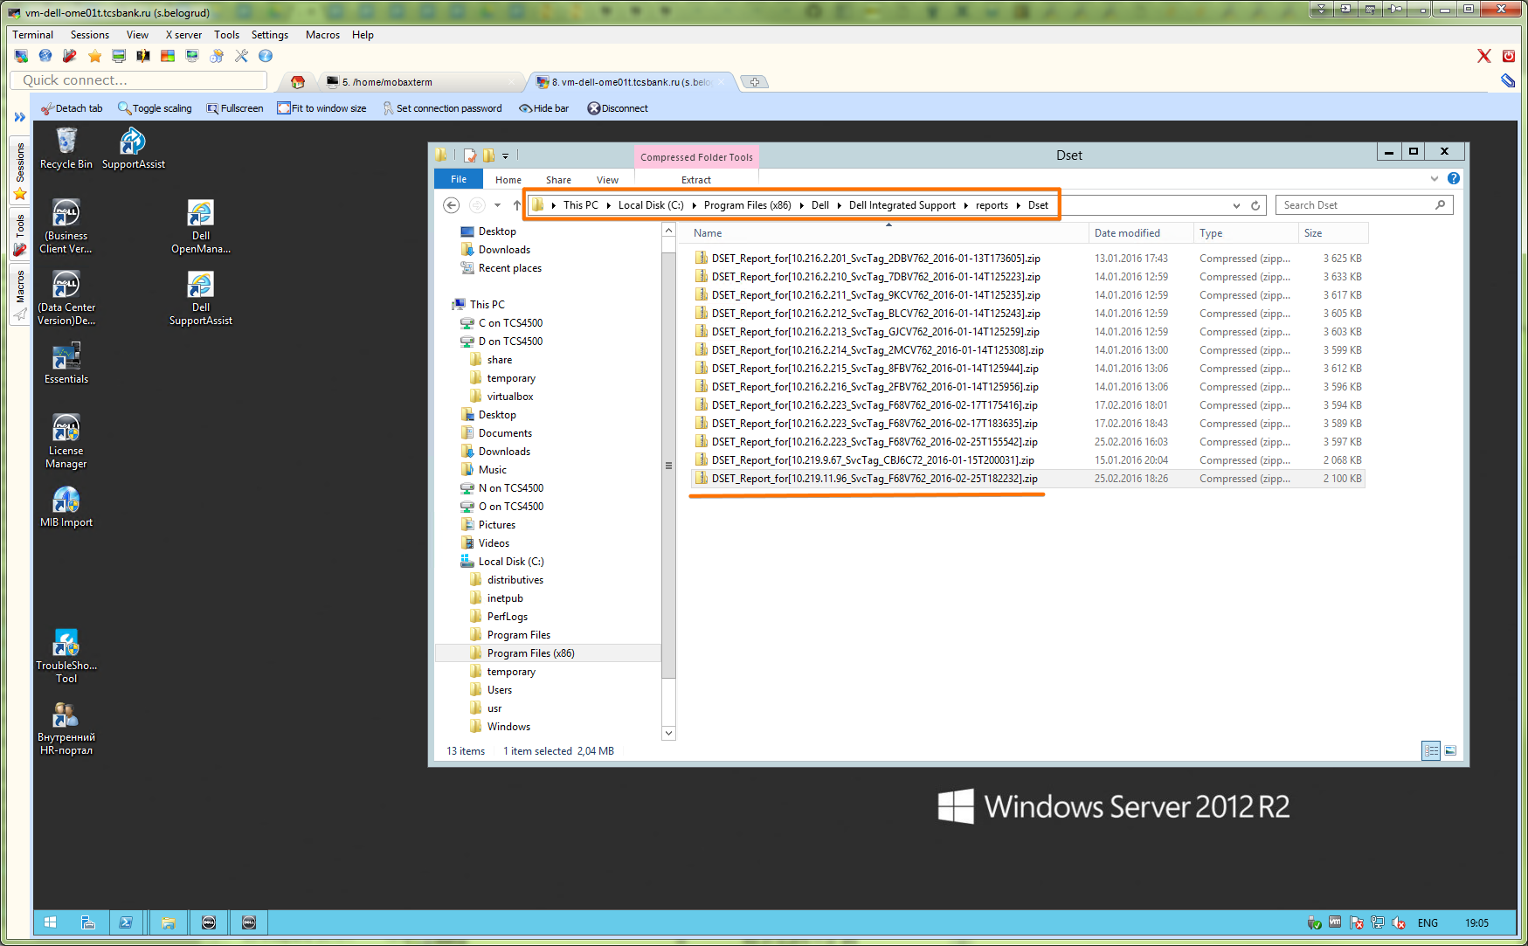

# This archive file can be extracted with password “dell”.
# Then we can open one file from it, where we can find some logs.

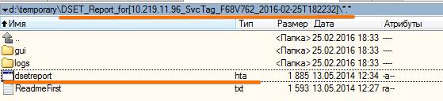

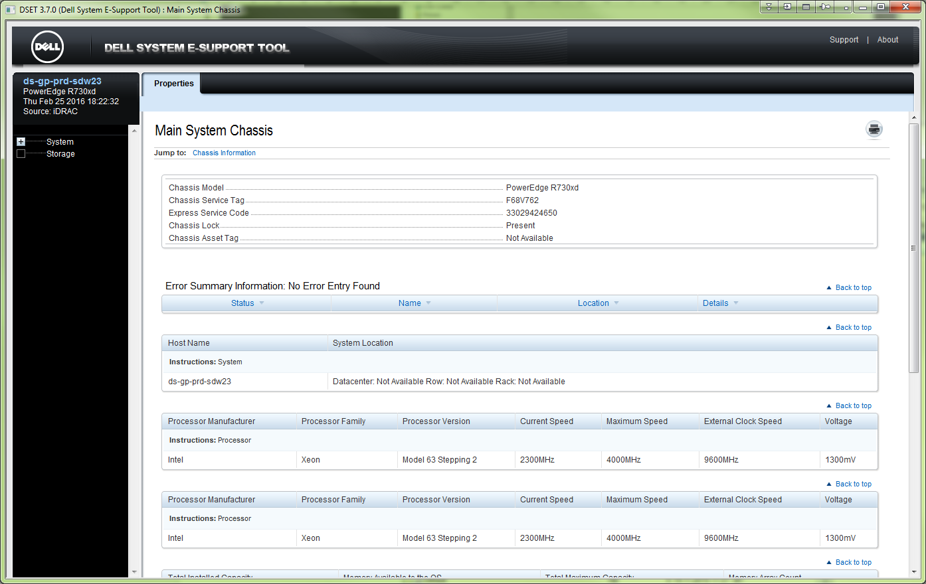

# Here is log, that sound like “embedded on server motherboard”.
25 Февраль 2016 г. 18:35:47 from Sergey Belogrud to All Participants: If in "hardware" we find something - it does mean that there not everything ok?
25 Февраль 2016 г. 18:36:12 from Laurent Frachisse to All Participants: it is a log
25 Февраль 2016 г. 18:36:20 from Laurent Frachisse to All Participants: like the syslog in windows or linux
25 Февраль 2016 г. 18:36:25 from Sergey Belogrud to All Participants: Ok.
25 Февраль 2016 г. 18:36:27 from Laurent Frachisse to All Participants: some events are just info
25 Февраль 2016 г. 18:36:40 from Laurent Frachisse to All Participants: others are warning or critical
25 Февраль 2016 г. 18:36:56 from Laurent Frachisse to All Participants: but this is logs embedded on the motherboard
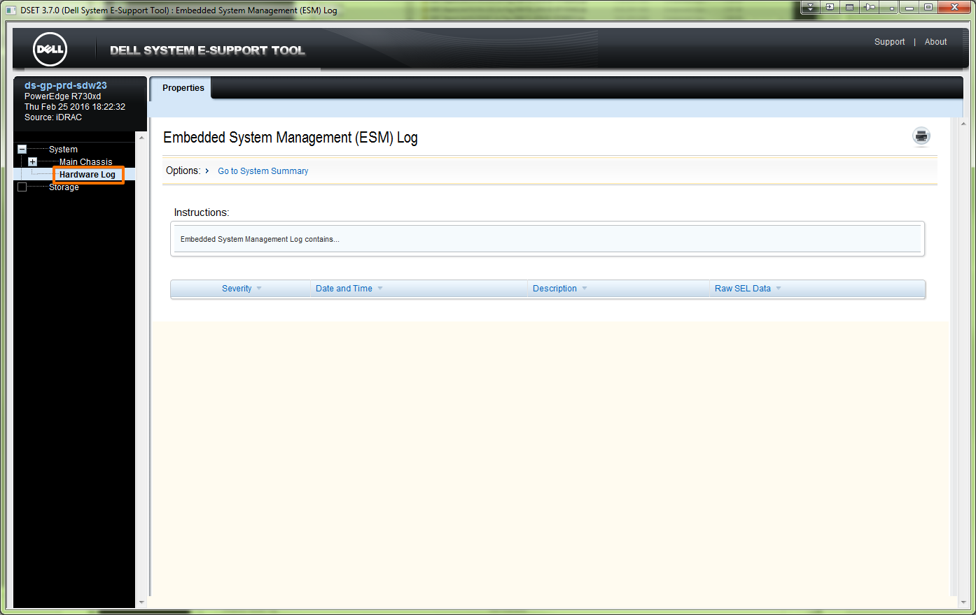

20160303
#

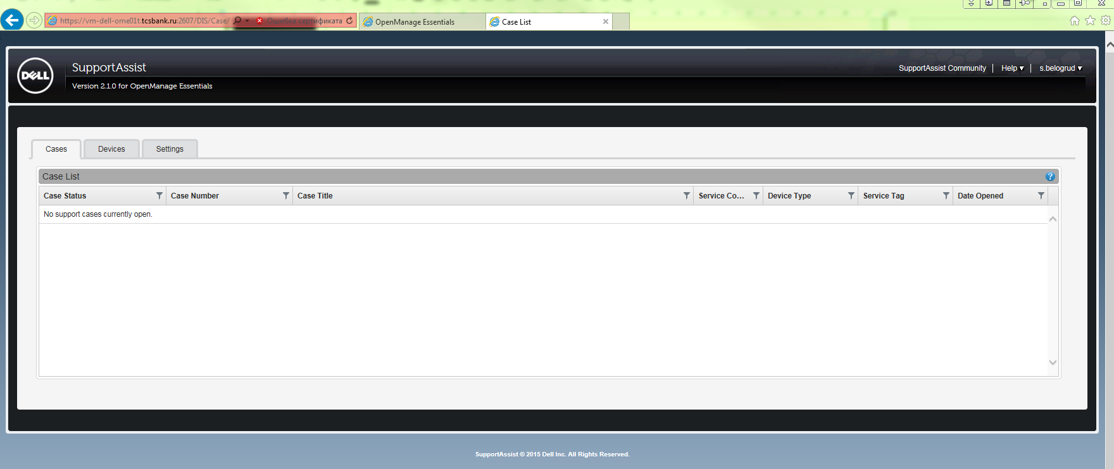

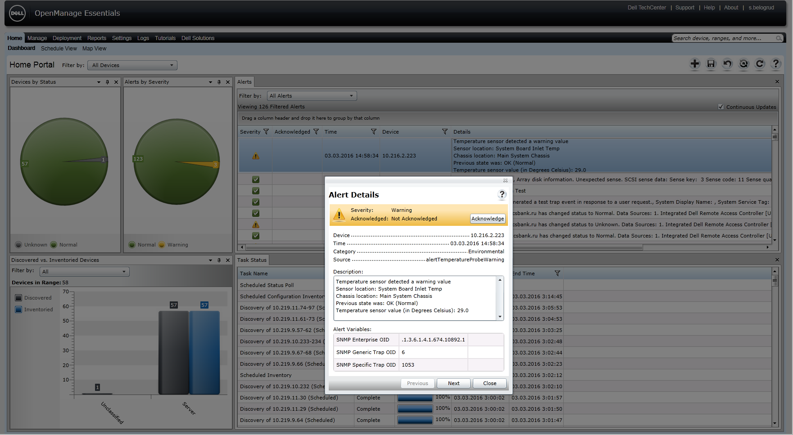

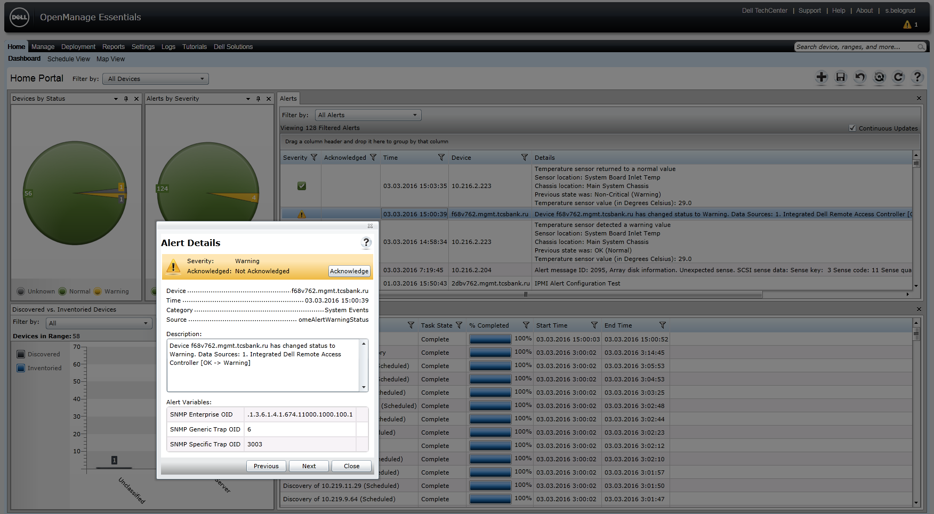

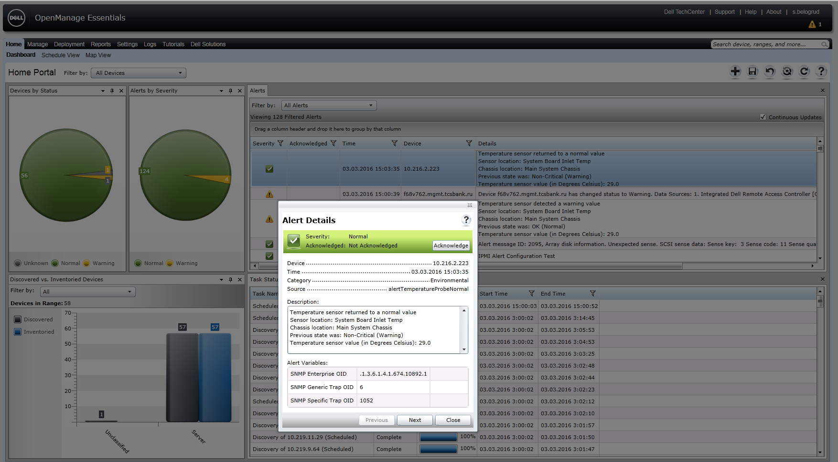

Кому: Joe_Bilinski@DELL.com; Laurent_Frachisse@Dell.com
Копия: Piotr_Kretkiewicz@Dell.com; Oleg_Udovenko@Dell.com; Leonov Aleksey Vladimirovich
Тема: RE: 925239190 - Automatic case creation in Support Assist

From: Joe_Bilinski@DELL.com [mailto:Joe_Bilinski@DELL.com]
Sent: Tuesday, March 22, 2016 9:23 PM
To: Belogrud Sergey Vladimirovich; Laurent_Frachisse@Dell.com
Cc: Piotr_Kretkiewicz@Dell.com; Oleg_Udovenko@Dell.com; Leonov Aleksey Vladimirovich
Subject: RE: 925239190 - Automatic case creation in Support Assist

Dell - Internal Use - Confidential
I closed SR 927111402, so the case should be removed from SupportAssist GUI within 15 minutes.

I do apologize for the back and forth emails and glad we were able to get this resolved.

Laurent – I’ll close this issue in our Remedy systems if you have no other action items?

Thanks Joe B

From: Belogrud Sergey Vladimirovich [mailto:s.belogrud@tinkoff.ru]
Sent: Tuesday, March 22, 2016 1:33 PM
To: Bilinski, Joe <Joe_Bilinski@DELL.com>; Frachisse, Laurent <Laurent_Frachisse@Dell.com>
Cc: Kretkiewicz, Piotr <Piotr_Kretkiewicz@Dell.com>; Udovenko, Oleg <Oleg_Udovenko@Dell.com>; Leonov Aleksey Vladimirovich <a.leonov@tinkoff.ru>
Subject: RE: 925239190 - Automatic case creation in Support Assist

Thanks Joe.

> I took ownership of SR 927111402 and I changed the status to In Progress which should reflect the change in the SupportAssist UI. I can close this SR if you’d like and it will disappear from the Cases tab.
I suppose, there is no reason to leave this case open. So, this case can be closed without any regrets.
If I’m wrong, please feel free to correct me.

I'm very appreciate you for your help.
We are stuck on resolving this difficulty. So many emails were in past just to move on few little steps forward. It took too much time.
Anyway everything is behind. This is very good.

Thanks for your very helpful answers.

With hope on your assist in future (if it require),
Sergey

From: Joe_Bilinski@DELL.com [mailto:Joe_Bilinski@DELL.com]
Sent: Tuesday, March 22, 2016 8:13 PM
To: Belogrud Sergey Vladimirovich; Laurent_Frachisse@Dell.com
Cc: Piotr_Kretkiewicz@Dell.com; Oleg_Udovenko@Dell.com; Leonov Aleksey Vladimirovich
Subject: RE: 925239190 - Automatic case creation in Support Assist

Dell - Internal Use - Confidential
Sergey,

There is no harm in leaving the DEBUG parameter set for a while. Just in case you have other questions we’ll have the logs. If after a month you have no other questions feel to roll it back.

I took ownership of SR 927111402 and I changed the status to In Progress which should reflect the change in the SupportAssist UI. I can close this SR if you’d like and it will disappear from the Cases tab.

I don’t use the Dell TechDirect Dashboard, if Laurent cannot answer this question I’ll ping some people

От: Joe_Bilinski@DELL.com
Отправлено: 22 марта 2016 г. 20:16
Кому: Belogrud Sergey Vladimirovich; Laurent_Frachisse@Dell.com
Копия: Piotr_Kretkiewicz@Dell.com; Oleg_Udovenko@Dell.com; Leonov Aleksey Vladimirovich
Тема: RE: 925239190 - Automatic case creation in Support Assist

Категории: Зеленая категория; Оранжевая категория; Желтая категория

Dell - Internal Use - Confidential
Collection Uploaded – when a case is created then Diagnostics will run via either LASSO or DSET. In this case for servers it ran DSET. Once the tool is finished collecting information its uploaded to Dell where someone from Tech Support can view the diagnostics information to help you with the case. You don’t have to upload anything, SupportAssist does it for you.

The collection file can be found here under the DSET folder.

C:\Program Files (x86)\Dell\Dell Integrated Support\reports

For example; Internal to Dell Inc
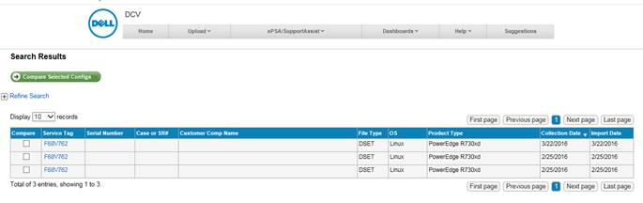
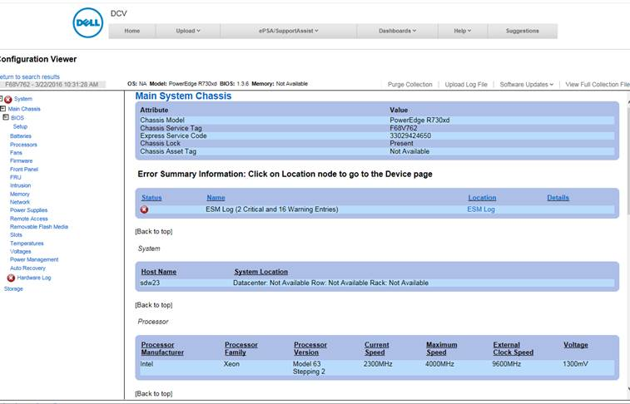

From: Belogrud Sergey Vladimirovich [mailto:s.belogrud@tinkoff.ru]
Sent: Tuesday, March 22, 2016 12:12 PM
To: Bilinski, Joe <Joe_Bilinski@DELL.com>; Frachisse, Laurent <Laurent_Frachisse@Dell.com>
Cc: Kretkiewicz, Piotr <Piotr_Kretkiewicz@Dell.com>; Udovenko, Oleg <Oleg_Udovenko@Dell.com>; Leonov Aleksey Vladimirovich <a.leonov@tinkoff.ru>
Subject: RE: 925239190 - Automatic case creation in Support Assist

Hi everybody.

As I understood, now I should do follow:
*. Roll back “DEBUG” level parameter in ms windows (HKEY_LOCAL_MACHINE\SOFTWARE\Wow6432Node\Dell\Dell Integrated Support ) reestr database.
*. Turn on “Alerts” to “Enabled” in iDRAC for all of our Dell servers.
*. Roll back “SNMP Trap” check-boxes, that I have changed for one of our server, that was under test usage.

*. There is a question what to do with new record about created case in SupportAssist?
*. And there is a question what does mean yellow rectangle in Dell TechDirect Dashboard. How to understand it, and what to do with it.

That's what was came up by me at this moment.
Please remind me if I forgotten something.

Thanks for help,
Sergey

From: Belogrud Sergey Vladimirovich
Sent: Tuesday, March 22, 2016 6:59 PM
To: 'Joe_Bilinski@DELL.com'; Laurent_Frachisse@Dell.com
Cc: Piotr_Kretkiewicz@Dell.com; Oleg_Udovenko@Dell.com; Leonov Aleksey Vladimirovich
Subject: RE: 925239190 - Automatic case creation in Support Assist

> I am not sure how iDRACs are configured but it appears the Alerts need to be enabled. Are all your systems disabled?
Yes, this option is as it was in its default state – disabled. We didn’t change it on all of our Dell servers.

>This could be the reason why you didn’t get a case for the Hard Drive failure and why temp alerts were not working
Confirmed, exactly. I'm thinking similar way.

At Dell TechDirect Dashboard appears yellow area with alarm record.
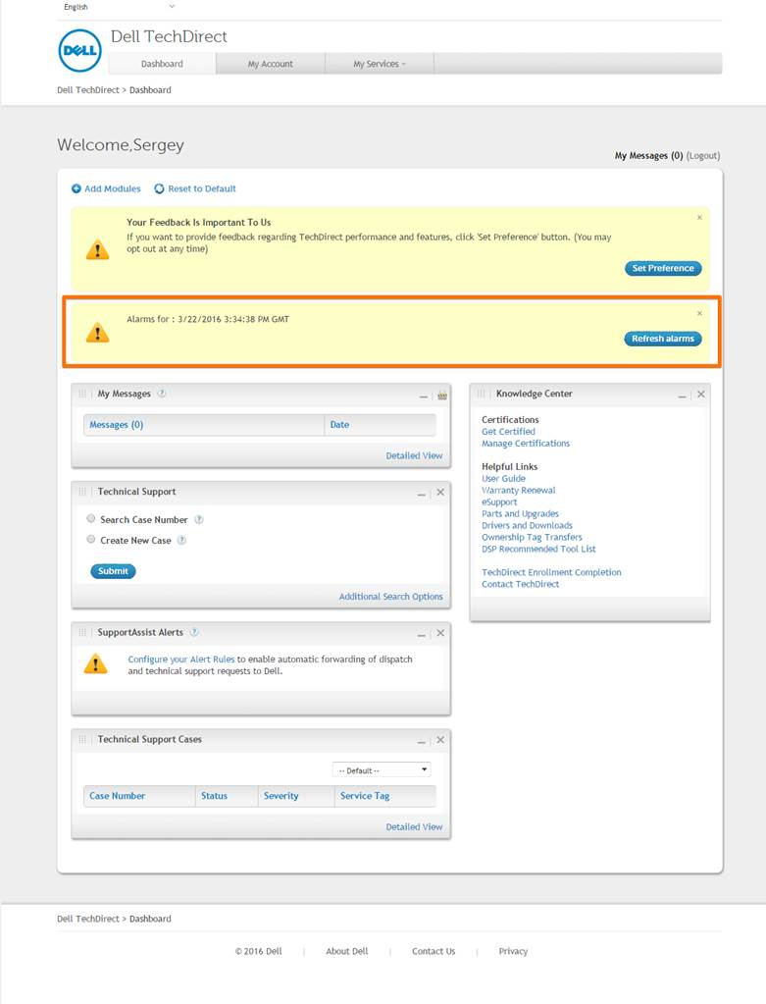

From: Joe_Bilinski@DELL.com [mailto:Joe_Bilinski@DELL.com]
Sent: Tuesday, March 22, 2016 6:51 PM
To: Belogrud Sergey Vladimirovich; Laurent_Frachisse@Dell.com
Cc: Piotr_Kretkiewicz@Dell.com; Oleg_Udovenko@Dell.com; Leonov Aleksey Vladimirovich
Subject: RE: 925239190 - Automatic case creation in Support Assist

Dell - Internal Use - Confidential
Ok great!

I am not sure how iDRACs are configured but it appears the Alerts need to be enabled. Are all your systems disabled?

This could be the reason why you didn’t get a case for the Hard Drive failure and why temp alerts were not working

From: Belogrud Sergey Vladimirovich [mailto:s.belogrud@tinkoff.ru]
Sent: Tuesday, March 22, 2016 11:39 AM
To: Bilinski, Joe <Joe_Bilinski@DELL.com>; Frachisse, Laurent <Laurent_Frachisse@Dell.com>
Cc: Kretkiewicz, Piotr <Piotr_Kretkiewicz@Dell.com>; Udovenko, Oleg <Oleg_Udovenko@Dell.com>; Leonov Aleksey Vladimirovich <a.leonov@tinkoff.ru>
Subject: RE: 925239190 - Automatic case creation in Support Assist

Hi Joe.

I’ve done it.

At this moment snmp trap was received by OME.
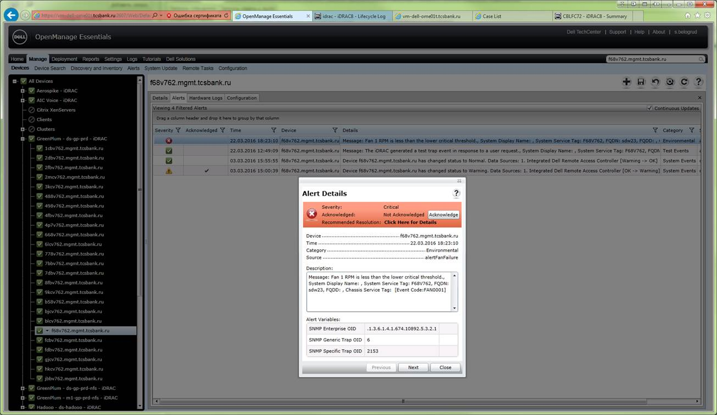

Case list of SupportAssist changed its state.
Now it have one row with one case record.
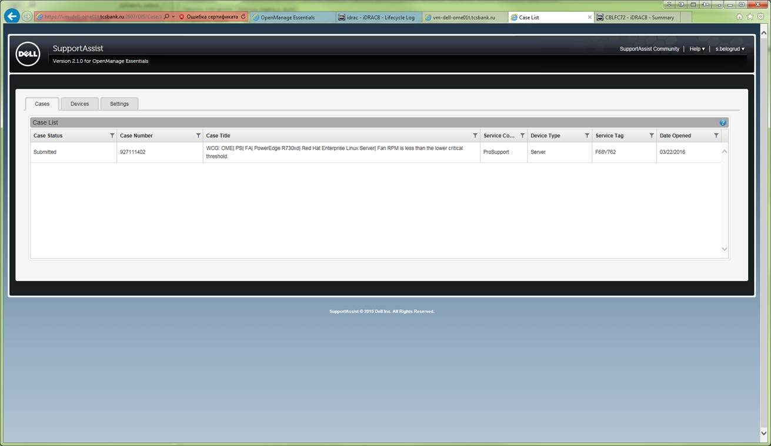

In addition I have received follow letter.

From: Dell SupportAssist [mailto:SupportAssist_NoReply@dell.com]
Sent: Tuesday, March 22, 2016 6:27 PM
To: Belogrud Sergey Vladimirovich
Subject: Dell SupportAssist - Обнаружена проблема с аппаратным обеспечением, заявка создана

Уважаемый Клиент!
SupportAssist обнаружила проблему с оборудованием, связанную с одним из устройств, вследствие чего был открыт случай оказания поддержки по данной проблеме.
Подробнее о проблеме с оборудованием:
Проблема: | Fan RPM is less than the lower critical threshold.
Название устройства: | f68v762.mgmt.tcsbank.ru
Сервисный код: | F68V762
Дата/время обнаружения проблемы: | 03/22/2016 15:26:55 PM UTC
Номер случая: | 927111402
Название случая: | WCG: OME| PS| FA| PowerEdge R730xd| Red Hat Enterprise Linux Server| Fan RPM is less than the lower critical threshold.
Мы свяжемся с вами, чтобы обеспечить своевременное устранение проблемы.
Спасибо!
Служба технической поддержки Dell
Это электронное письмо было отправлено каждому контактному лицу, связанному с данным устройством в рамках приложения SupportAssist. Если вы получили это уведомление по ошибке, внесите необходимые изменения в приложении SupportAssist или обратитесь к администратору приложения SupportAssist в своей организации.
Dell TechDirect website Dashboard looks epty – there is no case record.
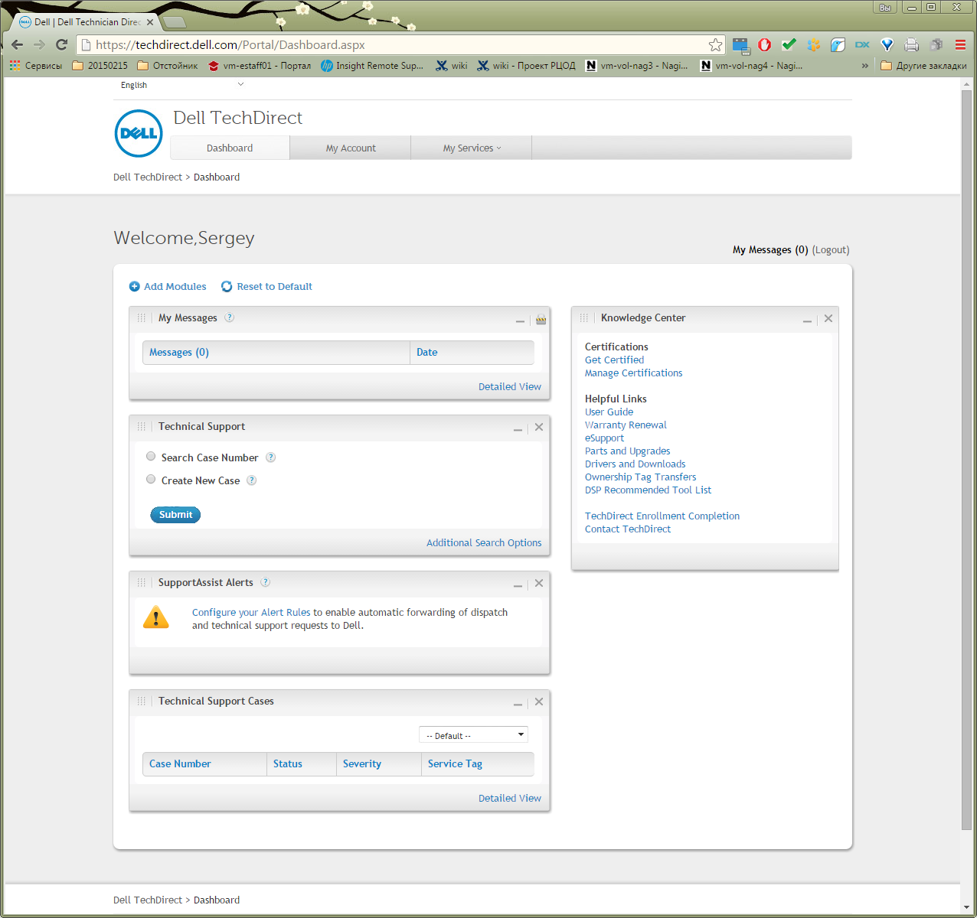

Log archive attached to the email.

> From: Joe_Bilinski@DELL.com [mailto:Joe_Bilinski@DELL.com]
Sent: Tuesday, March 22, 2016 6:37 PM
To: Belogrud Sergey Vladimirovich; Laurent_Frachisse@Dell.com
Cc: Piotr_Kretkiewicz@Dell.com; Oleg_Udovenko@Dell.com; Leonov Aleksey Vladimirovich
Subject: RE: 925239190 - Automatic case creation in Support Assist

> Dell - Internal Use - Confidential
> Could we also try more than one device to make sure it’s for all devices and not just one device
Yes – we could try.

So, what we will do next?

From: Joe_Bilinski@DELL.com [mailto:Joe_Bilinski@DELL.com]
Sent: Tuesday, March 22, 2016 6:15 PM
To: Belogrud Sergey Vladimirovich; Laurent_Frachisse@Dell.com
Cc: Piotr_Kretkiewicz@Dell.com; Oleg_Udovenko@Dell.com; Leonov Aleksey Vladimirovich
Subject: RE: 925239190 - Automatic case creation in Support Assist

Dell - Internal Use - Confidential
Sergey,

I was able to get a test system to play with. When I ran the racadm with alerts disabled like your setup, the alert didn’t come into OME The alert shows in OME when enabled. For the test can you enable alerts in your Alerts tab and rerun the fan test? The test SNMP Trap from the SNMP and Email Settings tab did work either way.
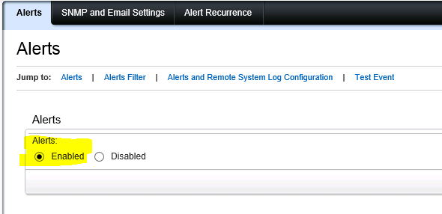

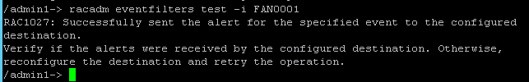

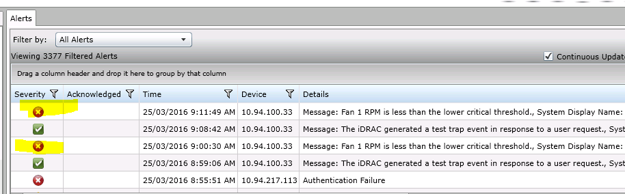

Joe

From: Belogrud Sergey Vladimirovich [mailto:s.belogrud@tinkoff.ru]
Sent: Tuesday, March 22, 2016 5:55 AM
To: Bilinski, Joe <Joe_Bilinski@DELL.com>; Frachisse, Laurent <Laurent_Frachisse@Dell.com>
Cc: Kretkiewicz, Piotr <Piotr_Kretkiewicz@Dell.com>; Udovenko, Oleg <Oleg_Udovenko@Dell.com>; Leonov Aleksey Vladimirovich <a.leonov@tinkoff.ru>
Subject: RE: 925239190 - Automatic case creation in Support Assist

Hello Joe, Laurent and other.

I have done test.
But there were no any alerts in OME at all.
Case in SupportAssist, of course, was not created too.

[root@ds-gp-prd-sdw23 ~]# racadm eventfilters test -i FAN0001
RAC1027: Successfully sent the alert for the specified event to the configured
destination.
Verify if the alerts were received by the configured destination. Otherwise,
reconfigure the destination and retry the operation.

[root@ds-gp-prd-sdw23 ~]#

Here is a screenshot of OME after test.
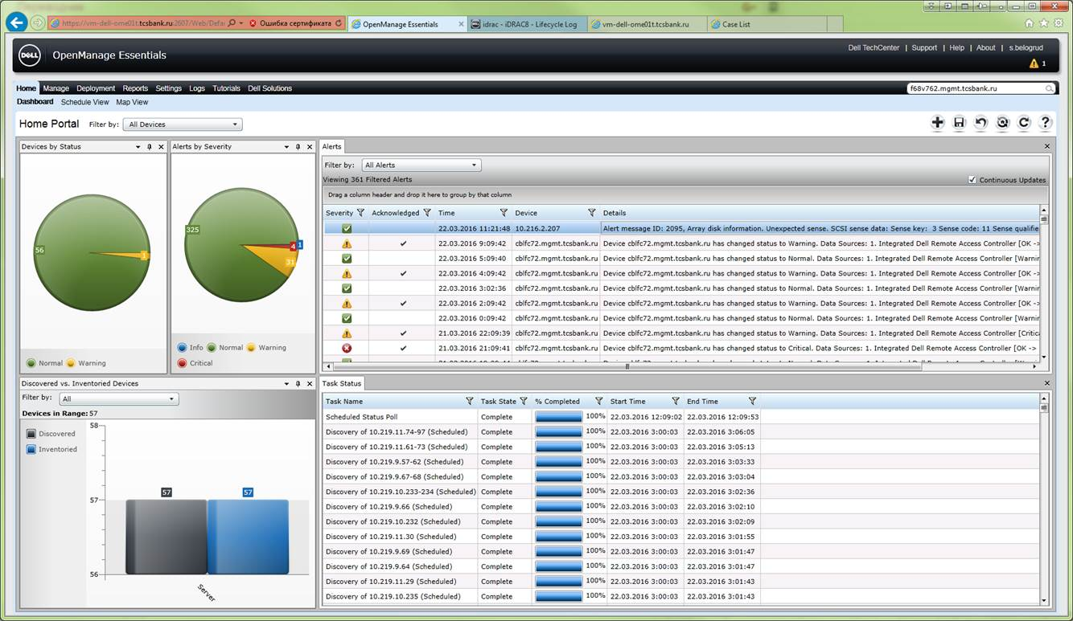

Here is Lifecycle Log in iDRAC web-interface of tested server.
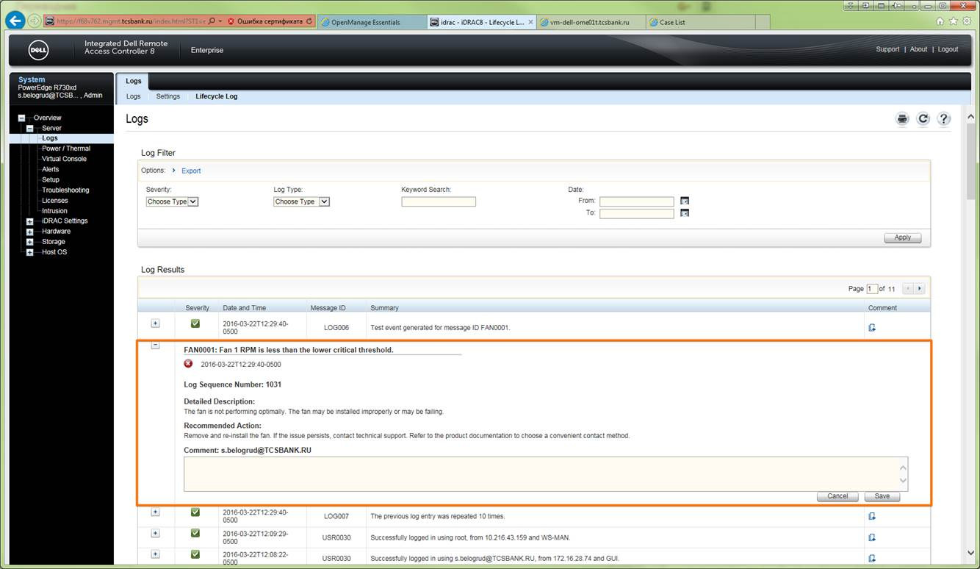

Zipped log file attached to email (the “zip” extension was removed from file name).

And, of couse, I have turned on all available “SNMP Trap” check boxes on all 19 pages at Alerts tab for target server.
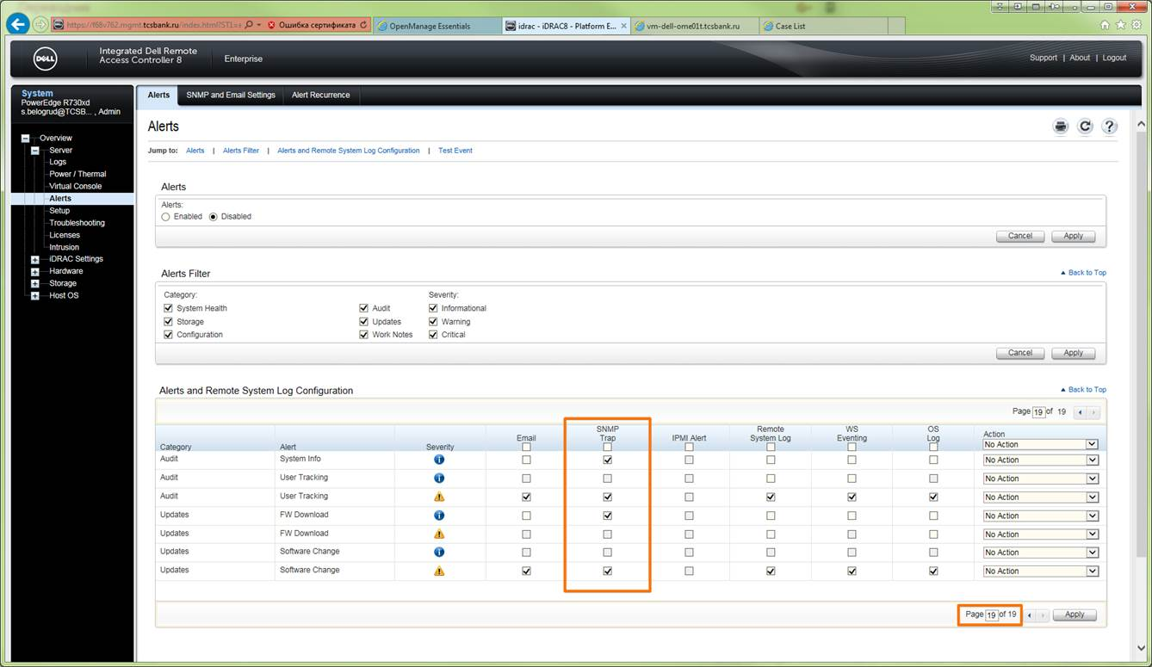

SNMP Traps receivers are same as it were all time before.
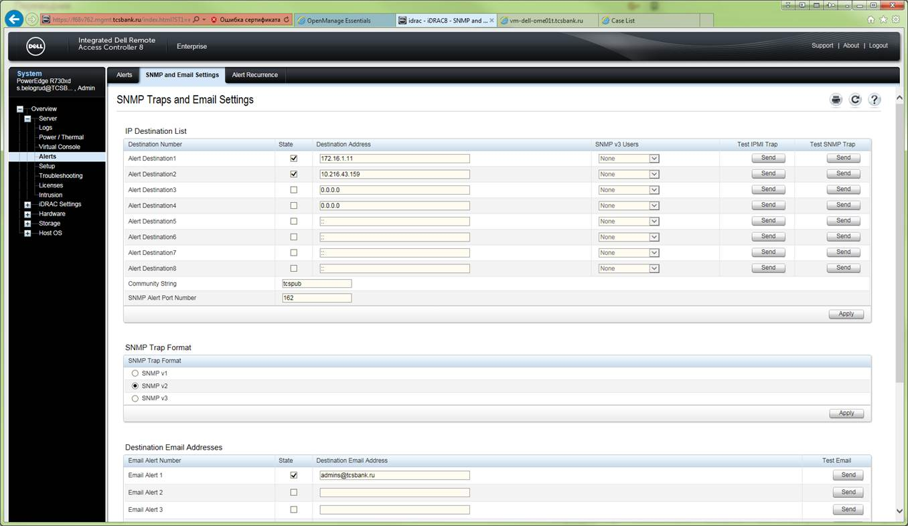

And when I push button “Send” at “Test SNMP Trap” column.
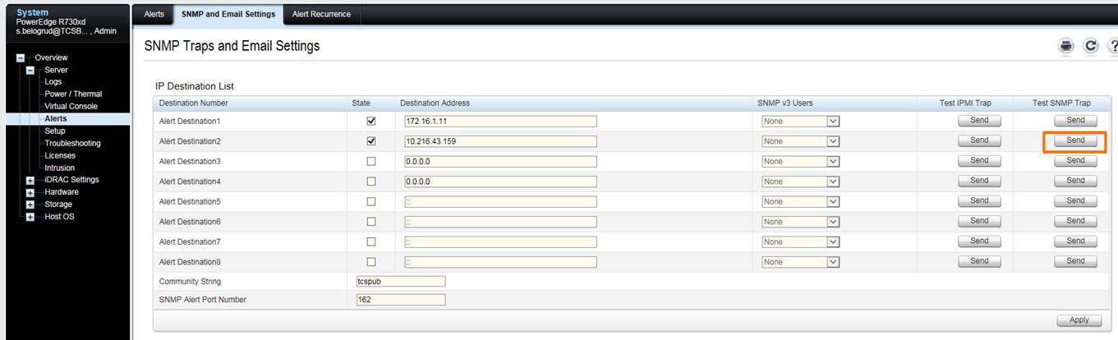

I see, that appropriate trap signal have been received by OME.
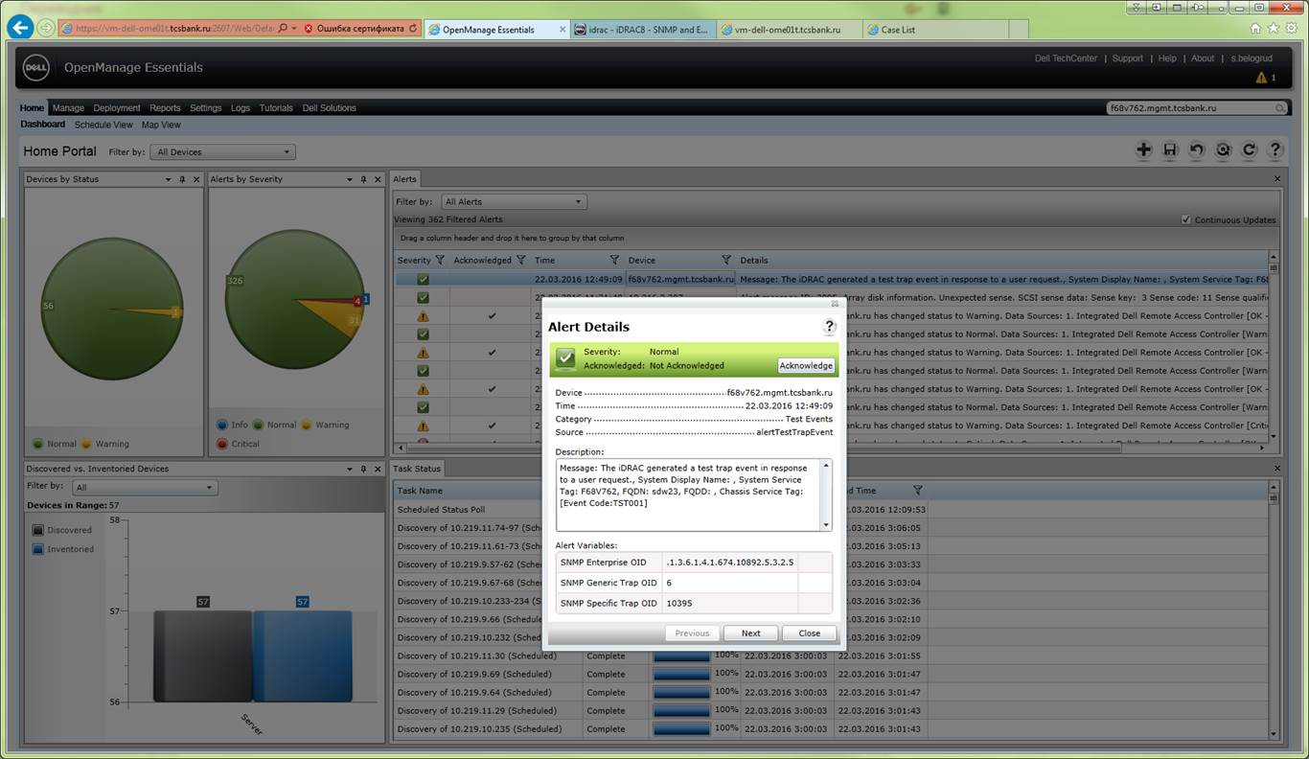

This way I understand, that SNMP trap works correctly.

Waiting for your conclusions,
Sergey

From: Belogrud Sergey Vladimirovich
Sent: Tuesday, March 22, 2016 11:55 AM
To: 'Joe_Bilinski@DELL.com'; Laurent_Frachisse@Dell.com
Cc: Piotr_Kretkiewicz@Dell.com; Oleg_Udovenko@Dell.com; Leonov Aleksey Vladimirovich
Subject: RE: 925239190 - Automatic case creation in Support Assist

Hello Joe.

It’s nice to get so fast feedback from you.
Can you or someone remind me, please, - where can I find place with “Logs should look something like”. I’m not sure that I met similar logs before…

With best wishes,
Sergey

From: Joe_Bilinski@DELL.com [mailto:Joe_Bilinski@DELL.com]
Sent: Monday, March 21, 2016 8:40 PM
To: Belogrud Sergey Vladimirovich; Laurent_Frachisse@Dell.com
Cc: Piotr_Kretkiewicz@Dell.com; Oleg_Udovenko@Dell.com; Leonov Aleksey Vladimirovich
Subject: RE: 925239190 - Automatic case creation in Support Assist

Dell - Internal Use - Confidential
I heard back from a QA team member, he’s based in India but gave me some quick feedback before he can reply with more details tomorrow

Can we try a different RACADM alert. This one is for the fan, it’s a firstMatch() so the case should open on 1 alert.

“racadm eventfilters test –i FAN0001”
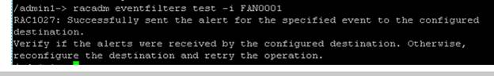

Logs should look something like
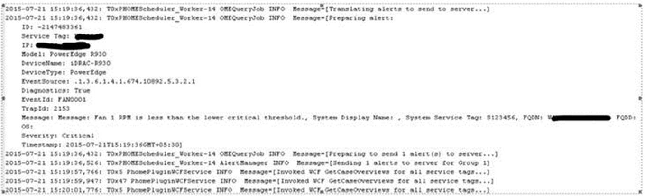

Before sending alert verify
o In iDRAC, settings to be performed, select all SNMP alerts(for all pages),
o Set trap destination as OME IP in one of the fields.
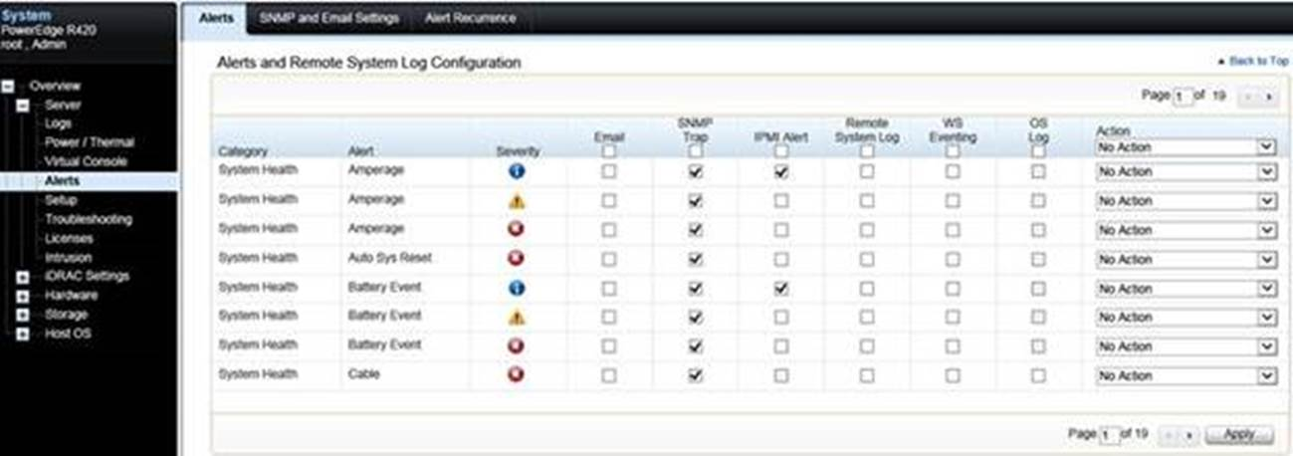

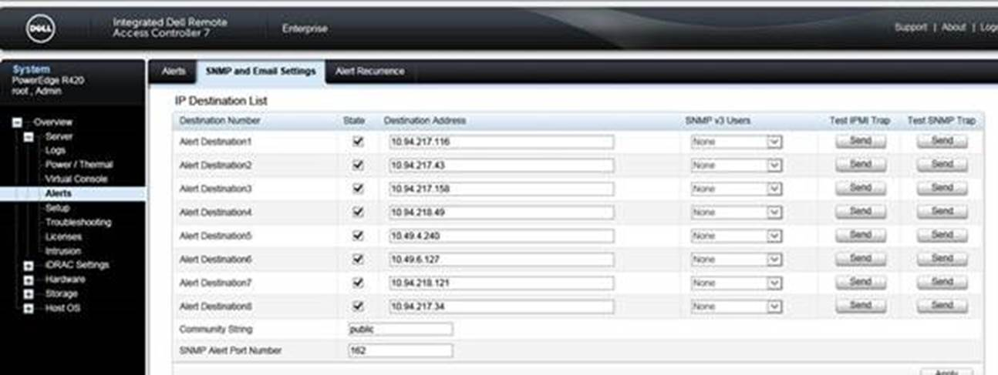

Send me the logs after and screen shot of OME alerts for that device if a case doesn’t open.

If case does open send me the SR so I can take ownership

Joe

From: Belogrud Sergey Vladimirovich [mailto:s.belogrud@tinkoff.ru]
Sent: Monday, March 21, 2016 12:00 PM
To: Bilinski, Joe <Joe_Bilinski@DELL.com>; Frachisse, Laurent <Laurent_Frachisse@Dell.com>
Cc: Kretkiewicz, Piotr <Piotr_Kretkiewicz@Dell.com>; Udovenko, Oleg <Oleg_Udovenko@Dell.com>; Leonov Aleksey Vladimirovich <a.leonov@tinkoff.ru>
Subject: RE: 925239190 - Automatic case creation in Support Assist

> Give me a day to consult with one of the QA engineers who has more Linus experience to see what next steps will be.
Ok, no problem.

> Question – do any of the devices have the OMSA GUI? Wondering if we tried the temp changes using the UI instead?
We have no OMSA GUI any place installed.
> Wondering if we tried the temp changes using the UI instead?
Probably you know – we successfully use CLI rackadm utility to do appropriate temperature changes:

[root@ds-gp-prd-sdw23 ~]# racadm sensorsettings set iDRAC.Embedded.1#SystemBoardInletTemp -level max 8
Object value modified successfully

[root@ds-gp-prd-sdw23 ~]# racadm sensorsettings set iDRAC.Embedded.1#SystemBoardInletTemp -level max 42
Object value modified successfully

[root@ds-gp-prd-sdw23 ~]#

> To confirm the RACDAM was executed by PUTTY into the device and running the commands?
I have connected with ssh from other server to target server (ds-gp-prd-sdw23), where I executed racadm command, shown above.

From: Joe_Bilinski@DELL.com [mailto:Joe_Bilinski@DELL.com]
Sent: Monday, March 21, 2016 6:48 PM
To: Belogrud Sergey Vladimirovich; Laurent_Frachisse@Dell.com
Cc: Piotr_Kretkiewicz@Dell.com; Oleg_Udovenko@Dell.com; Leonov Aleksey Vladimirovich
Subject: RE: 925239190 - Automatic case creation in Support Assist

Dell - Internal Use - Confidential
Give me a day to consult with one of the QA engineers who has more Linus experience to see what next steps will be.

Question – do any of the devices have the OMSA GUI? Wondering if we tried the temp changes using the UI instead?

The temp alerts I am looking at don’t have a DeviceName or Service tag so that may be the reason why SA isn’t grabbing them.

To confirm the RACDAM was executed by PUTTY into the device and running the commands?

From: Belogrud Sergey Vladimirovich [mailto:s.belogrud@tinkoff.ru]
Sent: Monday, March 21, 2016 8:08 AM
To: Frachisse, Laurent <Laurent_Frachisse@Dell.com>
Cc: Kretkiewicz, Piotr <Piotr_Kretkiewicz@Dell.com>; Udovenko, Oleg <Oleg_Udovenko@Dell.com>; Leonov Aleksey Vladimirovich <a.leonov@tinkoff.ru>; Bilinski, Joe <Joe_Bilinski@DELL.com>
Subject: RE: 925239190 - Automatic case creation in Support Assist

Hello Laurent, hello Joe.

Required file is attached to this email.

I'm not object to do Webex session. We just should negotiate time, when we can do webex. I can do it between 3:00 pm and 8:00 pm (our time shift is GMT+3, probably you already know it).

But if you want to pull out one of power cords from one of our server - this idea is not like me at all.
The servers what we use are not test servers. There are production servers.
Wherefore we have to use more safe methods to find root of Dell SupportAssist's problems.

With best wishes,
Sergey

From: Laurent_Frachisse@Dell.com [mailto:Laurent_Frachisse@Dell.com]
Sent: Monday, March 21, 2016 1:51 PM
To: Belogrud Sergey Vladimirovich
Cc: Piotr_Kretkiewicz@Dell.com; Oleg_Udovenko@Dell.com; Leonov Aleksey Vladimirovich; Joe_Bilinski@DELL.com
Subject: RE: 925239190 - Automatic case creation in Support Assist

Hello Sergey

My colleague Joe Bilinski is going to work with me on that case.
Joe is located in the US and we can arrange a Webex session with him to have a look at this issue.

Would that be possible to make a REST request on your system.
· Open your OME console
· Replace the /Web/Default.aspx part of your URL by the /api/OME.svc/Alerts
· This will open a XML report of the alerts received.
Would that be possible to send us the result of the XML result.

We would like to see if we can create a case by pulling the power cord. Wait to see if an alert message is sent to OME and replug the power supply. This should be done two times to trigger the case.

Best regards
Laurent Frachisse

От: Belogrud Sergey Vladimirovich
Отправлено: 21 марта 2016 г. 11:23
Кому: 'Laurent_Frachisse@Dell.com'
Копия: Piotr_Kretkiewicz@Dell.com; Oleg_Udovenko@Dell.com; Leonov Aleksey Vladimirovich
Тема: RE: 925239190 - Automatic case creation in Support Assist

Категории: Зеленая категория; Оранжевая категория; Желтая категория

Hi Laurent!

Have you any news for us?

With wishes work harder,
Sergey

From: Belogrud Sergey Vladimirovich
Sent: Friday, March 18, 2016 4:16 PM
To: 'Laurent_Frachisse@Dell.com'
Cc: Piotr_Kretkiewicz@Dell.com; Oleg_Udovenko@Dell.com; Leonov Aleksey Vladimirovich
Subject: RE: 925239190 - Automatic case creation in Support Assist

Very good friday Laurent!

Would you like write us something relates with my last email?
Exactly before we will have weekend.

With best wishes,
Sergey

From: Belogrud Sergey Vladimirovich
Sent: Wednesday, March 16, 2016 12:23 PM
To: 'Laurent_Frachisse@Dell.com'
Cc: Piotr_Kretkiewicz@Dell.com; Oleg_Udovenko@Dell.com; Leonov Aleksey Vladimirovich
Subject: RE: 925239190 - Automatic case creation in Support Assist

Good morning Laurent.

At this noon I have done your plan.

Below are the first four events.

Severity | Acknowledged | Time | Device | Details | Category | Source
Normal | Not Acknowledged | 16.03.2016 12:03:57 | 10.216.2.223 | Temperature sensor returned to a normal value Sensor location: System Board Inlet Temp Chassis location: Main System Chassis Previous state was: Non-Critical (Warning) Temperature sensor value (in Degrees Celsius): 30.0 | Environmental | alertTemperatureProbeNormal
Warning | Not Acknowledged | 16.03.2016 12:03:33 | 10.216.2.223 | Temperature sensor detected a warning value Sensor location: System Board Inlet Temp Chassis location: Main System Chassis Previous state was: OK (Normal) Temperature sensor value (in Degrees Celsius): 30.0 | Environmental | alertTemperatureProbeWarning
Normal | Not Acknowledged | 16.03.2016 12:02:24 | 10.216.2.223 | Temperature sensor returned to a normal value Sensor location: System Board Inlet Temp Chassis location: Main System Chassis Previous state was: Non-Critical (Warning) Temperature sensor value (in Degrees Celsius): 30.0 | Environmental | alertTemperatureProbeNormal
Warning | Not Acknowledged | 16.03.2016 12:02:00 | 10.216.2.223 | Temperature sensor detected a warning value Sensor location: System Board Inlet Temp Chassis location: Main System Chassis Previous state was: OK (Normal) Temperature sensor value (in Degrees Celsius): 30.0 | Environmental | alertTemperatureProbeWarning
Normal | Not Acknowledged | 16.03.2016 12:00:50 | 10.216.2.223 | Temperature sensor returned to a normal value Sensor location: System Board Inlet Temp Chassis location: Main System Chassis Previous state was: Non-Critical (Warning) Temperature sensor value (in Degrees Celsius): 30.0 | Environmental | alertTemperatureProbeNormal
Warning | Not Acknowledged | 16.03.2016 12:00:27 | 10.216.2.223 | Temperature sensor detected a warning value Sensor location: System Board Inlet Temp Chassis location: Main System Chassis Previous state was: OK (Normal) Temperature sensor value (in Degrees Celsius): 30.0 | Environmental | alertTemperatureProbeWarning
Normal | Not Acknowledged | 16.03.2016 11:59:18 | 10.216.2.223 | Temperature sensor returned to a normal value Sensor location: System Board Inlet Temp Chassis location: Main System Chassis Previous state was: Non-Critical (Warning) Temperature sensor value (in Degrees Celsius): 30.0 | Environmental | alertTemperatureProbeNormal
Warning | Not Acknowledged | 16.03.2016 11:58:54 | 10.216.2.223 | Temperature sensor detected a warning value Sensor location: System Board Inlet Temp Chassis location: Main System Chassis Previous state was: OK (Normal) Temperature sensor value (in Degrees Celsius): 30.0 | Environmental | alertTemperatureProbeWarning

Here are events after last fifth temperature changes.

Severity | Acknowledged | Time | Device | Details | Category | Source
Normal | Not Acknowledged | 16.03.2016 12:12:04 | 10.216.2.223 | Temperature sensor returned to a normal value Sensor location: System Board Inlet Temp Chassis location: Main System Chassis Previous state was: Non-Critical (Warning) Temperature sensor value (in Degrees Celsius): 30.0 | Environmental | alertTemperatureProbeNormal
Warning | Not Acknowledged | 16.03.2016 12:10:55 | 10.216.2.223 | Temperature sensor detected a warning value Sensor location: System Board Inlet Temp Chassis location: Main System Chassis Previous state was: OK (Normal) Temperature sensor value (in Degrees Celsius): 30.0 | Environmental | alertTemperatureProbeWarning
Normal | Not Acknowledged | 16.03.2016 12:06:51 | h98v762.mgmt.tcsbank.ru | Device h98v762.mgmt.tcsbank.ru has changed status to Normal. Data Sources: 1. Integrated Dell Remote Access Controller [Unknown -> OK] | System Events | omeAlertNormalStatus
Warning | Not Acknowledged | 16.03.2016 12:06:37 | h98v762.mgmt.tcsbank.ru | Device h98v762.mgmt.tcsbank.ru has changed status to Unknown. Data Sources: 1. Integrated Dell Remote Access Controller [OK -> Unknown] 2. iDRAC Service Module [Unknown -> Unknown] | System Events | omeAlertUnknownStatus

I didn't see any changes anywhere.

Requested files are attached.

Sergey.

From: Belogrud Sergey Vladimirovich
Sent: Tuesday, March 15, 2016 8:16 PM
To: 'Laurent_Frachisse@Dell.com'
Cc: Piotr_Kretkiewicz@Dell.com; Oleg_Udovenko@Dell.com; Leonov Aleksey Vladimirovich
Subject: RE: 925239190 - Automatic case creation in Support Assist

Hi Laurent.

I’m no doubt, that you remember our difficulties with Dell products.
Hmm, that’s unusual behavior this software.

Of course I will follow your advices.
I will do it tomorrow.

Just one question.
Do you mean restart follow service?

PS C:\Program Files (x86)\Dell\AdvDiags\DSET\bin> Get-Service -displayname *Dell*

Status Name DisplayName
------ ---- -----------
Running PhomePluginWind... Dell SupportAssist Service

PS C:\Program Files (x86)\Dell\AdvDiags\DSET\bin>

With best wishes,
Sergey

From: Laurent_Frachisse@Dell.com [mailto:Laurent_Frachisse@Dell.com]
Sent: Tuesday, March 15, 2016 7:40 PM
To: Belogrud Sergey Vladimirovich
Cc: Piotr_Kretkiewicz@Dell.com; Oleg_Udovenko@Dell.com; Leonov Aleksey Vladimirovich
Subject: RE: 925239190 - Automatic case creation in Support Assist

Hello Sergey

I haven’t forgotten about this issue. We don’t see many things in the log.
Would that be possible to try again but this time would that be possible to restart the service.

To create a case, I would suggest

1. changing the log level to DEBUG
2. restart the service
3. Run 4 temp changes, make sure 4 of them are viewing in OME
4. Verify SupportAssist is not in Maintenance Mode, if so take it out of MMode
5. Run the 5th temp test

I would need the same files.
• C:\Program Files (x86)\Dell\Dell Integrated Support\bin\phome.db
• C:\Program Files (x86)\Dell\Dell Integrated Support\logs in a zip file.

Best regards
Laurent Frachisse

From: Belogrud Sergey Vladimirovich [mailto:s.belogrud@tinkoff.ru]
Sent: Tuesday, March 15, 2016 1:55 PM
To: Frachisse, Laurent
Cc: Kretkiewicz, Piotr; Udovenko, Oleg; Leonov Aleksey Vladimirovich
Subject: RE: 925239190 - Automatic case creation in Support Assist

Hello Laurent!

I hope you are don’t forget about us.

Sergey.

From: Belogrud Sergey Vladimirovich
Sent: Thursday, March 10, 2016 7:28 PM
To: 'Laurent_Frachisse@Dell.com'
Cc: Piotr_Kretkiewicz@Dell.com; Oleg_Udovenko@Dell.com; Leonov Aleksey Vladimirovich
Subject: RE: 925239190 - Automatic case creation in Support Assist

Good evening Laurent.

Thanks for answer.
Requested logs are attached to this email.

I will be waiting for your conclusion after you analyze these logs.

With best wishes and hope on success,
Sergey

From: Laurent_Frachisse@Dell.com [mailto:Laurent_Frachisse@Dell.com]
Sent: Thursday, March 10, 2016 7:06 PM
To: Belogrud Sergey Vladimirovich
Cc: Piotr_Kretkiewicz@Dell.com; Oleg_Udovenko@Dell.com; Leonov Aleksey Vladimirovich
Subject: RE: 925239190 - Automatic case creation in Support Assist

Hello Sergey

The Debug is just a way to make the support Assist logs more verbose.
Would it be possible to send me the following logs :

∙ C:\Program Files (x86)\Dell\Dell Integrated Support\bin\phome.db
∙ C:\Program Files (x86)\Dell\Dell Integrated Support\logs in a zip file.

On the following questions :
1. Should I use “System Log Collection Schedule” in SupportAssist at all? Or should not...? I mean, perhaps, this rule was created for something special and there is no need to use it in my case…
It is necessary to have this schedule enabled for the ProSupport Plus reporting.
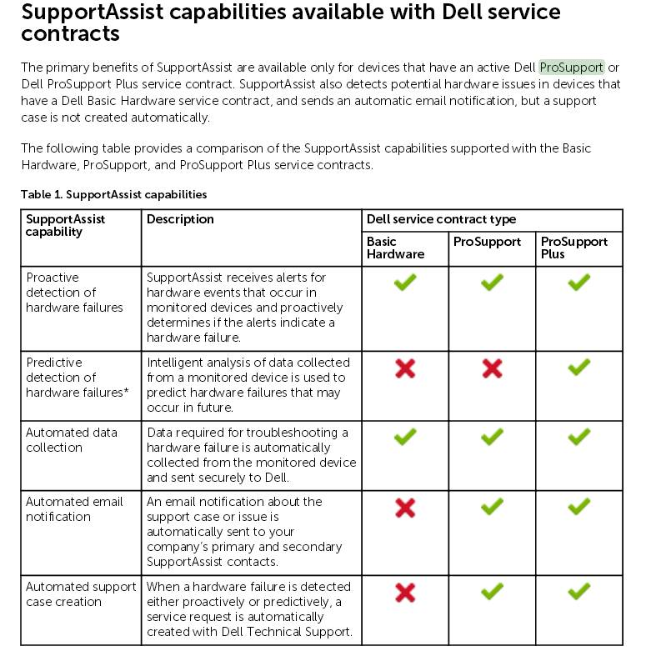
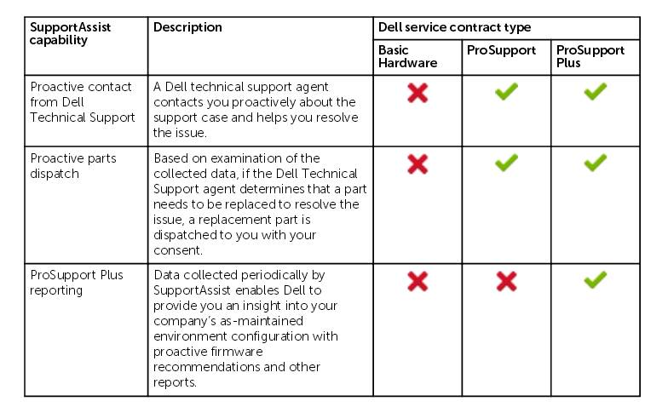

2. If above option recommends to use, why it work with so many errors... Why after manual restart this option for defined server - it works without errors... How to avoid a lot of errors and error messages.
For the servers that reports errors manually and with the schedule there might be a connectivity or credential issue. The Troubleshooting tool install on the desktop can help to investigate.
For the server that works manually the debug logs may help.

Best regards
Laurent Frachisse

From: Belogrud Sergey Vladimirovich [mailto:s.belogrud@tinkoff.ru]
Sent: Wednesday, March 09, 2016 9:56 AM
To: Frachisse, Laurent
Cc: Kretkiewicz, Piotr; Udovenko, Oleg; Quinn, Robert; Leonov Aleksey Vladimirovich
Subject: RE: 925239190 - Automatic case creation in Support Assist

Good afternoon Laurent.

I did everything you wrote.

1. Before tests I have changed key value.
Before changes it was like below.
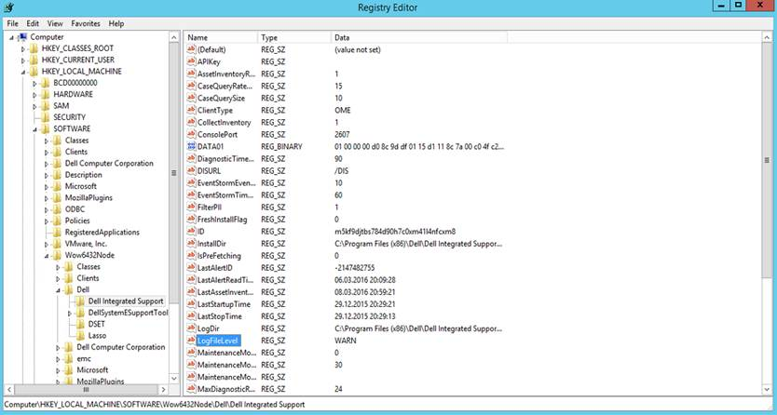

After changes it became like it shown below.
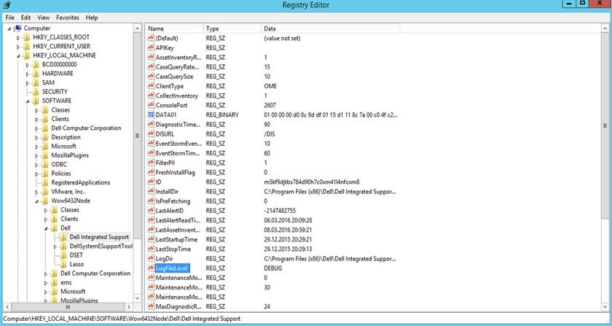

2. Then I run tests.
Four times I have run two commands.
After all command executed I have checked result in the OME. Every time everything were OK.

[root@ds-gp-prd-sdw23 ~]# racadm sensorsettings set iDRAC.Embedded.1#SystemBoardInletTemp -level max 8
Object value modified successfully

[root@ds-gp-prd-sdw23 ~]# racadm sensorsettings set iDRAC.Embedded.1#SystemBoardInletTemp -level max 42
Object value modified successfully

[root@ds-gp-prd-sdw23 ~]#

Then I looked at SupportAssist and checked it mode. It looks good. I have no found any signs that it switched to maintenance mode.

Then I run last fifth pair of commands.
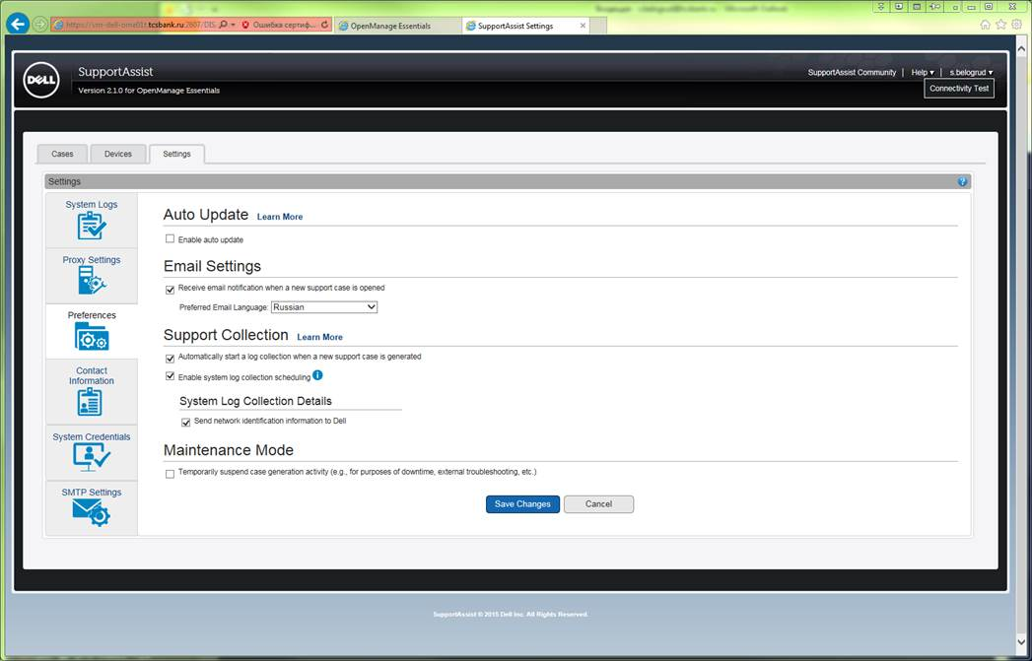
As a result, there are following messages in the OME.

Severity | Acknowledged | Time | Device | Details | Category | Source
Warning | Not Acknowledged | 09.03.2016 12:23:46 | 10.216.2.223 | Temperature sensor detected a warning value Sensor location: System Board Inlet Temp Chassis location: Main System Chassis Previous state was: OK (Normal) Temperature sensor value (in Degrees Celsius): 30.0 | Environmental | alertTemperatureProbeWarning
Normal | Not Acknowledged | 09.03.2016 12:24:32 | 10.216.2.223 | Temperature sensor returned to a normal value Sensor location: System Board Inlet Temp Chassis location: Main System Chassis Previous state was: Non-Critical (Warning) Temperature sensor value (in Degrees Celsius): 30.0 | Environmental | alertTemperatureProbeNormal
Warning | Not Acknowledged | 09.03.2016 12:25:42 | 10.216.2.223 | Temperature sensor detected a warning value Sensor location: System Board Inlet Temp Chassis location: Main System Chassis Previous state was: OK (Normal) Temperature sensor value (in Degrees Celsius): 30.0 | Environmental | alertTemperatureProbeWarning
Normal | Not Acknowledged | 09.03.2016 12:26:29 | 10.216.2.223 | Temperature sensor returned to a normal value Sensor location: System Board Inlet Temp Chassis location: Main System Chassis Previous state was: Non-Critical (Warning) Temperature sensor value (in Degrees Celsius): 30.0 | Environmental | alertTemperatureProbeNormal
Warning | Not Acknowledged | 09.03.2016 12:27:15 | 10.216.2.223 | Temperature sensor detected a warning value Sensor location: System Board Inlet Temp Chassis location: Main System Chassis Previous state was: OK (Normal) Temperature sensor value (in Degrees Celsius): 30.0 | Environmental | alertTemperatureProbeWarning
Normal | Not Acknowledged | 09.03.2016 12:27:38 | 10.216.2.223 | Temperature sensor returned to a normal value Sensor location: System Board Inlet Temp Chassis location: Main System Chassis Previous state was: Non-Critical (Warning) Temperature sensor value (in Degrees Celsius): 30.0 | Environmental | alertTemperatureProbeNormal
Warning | Not Acknowledged | 09.03.2016 12:29:34 | 10.216.2.223 | Temperature sensor detected a warning value Sensor location: System Board Inlet Temp Chassis location: Main System Chassis Previous state was: OK (Normal) Temperature sensor value (in Degrees Celsius): 30.0 | Environmental | alertTemperatureProbeWarning
Normal | Not Acknowledged | 09.03.2016 12:29:58 | 10.216.2.223 | Temperature sensor returned to a normal value Sensor location: System Board Inlet Temp Chassis location: Main System Chassis Previous state was: Non-Critical (Warning) Temperature sensor value (in Degrees Celsius): 30.0 | Environmental | alertTemperatureProbeNormal
Warning | Not Acknowledged | 09.03.2016 12:33:04 | 10.216.2.223 | Temperature sensor detected a warning value Sensor location: System Board Inlet Temp Chassis location: Main System Chassis Previous state was: OK (Normal) Temperature sensor value (in Degrees Celsius): 30.0 | Environmental | alertTemperatureProbeWarning
Normal | Not Acknowledged | 09.03.2016 12:33:27 | 10.216.2.223 | Temperature sensor returned to a normal value Sensor location: System Board Inlet Temp Chassis location: Main System Chassis Previous state was: Non-Critical (Warning) Temperature sensor value (in Degrees Celsius): 30.0 | Environmental | alertTemperatureProbeNormal

I watched on web-page of our techdirect.dell.com and nothing was happened. It looks exactly like before my tests.
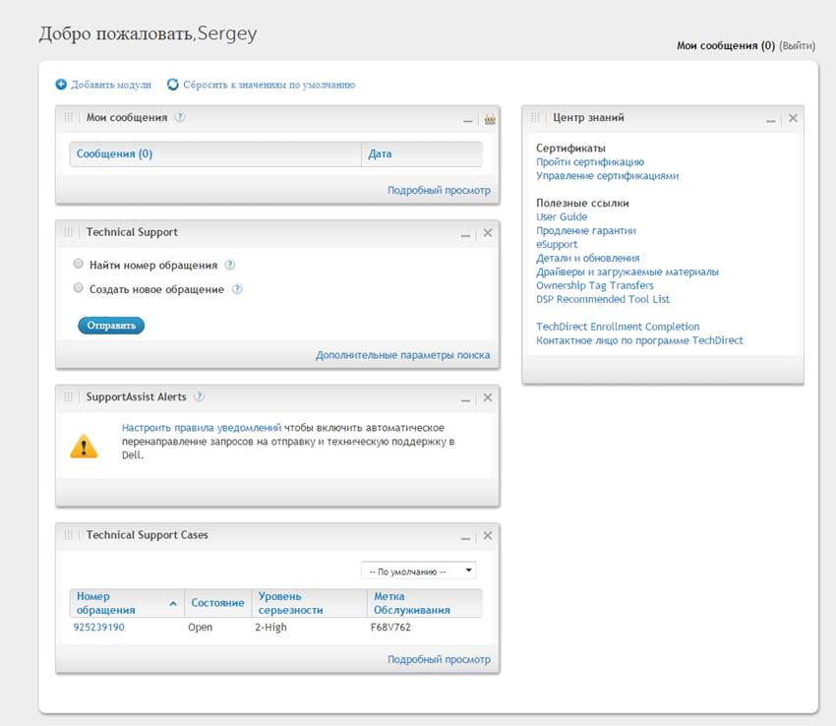

With best wishes,
Sergey

From: Laurent_Frachisse@Dell.com [mailto:Laurent_Frachisse@Dell.com]
Sent: Tuesday, March 08, 2016 11:53 AM
To: Belogrud Sergey Vladimirovich
Cc: Piotr_Kretkiewicz@Dell.com; Oleg_Udovenko@Dell.com; Robert_Quinn@Dell.com; Leonov Aleksey Vladimirovich
Subject: RE: 925239190 - Automatic case creation in Support Assist

Hello Sergey

For the events that occurred in February I can confirm that there was no events received on the Support Assist server database. It is possible that the Software was in maintenance mode following too many alerts within 60 minutes.

For the Support Assist case creation would that be possible to activate the debug mode during racadm test ?

HKEY_LOCAL_MACHINE\SOFTWARE\Wow6432Node\Dell\Dell Integrated Support
Change Value name = LogFileLevel, from INFO to DEBUG and restart the Dell SupportAssist service.
The temp changes should create a case on the 5th try within 5 hours. I didn’t see temp alerts on the image you provided. Was it done on this Device?

To create a case, I would suggest
1. changing the log level to DEBUG
2. Run 4 temp changes, make sure 4 of them are viewing in OME
3. Verify SupportAssist is not in Maintenance Mode, if so take it out of MMode
4. Run the 5th temp test

I will answer your other questions when I will get the feedback for engineering.

Best regards
Laurent Frachisse

From: Belogrud Sergey Vladimirovich [mailto:s.belogrud@tinkoff.ru]
Sent: Friday, March 04, 2016 4:02 PM
To: Frachisse, Laurent
Cc: Kretkiewicz, Piotr; Udovenko, Oleg; Quinn, Robert; Leonov Aleksey Vladimirovich
Subject: RE: 925239190 - Automatic case creation in Support Assist

Hi Laurent.

Thank you Laurent for your interest to our task.
The logs are attached to this email. As it was before, there are files compressed by zip with removed extension.

One note.
Today and yesterday I make lot of task with OME such as applying templates and update firmware. So it should not wonder you if you find lot of records about it in logs.

Please, keep me in touch about news.

With love from your customers :-) ,
Sergey

From: Laurent_Frachisse@Dell.com [mailto:Laurent_Frachisse@Dell.com]
Sent: Friday, March 04, 2016 6:28 PM
To: Belogrud Sergey Vladimirovich
Cc: Piotr_Kretkiewicz@Dell.com; Oleg_Udovenko@Dell.com; Robert_Quinn@Dell.com; Leonov Aleksey Vladimirovich
Subject: RE: 925239190 - Automatic case creation in Support Assist

Hello Sergey

Thank you for making this test and for the information provided on the dset.

The communication with the TechDirect has worked but there is no case created in support assist. There might be a reason for it but I need to engage engineering to clarify that point.
Would you mind sending me the last version of these logs :
· C:\Program Files (x86)\Dell\Dell Integrated Support\bin\phome.db
· C:\Program Files (x86)\Dell\Dell Integrated Support\logs in a zip file.

For the iDRAC attributes accessible from OME, I could not find that temperature entry neither. The name of the setting might be different or the setting is not available for the OME templates.
In my opinion the OME templates are used to provide information such as network configuration or credentials but I am going to ask engineering about that.

For your last request about OME’s behavior when system logs are collected I will also ask engineering if they are planning a change.

If you have any other question please let me know.

Best regards
Laurent Frachisse

From: Belogrud Sergey Vladimirovich [mailto:s.belogrud@tinkoff.ru]
Sent: Friday, March 04, 2016 9:37 AM
To: Frachisse, Laurent
Cc: Kretkiewicz, Piotr; Udovenko, Oleg; Quinn, Robert; Ilies, Adrian; Leonov Aleksey Vladimirovich
Subject: RE: 925239190 - Automatic case creation in Support Assist

Hi Laurent.

Hope you are doing well.

While you are preparing comments on my previous email, I'd like to clear some points.

Below I have collected several questions (most of them were already asked several times), that were stayed a side of your answers.
A little, note here - on next Monday and Tuesday will be holiday days for us. This means that we can continue our dialogue since Wednesday.

>And… you have forgotten to write me something about follow:
>> By the way could you translate this abbreviation “dset” – what does it mean. I cannot remember, that I have seen it before somewhere in manuals or user guides..
I have found answer on following question.
As I understood, you had no prepared answer on this question at that time. Now you can use my experience to help someone who will ask you this question again in future.
Following screenshot was made during reading education materials, that placed at Dell TechDirect website and this learning course has name «Dell Training for Server Systems (2 Hours)».
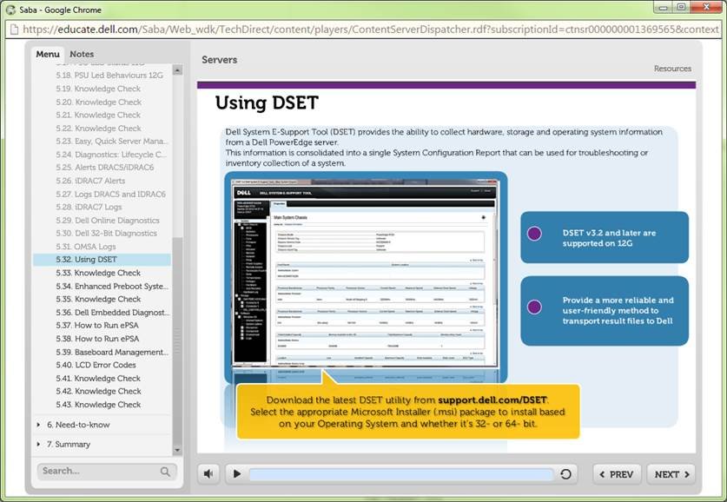

>Next clarifying question.
>Can I use deployment capabilities of Dell OpenManage Essentials to change described earlier parameter?
>> Change the Threshold Settings to “Set to Values”
>> Change the “Minimum Warning Threshold = 40”
>If answer is “yes”, where can I find this option in loaded configuration template?
As I understood, there is not appropriate parameter in server chassis configuration , that available in OME, that links with written parameter. I didn't find it. Wherefore means, that it cannot be set with template deployment method.
Correct me, please, if I'm wrong.
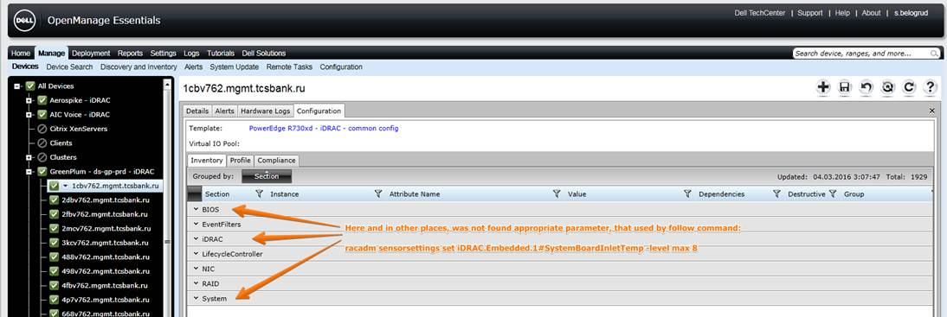

>Another one question.
>Did you ask your developers add required options to their plan for future version of Dell SupportAssist? Options, that fix bad behavior of Dell SupportAssist software.
>> I spoke to the development team about this problem. When a server is discovered by OpenManage and iDRAC the method to collect the logs will be OpenManage and not iDRAC. There is no way at the moment to change that behavior.
I’ll feel better if you say me that you have tried to transfer my wishes to Dell development team, even if you suppose, that it’s useless.

Sinserely yours,
Sergey

From: Belogrud Sergey Vladimirovich
Sent: Thursday, March 03, 2016 3:48 PM
To: 'Laurent_Frachisse@Dell.com'
Cc: Piotr_Kretkiewicz@Dell.com; Oleg_Udovenko@Dell.com; Leonov Aleksey Vladimirovich
Subject: RE: 925239190 - Automatic case creation in Support Assist

Hi Laurent.

I have tested changing temperature threshold.
Follow cycle was repeated six time.

[root@ds-gp-prd-sdw23 ~]# racadm sensorsettings set iDRAC.Embedded.1#SystemBoardInletTemp -level max 8
Object value modified successfully

[root@ds-gp-prd-sdw23 ~]# racadm getsensorinfo | grep -A 1 -B 2 SystemBoardInletTemp
Sensor Type : TEMPERATURE
<Sensor Name> <Status> <Reading> <lc> <uc> <lnc>[R/W] <unc>[R/W]
[Key = iDRAC.Embedded.1#SystemBoardInletTemp]
System Board Inlet Temp Warning 29C -7C 47C 3C [Y] 8C [Y]
[root@ds-gp-prd-sdw23 ~]# racadm sensorsettings set iDRAC.Embedded.1#SystemBoardInletTemp -level max 42
Object value modified successfully

[root@ds-gp-prd-sdw23 ~]# racadm getsensorinfo | grep -A 1 -B 2 SystemBoardInletTemp
Sensor Type : TEMPERATURE
<Sensor Name> <Status> <Reading> <lc> <uc> <lnc>[R/W] <unc>[R/W]
[Key = iDRAC.Embedded.1#SystemBoardInletTemp]
System Board Inlet Temp Ok 29C -7C 47C 3C [Y] 42C [Y]
[root@ds-gp-prd-sdw23 ~]#

Severity | Acknowledged | Time | Device | Details | Category | Source
Warning | Not Acknowledged | 03.03.2016 14:58:34 | 10.216.2.223 | Temperature sensor detected a warning value Sensor location: System Board Inlet Temp Chassis location: Main System Chassis Previous state was: OK (Normal) Temperature sensor value (in Degrees Celsius): 29.0 | Environmental | alertTemperatureProbeWarning
Warning | Not Acknowledged | 03.03.2016 15:00:39 | f68v762.mgmt.tcsbank.ru | Device f68v762.mgmt.tcsbank.ru has changed status to Warning. Data Sources: 1. Integrated Dell Remote Access Controller [OK -> Warning] | System Events | omeAlertWarningStatus
Normal | Not Acknowledged | 03.03.2016 15:03:35 | 10.216.2.223 | Temperature sensor returned to a normal value Sensor location: System Board Inlet Temp Chassis location: Main System Chassis Previous state was: Non-Critical (Warning) Temperature sensor value (in Degrees Celsius): 29.0 | Environmental | alertTemperatureProbeNormal
Warning | Not Acknowledged | 03.03.2016 15:07:05 | 10.216.2.223 | Temperature sensor detected a warning value Sensor location: System Board Inlet Temp Chassis location: Main System Chassis Previous state was: OK (Normal) Temperature sensor value (in Degrees Celsius): 29.0 | Environmental | alertTemperatureProbeWarning
Normal | Not Acknowledged | 03.03.2016 15:07:51 | 10.216.2.223 | Temperature sensor returned to a normal value Sensor location: System Board Inlet Temp Chassis location: Main System Chassis Previous state was: Non-Critical (Warning) Temperature sensor value (in Degrees Celsius): 29.0 | Environmental | alertTemperatureProbeNormal
Warning | Not Acknowledged | 03.03.2016 15:09:01 | 10.216.2.223 | Temperature sensor detected a warning value Sensor location: System Board Inlet Temp Chassis location: Main System Chassis Previous state was: OK (Normal) Temperature sensor value (in Degrees Celsius): 29.0 | Environmental | alertTemperatureProbeWarning
Normal | Not Acknowledged | 03.03.2016 15:09:48 | 10.216.2.223 | Temperature sensor returned to a normal value Sensor location: System Board Inlet Temp Chassis location: Main System Chassis Previous state was: Non-Critical (Warning) Temperature sensor value (in Degrees Celsius): 29.0 | Environmental | alertTemperatureProbeNormal
Warning | Not Acknowledged | 03.03.2016 15:10:57 | 10.216.2.223 | Temperature sensor detected a warning value Sensor location: System Board Inlet Temp Chassis location: Main System Chassis Previous state was: OK (Normal) Temperature sensor value (in Degrees Celsius): 29.0 | Environmental | alertTemperatureProbeWarning
Normal | Not Acknowledged | 03.03.2016 15:11:20 | 10.216.2.223 | Temperature sensor returned to a normal value Sensor location: System Board Inlet Temp Chassis location: Main System Chassis Previous state was: Non-Critical (Warning) Temperature sensor value (in Degrees Celsius): 29.0 | Environmental | alertTemperatureProbeNormal
Warning | Not Acknowledged | 03.03.2016 15:12:30 | 10.216.2.223 | Temperature sensor detected a warning value Sensor location: System Board Inlet Temp Chassis location: Main System Chassis Previous state was: OK (Normal) Temperature sensor value (in Degrees Celsius): 29.0 | Environmental | alertTemperatureProbeWarning
Normal | Not Acknowledged | 03.03.2016 15:13:17 | 10.216.2.223 | Temperature sensor returned to a normal value Sensor location: System Board Inlet Temp Chassis location: Main System Chassis Previous state was: Non-Critical (Warning) Temperature sensor value (in Degrees Celsius): 29.0 | Environmental | alertTemperatureProbeNormal
Warning | Not Acknowledged | 03.03.2016 15:16:22 | 10.216.2.223 | Temperature sensor detected a warning value Sensor location: System Board Inlet Temp Chassis location: Main System Chassis Previous state was: OK (Normal) Temperature sensor value (in Degrees Celsius): 29.0 | Environmental | alertTemperatureProbeWarning
Normal | Not Acknowledged | 03.03.2016 15:17:09 | 10.216.2.223 | Temperature sensor returned to a normal value Sensor location: System Board Inlet Temp Chassis location: Main System Chassis Previous state was: Non-Critical (Warning) Temperature sensor value (in Degrees Celsius): 29.0 | Environmental | alertTemperatureProbeNormal

After six time the commands were repeated, I have seen changes at Dell TechDirect web page.
There was appeared alarm in yellow field.
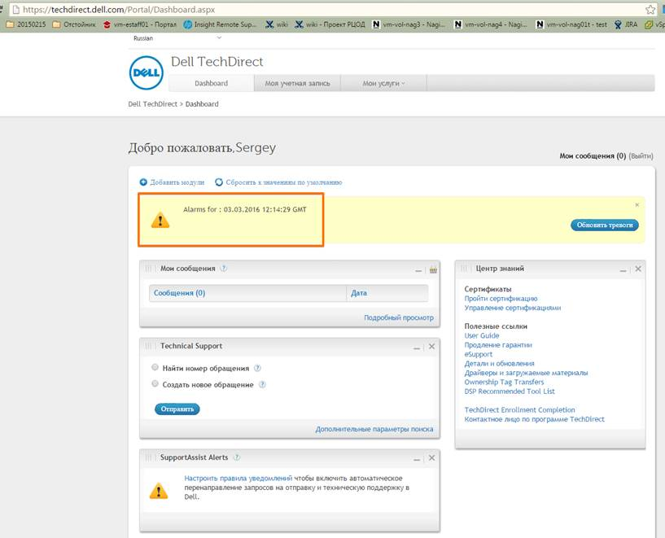

Opened cases were not changed.
Here is still opened one last case.
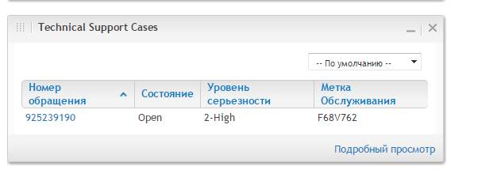
And the main thing – there was not any changes in SupportAssist application.
The tab «Cases» is still empty…
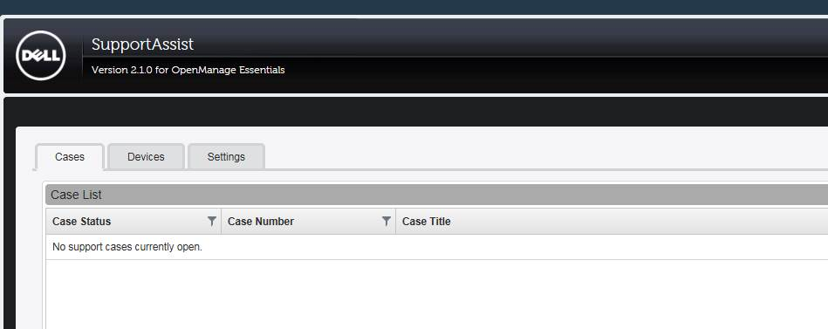
How to understand this behavior, Laurent?

From: Belogrud Sergey Vladimirovich
Sent: Wednesday, March 02, 2016 6:40 PM
To: 'Laurent_Frachisse@Dell.com'
Cc: Piotr_Kretkiewicz@Dell.com; Oleg_Udovenko@Dell.com; Leonov Aleksey Vladimirovich
Subject: RE: 925239190 - Automatic case creation in Support Assist

Hi Laurent!

That’s good news for us, as I can see.

Yesterday I have created template, that properly configure snmp trap sending, and have deployed that template on most of our servers.
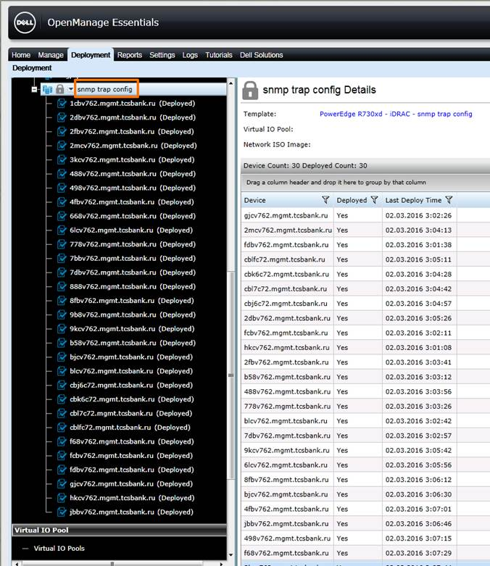

Now we can run test, that you are talking about.

From: Laurent_Frachisse@Dell.com [mailto:Laurent_Frachisse@Dell.com]
Sent: Wednesday, March 02, 2016 6:30 PM
To: Belogrud Sergey Vladimirovich
Cc: Piotr_Kretkiewicz@Dell.com; Oleg_Udovenko@Dell.com; Leonov Aleksey Vladimirovich
Subject: RE: 925239190 - Automatic case creation in Support Assist

Hello Sergey

I could trigger a case creation by applying the following :
racadm -r DRAC_IP -u root -p calvin sensorsettings set iDRAC.Embedded.1#SystemBoardInletTemp -level max 8 -> wait for the alert to show up in OME.
racadm -r DRAC_IP -u root -p calvin sensorsettings set iDRAC.Embedded.1#SystemBoardInletTemp -level max 42 -> wait for the state to change in OME
where DRAC_IP is the IP address of the iDRAC on which you want to run the test.

In my lab it creates a case in Support Assist but for some reason I can’t get a case number for it. It might be because our lab is a test environment.
If you want we can test it on one of you server.

Best regards
Laurent Frachisse

From: Belogrud Sergey Vladimirovich [mailto:s.belogrud@tinkoff.ru]
Sent: Monday, February 29, 2016 4:43 PM
To: Frachisse, Laurent
Cc: Kretkiewicz, Piotr; Udovenko, Oleg; Leonov Aleksey Vladimirovich
Subject: RE: 925239190 - Automatic case creation in Support Assist

Hello Laurent.
Thanks for explaining.
I will be waiting for completion of your double checks. And then I will reproduce your advices at our conditions.

At this moment I have no configured “SNMP Traps and Email Settings” in our iDRAC server pages.
I have only configured snmp service on several our linux servers.
[root@ds-gp-prd-sdw23 ~]# grep Trapsink /etc/snmp/snmpd.conf
Trapsink OME_server_ip_address our_snmp_trap_community
[root@ds-gp-prd-sdw23 ~]#
As I remember, it works – I have seen some traps, received from our linux servers by Dell OpenManage Essentials server.

I will configure similar things in iDRAC on all our servers too.

I already have deleted and added again all our servers, that were affected. Now they are have only iRAC method available in Dell OME.
These servers were tested in SupportAssist with “Send System Logs” option. This test was passed successfully. There no iptables modules were loaded, and no any suspected messages in /var/log/messages were found.
Now I can turn on and configure “System Log Collection Schedule” option in SupportAssist for iDRAC method.

Just for info.
This time SystemBoardInletTemp parameter have follow values.
[root@ds-gp-prd-sdw23 ~]# racadm getsensorinfo | grep -A 1 -B 2 SystemBoardInletTemp
Sensor Type : TEMPERATURE
<Sensor Name> <Status> <Reading> <lc> <uc> <lnc>[R/W] <unc>[R/W]
[Key = iDRAC.Embedded.1#SystemBoardInletTemp]
System Board Inlet Temp Ok 31C -7C 47C 3C [Y] 42C [Y]
[root@ds-gp-prd-sdw23 ~]#

From: Laurent_Frachisse@Dell.com [mailto:Laurent_Frachisse@Dell.com]
Sent: Monday, February 29, 2016 6:30 PM
To: Belogrud Sergey Vladimirovich
Cc: Piotr_Kretkiewicz@Dell.com; Oleg_Udovenko@Dell.com; Leonov Aleksey Vladimirovich
Subject: RE: 925239190 - Automatic case creation in Support Assist

Hello Sergey

To change or access some hardware settings it is something necessary to have a piece of software that can talk to the hardware. For Dell systems this tool is called Openmanage / System Administrator. HP and IBM have I think solutions around Insight Manager and Tivoli.
This tool works on Linux system as well but to directly access to it on Linux we need to use the interface provided by a System Administrator installed on a Windows. This is because some OS like ESX or Linux the GUI is not always installed. It is then necessary to use a Windows system like a clinet to access to the tool.

The documentation can be found on that link.
http://www.dell.com/support/home/us/en/19/Products/software/ent_sys_mgmt/ent_sys_mgmt_opnmng_sw

Today I managed to use the tool racadm (in C:\Program Files\Dell\SysMgt\rac5) to change the temperature but I need to double check if it is enough to create a case. The fact that Support Assist move to maintenance mode after 10 events makes the test difficult to operate.

racadm -r DRAC_IP -u root -p calvin sensorsettings set iDRAC.Embedded.1#SystemBoardInletTemp -level max 8 -> wait for the alert to show up in OME.
racadm -r DRAC_IP -u root -p calvin sensorsettings set iDRAC.Embedded.1#SystemBoardInletTemp -level max 42 -> wait for the state to change in OME
where DRAC_IP is the IP address of the iDRAC on which you want to run the test.

Running this operation 6 times might trigger a case creation but I could not test that for the moment.

We must make sure that sure that iDRAC is configured to send IPMI traps to your OME system.
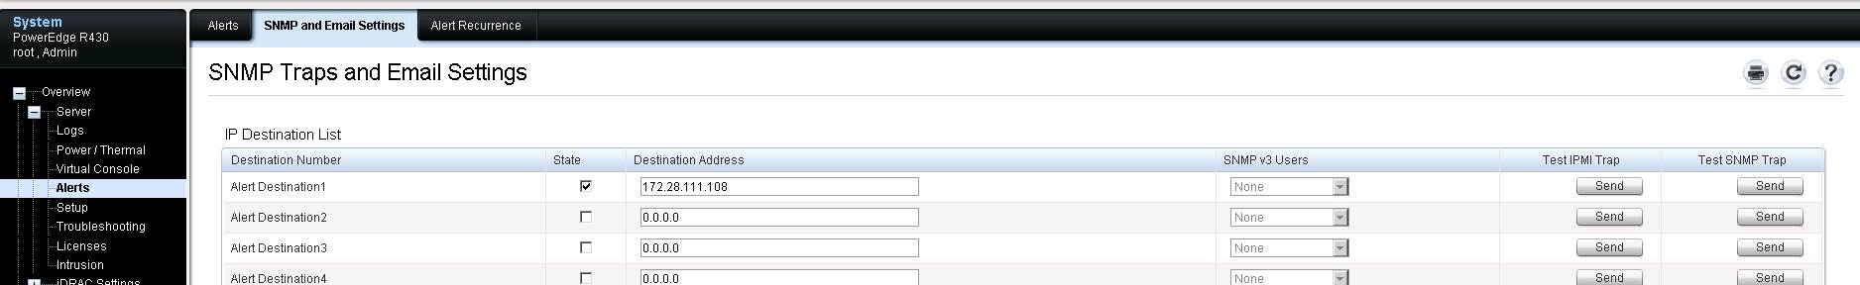

Best regards
Laurent Frachisse

From: Belogrud Sergey Vladimirovich [mailto:s.belogrud@tinkoff.ru]
Sent: Thursday, February 25, 2016 5:11 PM
To: Frachisse, Laurent
Cc: Kretkiewicz, Piotr; Udovenko, Oleg; Leonov Aleksey Vladimirovich
Subject: RE: 925239190 - Automatic case creation in Support Assist

Good evening Laurent.

That’s right – without deletion previously discovered servers – the SupportAssist would not work correctly if we want to connect to server only via iDRAC method.

Meanwhile you ought to answer on some not answered my questions, that I asked in previous email. Isn’t it?

I’d like to note, that it’s unusual, that we can set appropriate parameter of temperature, named as “Minimum Warning Threshold” only if we have installed somewhere special software:
> OpenMange/server Administrator installed on a Windows Server
But what we can do if we have only Linux servers…?
Perhaps there is somewhere way to do what we want even if we have no installed described ms windows’s software.

And Laurent – could you send me url, where I can read more about “OpenManage/server Administrator” – what is that and how it looks like.

And I’m not sure to understand properly – why you named alternative method as a method to set parameter via command line: “do that from a command line”.
During our last Webex I talked about setting this parameter via Dell OpenManage Essentials option, that named as a “Deployment”. Is the second name of this method – “command line” method? Or we are talking about two different methods? I’d like to clear it for my self.

Sergey

From: Laurent_Frachisse@Dell.com [mailto:Laurent_Frachisse@Dell.com]
Sent: Thursday, February 25, 2016 7:24 PM
To: Belogrud Sergey Vladimirovich
Cc: Piotr_Kretkiewicz@Dell.com; Oleg_Udovenko@Dell.com; Leonov Aleksey Vladimirovich
Subject: RE: 925239190 - Automatic case creation in Support Assist

Hello Sergey

Following our Webex we could collect the logs from the iDRAC using Support Assist.
You just need to delete the Linux servers so that they are discovered a new time without any entry for OpenManage.

To test the case creation if you don’t have OpenMange/server Administrator installed on a Windows Server, I can check in a lab if it is possible to do that from a command line.

That will require a bit of time as I have to set up the right equipment and do the tests. If I manage to create a case in Support Assist using this tool I will contact you and we will test it in your environment.

Best regards
Laurent Frachisse

From: Belogrud Sergey Vladimirovich [mailto:s.belogrud@tinkoff.ru]
Sent: Thursday, February 25, 2016 1:49 PM
To: Frachisse, Laurent
Cc: Quinn, Robert; Ilies, Adrian; Kretkiewicz, Piotr; Udovenko, Oleg; Leonov Aleksey Vladimirovich
Subject: RE: 925239190 - Automatic case creation in Support Assist

Hello Laurent.

I still have same troubles...
I have disables one discovery group, that use snmp access to our servers.
There are presets only iRAC methods discovery rules.
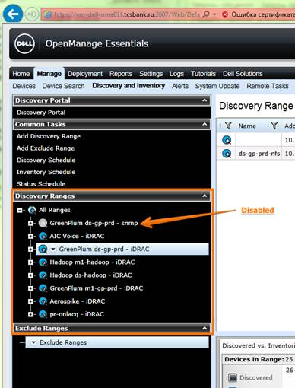

Here you can see, that only WS-MAN method is here.
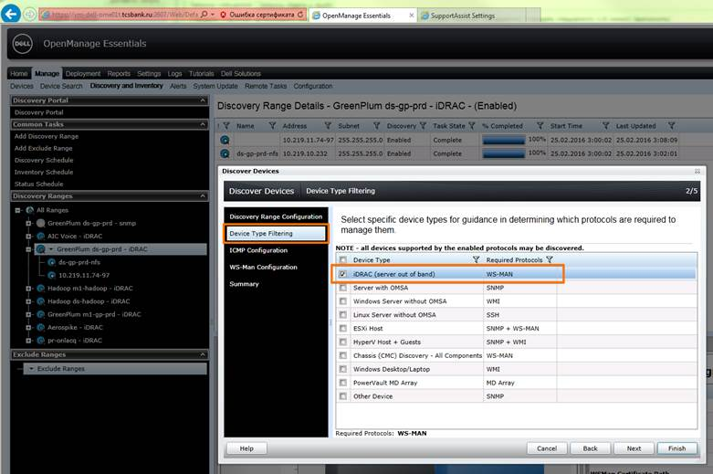

Then I have tested option “Send System Logs” in Dell SupportAssist for our early known server.
And I get already known trouble with nf_conntrack loaded modules:
…
Feb 25 16:00:47 sdw23 kernel: sd 17:0:0:0: [sdd] 2112 512-byte logical blocks: (1.08 MB/1.03 MiB)
Feb 25 16:00:47 sdw23 kernel: sd 17:0:0:0: [sdd] Write Protect is off
Feb 25 16:00:47 sdw23 kernel: sd 17:0:0:0: [sdd] Assuming drive cache: write through
Feb 25 16:00:47 sdw23 kernel: sd 17:0:0:0: [sdd] Assuming drive cache: write through
Feb 25 16:00:47 sdw23 kernel: sdd:
Feb 25 16:00:48 sdw23 kernel: sd 17:0:0:0: [sdd] Assuming drive cache: write through
Feb 25 16:00:48 sdw23 kernel: sd 17:0:0:0: [sdd] Attached SCSI removable disk
Feb 25 16:01:05 sdw23 kernel: usb 1-1.6.2: USB disconnect, device number 20
Feb 25 16:01:08 sdw23 udevd[1249]: can not read '/etc/udev/rules.d/00-secupd-dell.rules'
Feb 25 16:01:32 sdw23 kernel: bnx2x 0000:01:00.2: em3: using MSI-X IRQs: sp 189 fp[0] 191 ... fp[7] 198
Feb 25 16:01:32 sdw23 kernel: ADDRCONF(NETDEV_UP): em3: link is not ready
Feb 25 16:01:32 sdw23 kernel: bnx2x 0000:01:00.3: em4: using MSI-X IRQs: sp 199 fp[0] 201 ... fp[7] 208
Feb 25 16:01:33 sdw23 kernel: ADDRCONF(NETDEV_UP): em4: link is not ready
…

After that, I have to ask you my question in third time:
How to disable bad method in Dell SupportAssist and stay only one method: iDRAC method?
What’s wrong?
I conclude that forcement method, that was advised by your development team – doesn't work correctly!
> If you want to force Support Assist to use only the iDRAC, you need to have discovery ranges in Openmanage Essentials that only use WS-MAN so that iDRAC will be discovered.
Could you contact to someone from your development team, who really have deep knowledge about Dell SupportAssist?
We are going around in circles and have no fix this glitch. That is annoying.

And… you have forgotten to write me something about follow:
> By the way could you translate this abbreviation “dset” – what does it mean. I cannot remember, that I have seen it before somewhere in manuals or user guides..

Next clarifying question.
Can I use deployment capabilities of Dell OpenManage Essentials to change described earlier parameter?
> Change the Threshold Settings to “Set to Values”
> Change the “Minimum Warning Threshold = 40”

If answer is “yes”, where can I find this option in loaded configuration template?
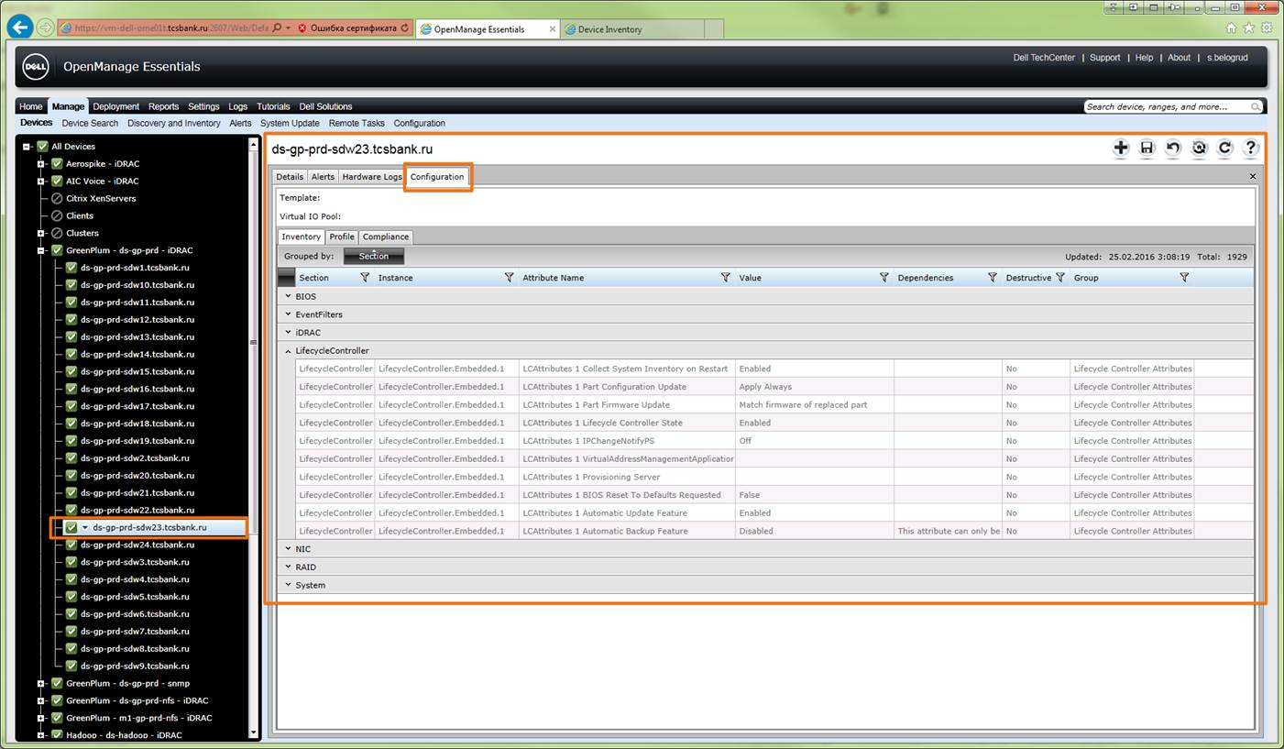

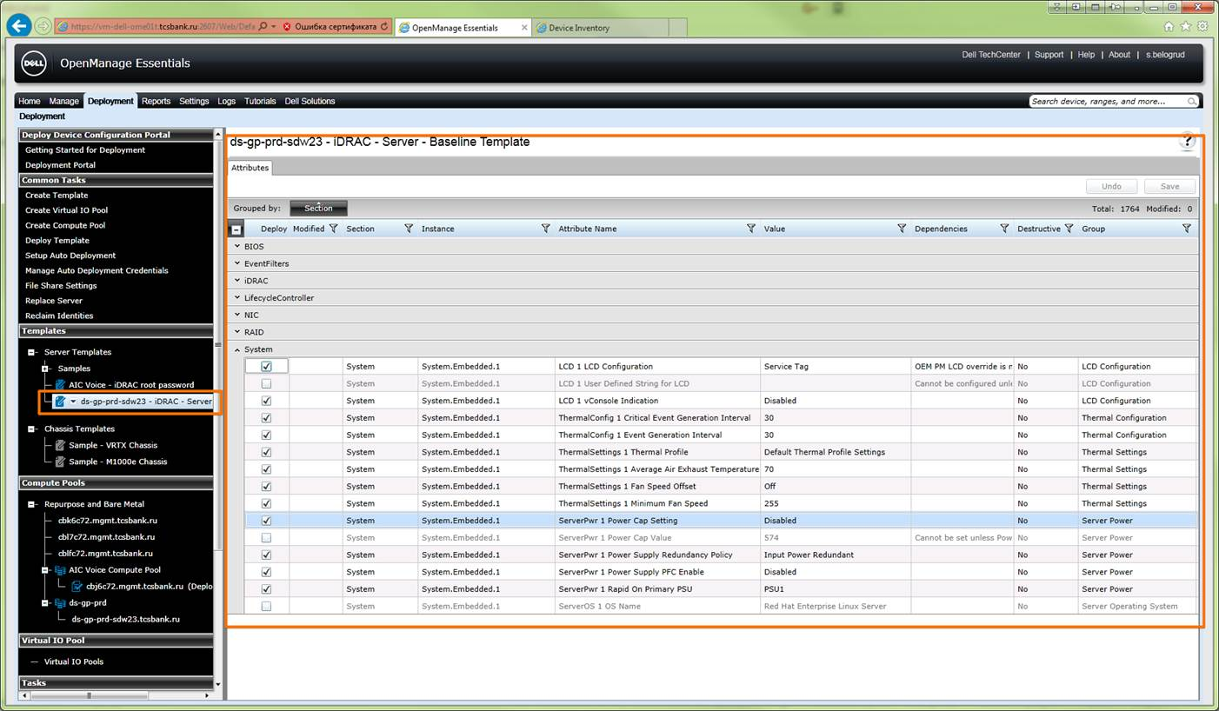

Another one question.
Did you ask your developers add required options to their plan for future version of Dell SupportAssist? Options, that fix bad behavior of Dell SupportAssist software.
> I spoke to the development team about this problem. When a server is discovered by OpenManage and iDRAC the method to collect the logs will be OpenManage and not iDRAC. There is no way at the moment to change that behavior.

From: Laurent_Frachisse@Dell.com [mailto:Laurent_Frachisse@Dell.com]
Sent: Thursday, February 25, 2016 1:24 PM
To: Belogrud Sergey Vladimirovich
Cc: Piotr_Kretkiewicz@Dell.com; Oleg_Udovenko@Dell.com; Leonov Aleksey Vladimirovich
Subject: RE: 925239190 - Automatic case creation in Support Assist

That’s not available on the DRAC interface unfortunately.
That operation can be made from OpenManage. I think that for Linux you would need to use on OpenManage installed on a Windows to connect to the OpenMange installed on the Linux.
Be aware that Dell Support Assist will put itself in Maintenance mode as soon as it receives 10 events (which are registered in the policy.xml file) within 60 minutes. That can make the execution of the test quite challenging.

You can see that Support Assist is in maintenance mode when you open Support Assist and select the settings tab.

Laurent

From: Belogrud Sergey Vladimirovich [mailto:s.belogrud@tinkoff.ru]
Sent: Thursday, February 25, 2016 10:09 AM
To: Frachisse, Laurent
Cc: Kretkiewicz, Piotr; Udovenko, Oleg; Leonov Aleksey Vladimirovich
Subject: RE: 925239190 - Automatic case creation in Support Assist

Thanks for information.
I will try it very soon and say our results.

Next question is: could you advise me where in iDRAC web interface I can find follow settings, that you have written not so far:
>
> Change the Threshold Settings to “Set to Values”
> Change the “Minimum Warning Threshold = 40”

From: Laurent_Frachisse@Dell.com [mailto:Laurent_Frachisse@Dell.com]
Sent: Thursday, February 25, 2016 12:55 PM
To: Belogrud Sergey Vladimirovich
Cc: Piotr_Kretkiewicz@Dell.com; Oleg_Udovenko@Dell.com; Leonov Aleksey Vladimirovich
Subject: RE: 925239190 - Automatic case creation in Support Assist

Hello Sergey

I spoke to the development team about this problem. When a server is discovered by OpenManage and iDRAC the method to collect the logs will be OpenManage and not iDRAC. There is no way at the moment to change that behavior.
If you want to force Support Assist to use only the iDRAC, you need to have discovery ranges in Openmanage Essentials that only use WS-MAN so that iDRAC will be discovered.

Best regards
Laurent Frachisse

From: Belogrud Sergey Vladimirovich
Sent: Thursday, February 25, 2016 12:50 PM
To: 'Laurent_Frachisse@Dell.com'
Cc: Piotr_Kretkiewicz@Dell.com; Oleg_Udovenko@Dell.com; Leonov Aleksey Vladimirovich
Subject: RE: 925239190 - Automatic case creation in Support Assist

We are still need your help.

From: Belogrud Sergey Vladimirovich
Sent: Thursday, February 25, 2016 12:47 PM
To: 'Laurent_Frachisse@Dell.com'
Cc: Piotr_Kretkiewicz@Dell.com; Oleg_Udovenko@Dell.com; Leonov Aleksey Vladimirovich
Subject: RE: 925239190 - Automatic case creation in Support Assist

Hello Laurent.

Hope you are don’t foget about us and our difficulties…

Sergey.

From: Laurent_Frachisse@Dell.com [mailto:Laurent_Frachisse@Dell.com]
Sent: Saturday, February 20, 2016 4:04 PM
To: Belogrud Sergey Vladimirovich
Subject: Отсутствует: 925239190 - Automatic case creation in Support Assist

Hello,

I am out of office and will be back on Monday.
Should you require immediate assistance please contact one of my colleagues.
Adrian_Ilies@dell.com
Robert_Quinn@Dell.com

Have a nice day!

From: Belogrud Sergey Vladimirovich
Sent: Saturday, February 20, 2016 4:04 PM
To: 'Laurent_Frachisse@Dell.com'
Cc: Piotr_Kretkiewicz@Dell.com; Oleg_Udovenko@Dell.com; Leonov Aleksey Vladimirovich
Subject: RE: 925239190 - Automatic case creation in Support Assist

Hello Laurent.

Excuse me for absent my answer yesterday.
I was to much busy and had to do some very important deals. So there was no time to answer.

First of all - we are celebrating in our country national holidays at Monday and tuesday. Wherefore we would continue our attempts to tune Dell SupportAssist at Wednesday.

> That shows us that if we use iDRAC, the OS will not try to load the kernel module that breaks your application.
Excellent! That’s what we need!
Only one question – how to configure Dell SupportAssist to use only iDRAC way to connect to our servers.
I’m not insisting to have both method of access to our servers from Dell SupportAssist. I think there is completely enough to have only one – connection via iDRAC. But you should tell me how to completely remove other method of connection. Last time during our Webex I have tried to stay only iDRAC method, but, as you have seen, it was not worked properly. That’s kindly confuse me – I have removed some authorization records (you have seen it), but it was not bring results to us.

> It seems that when Open Manage Essential discovers an OS that has Open Manage and iDRAC, OpenManage will be used to get the dset. I am not aware of any way to give iDRAC priority over OpenManage.
> I need to ask the developers if that is possible but I think this is not implemented in Support Assist. You may have to discover the servers by using WS-MAN only so that only iDRAC will be used.
Here you are writing that OME gets dset.
By the way could you translate this abbreviation “dset” – what does it mean. I cannot remember, that I have seen it before somewhere in manuals or user guides..

Before I read written by you words, I thought that OpenManage Essentials and SupportAssist are use its own methods to connect to servers. I thought if both of them have its own configuration, how to connect to servers, that means they can use different methods, that does not depend from each other.
In our case – I have installed OME with both method of connection – connection that describes in “Discover Devices” menu option: “Device type: Server with OMSA – SNMP protocol” and “Device type: iDRAC (server out of band) – WS-MAN protocol”. I want to say, that, as I understand, we have not troubles with OME. It works and nothing bad was noted.

And in same time – I have configured SupportAssist. It was configured to use two method of connection to our servers: “Credential type: Linux” (that bring to us lot of trouble) and another one “Credential type: iDRAC”. As known for me at this moment, we tried to turn off bad method, named “Linux”, but you can see on screenshots below – it still here… I suppose, you should ask your engineers – how to remove this credential from SupportAssist.
Below you can see, as you have seen it before in our Webex session, if I clear both fields and try to push “Save changes” button – I receive error messages… What’s wrong?

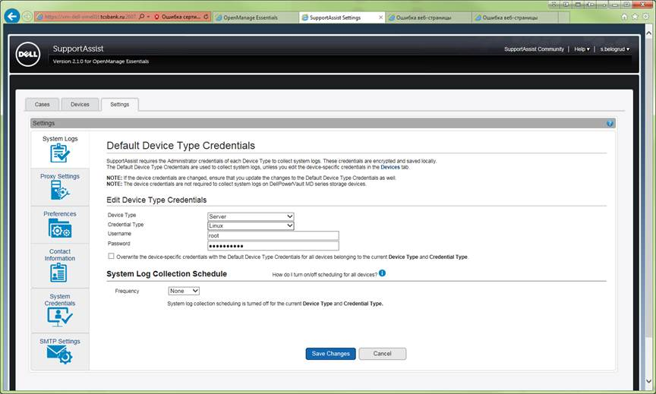

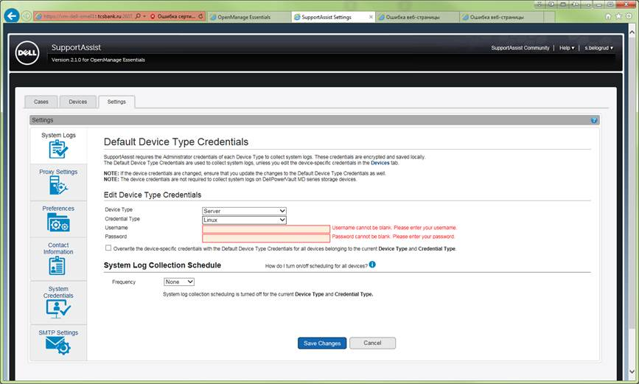

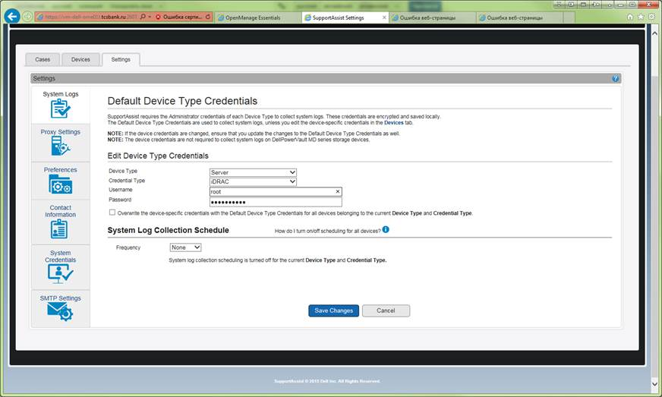

Here is right method of connection. This method should stay where it is at this time.

That’s good idea to test your achievements with increasing temperature threshold, but I think we should test it only after we fix SupportAssist to use only one credential type method – only iDRAC method. After fixing, I can test SupportAssist without afraid to brake down our application software.

What you say?

See you soon,
Sergey

From: Laurent_Frachisse@Dell.com [mailto:Laurent_Frachisse@Dell.com]
Sent: Thursday, February 18, 2016 7:05 PM
To: Belogrud Sergey Vladimirovich
Cc: Piotr_Kretkiewicz@Dell.com; Oleg_Udovenko@Dell.com; Leonov Aleksey Vladimirovich
Subject: RE: 925239190 - Automatic case creation in Support Assist

Hello Sergey

That shows us that if we use iDRAC, the OS will not try to load the kernel module that breaks your application.
It seems that when Open Manage Essential discovers an OS that has Open Manage and iDRAC, OpenManage will be used to get the dset. I am not aware of any way to give iDRAC priority over OpenManage.
I need to ask the developers if that is possible but I think this is not implemented in Support Assist. You may have to discover the servers by using WS-MAN only so that only iDRAC will be used.

For the case not created in Support Assist:
The only way to test creation is the following Action Plan.
If you OMSA installed on the discovered server you can change the temperature settings to trigger an alert. This would need to be done 5 times for the case to be created.

Change the Threshold Settings to “Set to Values”
Change the “Minimum Warning Threshold = 40”
Click Apply
Verify that OME has registered the Alerts
Set back to default or minimum threshold to 8
Click Apply
Repeat 2 – 6 until you get 5 alerts

I will be off tomorrow but we can try to do that on Monday if you want. Be aware that if you exceed 10 events in 60 minutes, Support Assist will be in maintenance mode and no case creation will occur.

Best regards
Laurent Frachisse

From: Belogrud Sergey Vladimirovich [mailto:s.belogrud@tinkoff.ru]
Sent: Thursday, February 18, 2016 12:16 PM
To: Frachisse, Laurent
Cc: Kretkiewicz, Piotr; Udovenko, Oleg; Leonov Aleksey Vladimirovich
Subject: [WARNING: MESSAGE ENCRYPTED]RE: 925239190 - Automatic case creation in Support Assist

Hello Laurent.

Point No.1.
I have run utility, what you asked.
Its output file is attached.

PS C:\Program Files (x86)\Dell\AdvDiags\DSET\bin> .\DellSystemInfo.exe -s 10.219.11.96 -u root -r c:\dset.zip
Dell System E-Support Tool, Version 3.7.0
@2004-2014 Dell Inc. All Rights Reserved.

Please enter "root" password:
* Gathering Chassis information...
* Gathering Storage information...
* Gathering System Summary information...
* Preparing and Compressing Report...
* Saving DSET CIM report to path: c:\ with report file name: dset.zip
PS C:\Program Files (x86)\Dell\AdvDiags\DSET\bin> dir C:\dset.zip

Directory: C:\

Mode LastWriteTime Length Name
---- ------------- ------ ----
-a--- 18.02.2016 14:56 2148610 dset.zip

PS C:\Program Files (x86)\Dell\AdvDiags\DSET\bin>

I watched /var/log/messages on the server and nothing was happened at all.
No one record, related with executed process.
Nothing iptables modules were loaded.
Everything looks like Ok.

Point No.2.
I have collected today another one archive file with logs.
You can find it attached to this email.

With best wishes,
Sergey

From: Laurent_Frachisse@Dell.com [mailto:Laurent_Frachisse@Dell.com]
Sent: Thursday, February 18, 2016 12:59 PM
To: Belogrud Sergey Vladimirovich
Cc: Piotr_Kretkiewicz@Dell.com; Oleg_Udovenko@Dell.com; Leonov Aleksey Vladimirovich
Subject: RE: 925239190 - Automatic case creation in Support Assist

Hi Sergey

Thanks for this update the problem you described is clear.

Would you mind running the following command:
DellSystemInfo.exe –s IP_iDRAC –u root –r c:\dset.zip
With the IP_iDRAC the IP address of the iDRAC server and where root is the name of the account you use for iDRAC.
You will find this command in the directory C:\Programme (X86)\Dell\AdvDiags\DSET\bin.
Please check the /var/log/message of your server. I want to bypass support assist and be 100% sure that we use iDRAC to get the dset and nothing else.

For the problem 2:
The logs are quite scarce but I suspect Support Assist to be in maintenance mode at the time the problem occurred.

2016-02-15 00:14:30,671: T0xPHOMEScheduler_Worker-20 OMEQueryJob ERROR Message=[Now entering Maintenance Mode due to receiving at least 10 events within 60 minutes!]

Maintenance mode is some sort of security. When Open Manage Essential receives too many alerts, the maintenance mode is enabled and no case will be created. This is to prevent Support Assist to create too many cases if there is for example a problem that would affect all the network. That would also prevent many cases for the same problem.

Could you please send me the last logs in the folder C:\Program Files (x86)\Dell\Dell Integrated Support\logs. Yesterday Support Assist was not in maintenance mode I would like to have a look at the logs when we did the tests.

Best regards
Laurent Frachisse

From: Belogrud Sergey Vladimirovich [mailto:s.belogrud@tinkoff.ru]
Sent: Wednesday, February 17, 2016 5:33 PM
To: Frachisse, Laurent
Cc: Kretkiewicz, Piotr; Udovenko, Oleg; Leonov Aleksey Vladimirovich
Subject: RE: 925239190 - Automatic case creation in Support Assist

That’s right Laurent.

I’d like to add some details to «problem 1».

Here is part of /var/log/messages file, that was taken some time ago. At that time we didn't know about tragic feature of SupportAssist software, that conclude in loading iptables modules and exactly nf_conntract module, after option «Send System Logs» was executed in it.
Here you can see, that after short time, since dset was taken, appears lot of rows with information about dropped packets:
Jan 14 12:58:30 sdw10 kernel: nf_conntrack: table full, dropping packet.
Exactly this behavior is the reason of crushing of our application software GreenPlum.
And by the way, this part of log was taken from other server, not from this server, what we have used in our Webex session. In our Webex session we have used server from the last case, that was created about out of order HDD on it.

[root@ds-gp-prd-sdw10 ~]# less /var/log/messages
...
Jan 14 12:56:52 sdw10 kernel: usb 1-1.6.2: new high speed USB device number 7 using ehci_hcd
Jan 14 12:56:52 sdw10 kernel: usb 1-1.6.2: New USB device found, idVendor=0624, idProduct=0250
Jan 14 12:56:52 sdw10 kernel: usb 1-1.6.2: New USB device strings: Mfr=4, Product=5, SerialNumber=6
Jan 14 12:56:52 sdw10 kernel: usb 1-1.6.2: Product: Mass Storage Function
Jan 14 12:56:52 sdw10 kernel: usb 1-1.6.2: Manufacturer: Avocent
Jan 14 12:56:52 sdw10 kernel: usb 1-1.6.2: SerialNumber: 20120731
Jan 14 12:56:52 sdw10 kernel: usb 1-1.6.2: configuration #1 chosen from 1 choice
Jan 14 12:56:52 sdw10 kernel: scsi4 : SCSI emulation for USB Mass Storage devices
Jan 14 12:56:53 sdw10 kernel: scsi 4:0:0:0: Direct-Access iDRAC SECUPD 0329 PQ: 0 ANSI: 0 CCS
Jan 14 12:56:53 sdw10 kernel: sd 4:0:0:0: Attached scsi generic sg3 type 0
Jan 14 12:56:53 sdw10 kernel: sd 4:0:0:0: [sdd] 2112 512-byte logical blocks: (1.08 MB/1.03 MiB)
Jan 14 12:56:53 sdw10 kernel: sd 4:0:0:0: [sdd] Write Protect is off
Jan 14 12:56:53 sdw10 kernel: sd 4:0:0:0: [sdd] Assuming drive cache: write through
Jan 14 12:56:53 sdw10 kernel: sd 4:0:0:0: [sdd] Assuming drive cache: write through
Jan 14 12:56:53 sdw10 kernel: sdd:
Jan 14 12:56:53 sdw10 kernel: sd 4:0:0:0: [sdd] Assuming drive cache: write through
Jan 14 12:56:53 sdw10 kernel: sd 4:0:0:0: [sdd] Attached SCSI removable disk
Jan 14 12:57:11 sdw10 kernel: usb 1-1.6.2: USB disconnect, device number 7
Jan 14 12:57:16 sdw10 kernel: usb 1-1.6.2: new high speed USB device number 8 using ehci_hcd
Jan 14 12:57:16 sdw10 kernel: usb 1-1.6.2: New USB device found, idVendor=0624, idProduct=0250
Jan 14 12:57:16 sdw10 kernel: usb 1-1.6.2: New USB device strings: Mfr=4, Product=5, SerialNumber=6
Jan 14 12:57:16 sdw10 kernel: usb 1-1.6.2: Product: Mass Storage Function
Jan 14 12:57:16 sdw10 kernel: usb 1-1.6.2: Manufacturer: Avocent
Jan 14 12:57:16 sdw10 kernel: usb 1-1.6.2: SerialNumber: 20120731
Jan 14 12:57:16 sdw10 kernel: usb 1-1.6.2: configuration #1 chosen from 1 choice
Jan 14 12:57:16 sdw10 kernel: scsi5 : SCSI emulation for USB Mass Storage devices
Jan 14 12:57:17 sdw10 kernel: scsi 5:0:0:0: Direct-Access iDRAC SECUPD 0329 PQ: 0 ANSI: 0 CCS
Jan 14 12:57:17 sdw10 kernel: sd 5:0:0:0: Attached scsi generic sg3 type 0
Jan 14 12:57:17 sdw10 kernel: sd 5:0:0:0: [sdd] 2112 512-byte logical blocks: (1.08 MB/1.03 MiB)
Jan 14 12:57:18 sdw10 kernel: sd 5:0:0:0: [sdd] Write Protect is off
Jan 14 12:57:18 sdw10 kernel: sd 5:0:0:0: [sdd] Assuming drive cache: write through
Jan 14 12:57:18 sdw10 kernel: sd 5:0:0:0: [sdd] Assuming drive cache: write through
Jan 14 12:57:18 sdw10 kernel: sdd:
Jan 14 12:57:18 sdw10 kernel: sd 5:0:0:0: [sdd] Assuming drive cache: write through
Jan 14 12:57:18 sdw10 kernel: sd 5:0:0:0: [sdd] Attached SCSI removable disk
Jan 14 12:57:34 sdw10 kernel: usb 1-1.6.2: USB disconnect, device number 8
Jan 14 12:57:56 sdw10 kernel: bnx2x 0000:01:00.2: em3: using MSI-X IRQs: sp 189 fp[0] 191 ... fp[7] 198
Jan 14 12:57:57 sdw10 kernel: ADDRCONF(NETDEV_UP): em3: link is not ready
Jan 14 12:57:57 sdw10 kernel: bnx2x 0000:01:00.3: em4: using MSI-X IRQs: sp 199 fp[0] 201 ... fp[7] 208
Jan 14 12:57:57 sdw10 kernel: ADDRCONF(NETDEV_UP): em4: link is not ready
Jan 14 12:58:08 sdw10 snmpd[118113]: Got trap from peer on fd 11
Jan 14 12:58:13 sdw10 snmpd[118113]: Got trap from peer on fd 11
Jan 14 12:58:18 sdw10 kernel: process `cp' is using deprecated sysctl (syscall) net.ipv6.neigh.default.retrans_time; Use net.ipv6.neigh.default.retrans_time_ms instead.
Jan 14 12:58:19 sdw10 kernel: ip_tables: (C) 2000-2006 Netfilter Core Team
Jan 14 12:58:19 sdw10 kernel: nf_conntrack version 0.5.0 (16384 buckets, 65536 max)
Jan 14 12:58:21 sdw10 kernel: ACPI: No handler for Region [POWR] (ffff88305beb81e0) [IPMI]
Jan 14 12:58:30 sdw10 kernel: nf_conntrack: table full, dropping packet.
Jan 14 12:58:30 sdw10 kernel: nf_conntrack: table full, dropping packet.
Jan 14 12:58:45 sdw10 kernel: nf_conntrack: table full, dropping packet.
Jan 14 12:58:46 sdw10 kernel: nf_conntrack: table full, dropping packet.
...
Jan 14 14:21:35 sdw10 kernel: nf_conntrack: table full, dropping packet.
…

Another one part of log was taken not so long after HDD was failed on server, what we are talking about.
Here we can see, that something have gotten «dset» and there were no iptables modules loaded.
Why so – I don’t know. And what software have gotten «dset» data.

…
Feb 15 00:11:14 sdw23 snmpd[132486]: Got trap from peer on fd 11
Feb 15 00:11:56 sdw23 kernel: usb 1-1.6.2: new high speed USB device number 9 using ehci_hcd
Feb 15 00:11:56 sdw23 kernel: usb 1-1.6.2: New USB device found, idVendor=0624, idProduct=0250
Feb 15 00:11:56 sdw23 kernel: usb 1-1.6.2: New USB device strings: Mfr=4, Product=5, SerialNumber=6
Feb 15 00:11:56 sdw23 kernel: usb 1-1.6.2: Product: Mass Storage Function
Feb 15 00:11:56 sdw23 kernel: usb 1-1.6.2: Manufacturer: Avocent
Feb 15 00:11:56 sdw23 kernel: usb 1-1.6.2: SerialNumber: 20120731
Feb 15 00:11:56 sdw23 kernel: usb 1-1.6.2: configuration #1 chosen from 1 choice
Feb 15 00:11:56 sdw23 kernel: scsi6 : SCSI emulation for USB Mass Storage devices
Feb 15 00:11:57 sdw23 kernel: scsi 6:0:0:0: Direct-Access iDRAC SECUPD 0329 PQ: 0 ANSI: 0 CCS
Feb 15 00:11:57 sdw23 kernel: sd 6:0:0:0: Attached scsi generic sg3 type 0
Feb 15 00:11:57 sdw23 kernel: sd 6:0:0:0: [sdd] 2112 512-byte logical blocks: (1.08 MB/1.03 MiB)
Feb 15 00:11:57 sdw23 kernel: sd 6:0:0:0: [sdd] Write Protect is off
Feb 15 00:11:57 sdw23 kernel: sd 6:0:0:0: [sdd] Assuming drive cache: write through
Feb 15 00:11:57 sdw23 kernel: sd 6:0:0:0: [sdd] Assuming drive cache: write through
Feb 15 00:11:57 sdw23 kernel: sdd:
Feb 15 00:11:57 sdw23 kernel: sd 6:0:0:0: [sdd] Assuming drive cache: write through
Feb 15 00:11:57 sdw23 kernel: sd 6:0:0:0: [sdd] Attached SCSI removable disk
Feb 15 00:12:14 sdw23 kernel: usb 1-1.6.2: USB disconnect, device number 9
Feb 15 00:12:20 sdw23 kernel: usb 1-1.6.2: new high speed USB device number 10 using ehci_hcd
Feb 15 00:12:20 sdw23 kernel: usb 1-1.6.2: New USB device found, idVendor=0624, idProduct=0250
Feb 15 00:12:20 sdw23 kernel: usb 1-1.6.2: New USB device strings: Mfr=4, Product=5, SerialNumber=6
Feb 15 00:12:20 sdw23 kernel: usb 1-1.6.2: Product: Mass Storage Function
Feb 15 00:12:20 sdw23 kernel: usb 1-1.6.2: Manufacturer: Avocent
Feb 15 00:12:20 sdw23 kernel: usb 1-1.6.2: SerialNumber: 20120731
Feb 15 00:12:20 sdw23 kernel: usb 1-1.6.2: configuration #1 chosen from 1 choice
Feb 15 00:12:20 sdw23 kernel: scsi7 : SCSI emulation for USB Mass Storage devices
Feb 15 00:12:21 sdw23 kernel: scsi 7:0:0:0: Direct-Access iDRAC SECUPD 0329 PQ: 0 ANSI: 0 CCS
Feb 15 00:12:21 sdw23 kernel: sd 7:0:0:0: Attached scsi generic sg3 type 0
Feb 15 00:12:21 sdw23 kernel: sd 7:0:0:0: [sdd] 2112 512-byte logical blocks: (1.08 MB/1.03 MiB)
Feb 15 00:12:21 sdw23 kernel: sd 7:0:0:0: [sdd] Write Protect is off
Feb 15 00:12:21 sdw23 kernel: sd 7:0:0:0: [sdd] Assuming drive cache: write through
Feb 15 00:12:21 sdw23 kernel: sd 7:0:0:0: [sdd] Assuming drive cache: write through
Feb 15 00:12:21 sdw23 kernel: sdd:
Feb 15 00:12:21 sdw23 kernel: sd 7:0:0:0: [sdd] Assuming drive cache: write through
Feb 15 00:12:21 sdw23 kernel: sd 7:0:0:0: [sdd] Attached SCSI removable disk
Feb 15 00:12:26 sdw23 puppet-agent[34383]: Finished catalog run in 1.34 seconds
Feb 15 00:12:38 sdw23 kernel: usb 1-1.6.2: USB disconnect, device number 10
Feb 15 00:12:41 sdw23 udevd[1249]: can not read '/etc/udev/rules.d/00-secupd-dell.rules'
Feb 15 00:13:03 sdw23 kernel: bnx2x 0000:01:00.2: em3: using MSI-X IRQs: sp 189 fp[0] 191 ... fp[7] 198
Feb 15 00:13:03 sdw23 kernel: ADDRCONF(NETDEV_UP): em3: link is not ready
Feb 15 00:13:03 sdw23 kernel: bnx2x 0000:01:00.3: em4: using MSI-X IRQs: sp 199 fp[0] 201 ... fp[7] 208
Feb 15 00:13:03 sdw23 kernel: ADDRCONF(NETDEV_UP): em4: link is not ready
Feb 15 00:16:03 sdw23 snmpd[132486]: truncating integer value > 32 bits
…

From: Laurent_Frachisse@Dell.com [mailto:Laurent_Frachisse@Dell.com]
Sent: Wednesday, February 17, 2016 7:15 PM
To: Belogrud Sergey Vladimirovich
Cc: Piotr_Kretkiewicz@Dell.com; Oleg_Udovenko@Dell.com; Leonov Aleksey Vladimirovich
Subject: RE: 925239190 - Automatic case creation in Support Assist

Hello Sergey,

To summarize the Webex session. We come across two problems :

· Module nf_conntrack loaded when the dset is taken.
I am going to test this in my lab. It is not clear why this module is loaded when the dset is taken from the iDRAC.
· The case creation after the disk failure.
I will investigate the logs collected today and check what has happened in support assist at the time the disk failure occurred.

Best regards
Laurent Frachisse

From: Belogrud Sergey Vladimirovich [mailto:s.belogrud@tinkoff.ru]
Sent: Wednesday, February 17, 2016 2:14 PM
To: Frachisse, Laurent
Cc: Kretkiewicz, Piotr; Udovenko, Oleg; Leonov Aleksey Vladimirovich
Subject: RE: 925239190 - Automatic case creation in Support Assist

Hello Laurent.

First of all, please, send me the Webex details. I'll try it to connect, using it. But you should know, that our security service restricts connection to and from Internet, so it’s possible the Webex will be unavailable for us.
Next point - I can send you some screenshots, that you will say me to do. And I can execute some commands, that you tell me to do.
As I have seen, there are not so many points of configuration, so it wouldn't take much time, I think.

Sergey.

From: Leonov Aleksey Vladimirovich
Sent: Wednesday, February 17, 2016 4:56 PM
To: 'Laurent_Frachisse@Dell.com'
Cc: Piotr_Kretkiewicz@Dell.com; Oleg_Udovenko@Dell.com; Belogrud Sergey Vladimirovich
Subject: RE: 925239190 - Automatic case creation in Support Assist

Hello.

add my colleague, Sergey Belogrud. he investigates this problem =).

From: Laurent_Frachisse@Dell.com [mailto:Laurent_Frachisse@Dell.com]
Sent: Wednesday, February 17, 2016 4:30 PM
To: Leonov Aleksey Vladimirovich
Cc: Piotr_Kretkiewicz@Dell.com; Oleg_Udovenko@Dell.com
Subject: 925239190 - Automatic case creation in Support Assist

Hello Mr Leonov

We would like to investigate this problem with a Webex session.

I am available this afternoon until 6pm Russian time or tomorrow morning from 11 am Russian time.

Best regards

Laurent Frachisse
Enterprise Technical Support, Solution Support Team (SST)
Dell | EMEA Expert Center
' + 353 1 279 2763
' + 353 8 60 26 79 06

